UNITED STATES

SECURITIES AND EXCHANGE COMMISSION
Washington, D.C. 20549

FORM 8-K

CURRENT REPORT

Pursuant to Section 13 or 15(d)

of the Securities Exchange Act of 1934

Date of Report (Date of earliest event reported): June 12, 2020

UNITED AIRLINES HOLDINGS, INC.

UNITED AIRLINES, INC.
(Exact name of registrant as specified in its charter)

Delaware | 001-06033 | 36-2675207
Delaware | 001-10323 | 74-2099724
(State or other jurisdiction | (Commission | (IRS Employer
of incorporation) | File Number) | Identification Number)
233 S. Wacker Drive, Chicago, IL |  | 60606
233 S. Wacker Drive, Chicago, IL |  | 60606
(Address of principal executive offices) |  | (Zip Code)

- 825-4000

- 825-4000

Registrant’s telephone number, including area code

(Former name or former address, if changed since last report.)

Check the appropriate box below if the Form 8-K filing is intended to simultaneously satisfy the filing obligation of the registrant under any of the following provisions:

- Written communications pursuant to Rule 425 under the Securities Act (17 CFR 230.425)

- Soliciting material pursuant to Rule 14a-12 under the Exchange Act (17 CFR 240.14a-12)

- Pre-commencement communications pursuant to Rule 14d-2(b) under the Exchange Act (17 CFR 240.14d-2(b))

- Pre-commencement communications pursuant to Rule 13e-4(c) under the Exchange Act (17 CFR 240.13e-4(c)) Securities registered pursuant to Section 12(b) of the Act:

 |  |  |  | Trading |  | Name of Each Exchange
Registrant |  | Title of Each Class |  | Symbol |  | on Which Registered
United Airlines Holdings, Inc. |  | Common Stock, $0.01 par value |  | UAL |  | The Nasdaq Stock Market LLC
United Airlines, Inc. |  | None |  | None |  | None

Indicate by check mark whether the registrant is an emerging growth company as defined in Rule 405 of the Securities Act of 1933 (§230.405 of this chapter) or Rule 12b-2 of the Securities Exchange Act of 1934 (§240.12b-2 of this chapter). Emerging growth company o

If an emerging growth company, indicate by check mark if the registrant has elected not to use the extended transition period for complying with any new or revised financial accounting standards provided pursuant to Section 13(a) of the Exchange Act. o

Item 8.01 Other Events

Liquidity Enhancing Activities

United Airlines, Inc. (“United”), a wholly-owned subsidiary of United Airlines Holdings, Inc. (“UAL” and, together with United, the “Company”), expects to have approximately $17 billion of available liquidity at the end of the third quarter of 2020, which includes liquidity available under the Company’s $2 billion revolving credit facility, $5 billion of committed financing to be secured by the Company’s loyalty program, MileagePlus (further described below), as well as $4.5 billion expected to be available to the Company through the Coronavirus Aid, Relief, and Economic Security Act (the “CARES Act”) Loan Program.

The Company continues to work with the U.S. Treasury Department on the CARES Act Loan Program loan, and it is the Company’s expectation that, if the Company takes the loan, it will use available slots, gates and routes collateral. The Company believes it has sufficient slots, gates and routes collateral available to meet the collateral coverage that may be required for the full $4.5 billion available to the Company under the Loan Program.

MileagePlus Financing

On June 12, 2020, UAL, United and their subsidiaries Mileage Plus Holdings, LLC (“MPH”) and Mileage Plus Intellectual Property Assets, Ltd. (“MIPA”) entered into a commitment letter (the “Commitment Letter”) with Goldman Sachs Lending Partners LLC (“GSLP”), Barclays Bank PLC and Morgan Stanley Senior Funding, Inc. (collectively, the “Lead Arrangers” or the “Committed Lenders”) pursuant to which, the Committed Lenders have committed to provide MPH and MIPA with, and the Lead Arrangers have agreed to arrange, a term loan facility of up to $5.0 billion, subject to the satisfaction of certain customary conditions (the “MileagePlus Financing”). GSLP will act as sole structuring agent and lead left arranger for the MileagePlus Financing. It is expected that MPH and MIPA will seek long-term debt financing in lieu of borrowing the full available amount under the committed term loan facility, or in order to refinance amounts drawn under the committed term loan facility, subject to market and other conditions.

Prior to the closing of the proposed MileagePlus Financing, United and MPH will contribute to MIPA their respective rights to certain MileagePlus intellectual property, including brands and member data. The debt issued in the proposed MileagePlus Financing will be secured on a first priority basis by, among other things, the assets of MIPA, MPH and their subsidiaries, specified cash accounts that include the accounts into which MileagePlus revenues are or will be paid by its marketing partners and by United, and pledges of the equity in MIPA, MPH and certain additional subsidiaries. In addition, UAL, United and certain of their subsidiaries, including all subsidiaries of MPH, will provide senior guarantees of the obligations under the proposed MileagePlus Financing. MIPA and MPH will continue to be wholly-owned subsidiaries of UAL and United, and the MileagePlus program is expected to continue to operate as it has in the past. The agreements governing the MileagePlus Financing will include the requirement that, upon the occurrence of certain mandatory prepayment events, which include, among others, issuances of debt other than permitted debt, MPH and MIPA will prepay the MileagePlus Financing debt to the extent of any cash proceeds received in connection with such prepayment event, plus an applicable premium. In addition, the financing documents will provide that an uncured early amortization event, which includes, among others, the failure to meet a required debt service coverage ratio, will require MPH and MIPA to make one or more early amortization payments. The occurrence of an event of default under the financing documents may cause the entire outstanding portion of the MileagePlus Financing debt to become immediately due and payable.

Following the closing of the proposed MileagePlus Financing, MPH and MIPA intend to lend to the Company the net proceeds from the MileagePlus Financing, after depositing a portion of such proceeds in a reserve account.

The MileagePlus Financing is expected to be seamless for both MileagePlus members and partners, with no change in the day-to-day operations of the program.

Multiplying MPH 2019 EBITDA by a factor of 12 equates to a MileagePlus valuation of approximately $21.9 billion.

In connection with commencing discussions with potential investors in the proposed MileagePlus Financing, the Company is making available certain information about MPH and the proposed MileagePlus Financing, a copy of which is attached to this report as Exhibit 99.1, and a term sheet setting forth the significant terms and conditions of the proposed MileagePlus Financing, a copy of which is attached to this report as Exhibit 99.2.

There is no assurance that the proposed MileagePlus Financing will be completed on the terms described herein or at all or when it may be completed.

Company Outlook

The Company continues to see a steady improvement in demand in the domestic United States and certain international destinations, with a more than 70% reduction in customer cancellation rates since the high rates experienced in April 2020. June ticketed passenger revenue is expected to be up close to 400% versus April.

Net bookings for the remainder of the second quarter and the third quarter have remained positive since the end of May.

As such, for July 2020 the Company expects consolidated capacity to be down approximately 75%, and domestic capacity to be down approximately 70%, which is almost double the June 2020 schedule. The Company also expects July passenger revenue to be up between 50% and 100% versus the Company’s June 2020 passenger revenue estimate.

 | April 2020 | May 2020 | June 2020E | July 2020E
Available Seat Miles¹ year-over-year | down 88% | down 88% | down ~85% | down ~75%
Domestic | down 84% | down 85% | down ~85% | down ~70%
International | down 93% | down 92% | down ~90% | down ~80%
Passenger Load Factor² year over year | 16% | 35% | ~50% | ~55%
Domestic | 13% | 39% | ~60%
International | 20% | 25% | ~40%
Ticketed Passenger Revenue³ year-over-year | down 98% | down 95% | down ~90% | down 82% - 88%
Gross year-over-year bookings⁴ | down 87% | down 82% | down 73%⁵

- The number of seats available for passengers multiplied by the number of scheduled miles those seats are flown.

- Revenue passenger miles divided by available seat miles.

- Ticketed passenger revenue is a component of total passenger revenue. It excludes ancillary fees and frequent flyer revenue (including both passengers flying on awards and the deferred revenue associated with frequent flyer miles earned will traveling) among other items, which are reported as part of passenger revenue. It also excludes passenger revenue associated with expired tickets, other airline interline billing differences, certain travel agency commissions, charters, customer compensation for oversold flights, and changes fees.

- Gross bookings include new bookings made for all future time periods as compared to the corresponding month in 2019.

- June gross bookings reflect month-to-date bookings through June 13, 2020.

Cargo revenues continue to be strong and are expected to be up over 30% in the second quarter of 2020 versus the second quarter of 2019. These results support international cargo-only flying and have been a significant driver of revenue and cash flow to the Company.

Including Cargo and other revenue, the Company now expects total revenues to be down 88% in the second quarter of 2020 compared to the second quarter of 2019.

The Company has aggressively managed its costs and capital expenditures to preserve cash. Operating expenses in the second quarter are expected to decline by 53% as compared to the second quarter of 2019. Operating expenses excluding special charges, salaries and related costs and depreciation are expected to

decline by 72% in the second quarter or $4.6 billion.⁶ In addition, the Company is on track to achieve more than $2.5 billion of full-year reductions in adjusted capital expenditures, bringing expected 2020 full-year adjusted capital expenditures to below $4.5 billion.⁷

The Company currently expects average daily cash burn for the second quarter of 2020 to be at the low end of the previously-provided guidance range of between $40 million and $45 million, at approximately $40 million per day. The Company also currently expects average daily cash burn in the third quarter of 2020 to be approximately $30 million per day. For this purpose, “cash burn” is defined as net cash from operations, less investing and financing activities. Proceeds from the issuance of new debt (excluding expected aircraft financing), government grants associated with the Payroll Support Program of the CARES Act and any new issuances of UAL common stock are not included in this figure.

The Company expects to end the second quarter of 2020 with approximately $9.4 billion in total liquidity which does not include the proposed MileagePlus Financing, the approximately $500 million of funding to be received under the Payroll Support Program of the CARES Act, which is expected to be received in July 2020, or the $4.5 billion CARES Act loan.

In the second quarter of 2020, the Company’s wholly-owned subsidiary, MPH, expects to record revenue, net of redemptions, of $300 to $350 million. In April and May 2020, MPH recorded cash flow from sales of $270 million and $185 million, respectively, which results are preliminary and subject to change.

While the Company has seen improvements in the demand environment as described above, it continues to expect that demand will be reduced year-over-year as of October 1, 2020. Since March 2020, thousands of Company employees have elected to take part in voluntary programs, including leaves of absences, reduced work hours and voluntary separation programs. The Company plans to continue to use these and similar programs to align payroll expenses with the demand environment and is continuing negotiations with its labor union partners; however, it is possible that the Company may need to use furloughs or other measures to align its payroll expenses with the demand environment. As required by applicable federal and state law, including the Worker Adjustment and Retraining Notification Act of 1988, the Company anticipates issuing certain required notices to employees in July 2020.

Update to Risk Factors

The Company is providing the following risk factors to update the risk factors of the Company previously disclosed in periodic reports filed with the U.S. Securities and Exchange Commission (the “SEC”), including its Annual Report on Form 10-K for the fiscal year ended December 31, 2019 (the “2019 Form 10-K”) and its Quarterly Report on Form 10-Q for the fiscal quarter ended March 31, 2020 (the “Q1 2020 Form 10-Q”).

- Operating expenses excluding special charges, salaries and related costs and depreciation is a non-GAAP measure and certain components, including special charges, are not determinable at this time. Accordingly, the Company is not providing this guidance on a GAAP basis.

- Non-cash capital expenditures are not determinable at this time. Accordingly, the Company is not providing capital expenditure guidance on a GAAP basis.

The global pandemic resulting from a novel strain of coronavirus has had an adverse impact that has been material to the Company's business, operating results, financial condition and liquidity, and the duration and spread of the pandemic could result in additional adverse impacts. The outbreak of another disease or similar public health threat in the future could also have an adverse effect on the Company's business, operating results, financial condition and liquidity.

In December 2019, a novel strain of coronavirus ("COVID-19") was reported in Wuhan, China, and the World Health Organization (the "WHO") subsequently declared COVID-19 a "pandemic." As a result of COVID-19, the U.S. government has declared a national emergency, the U.S. Department of State has issued numerous travel advisories, including a global Level 4 "do not travel" advisory advising U.S. citizens to avoid all international travel, and the U.S. government has implemented a number of travel-related protocols, including enhanced screenings and mandatory 14-day quarantines. Many foreign and U.S. state governments have instituted similar measures and declared states of emergency.

In the United States and other locations around the world, throughout the first half of 2020, people were instructed to stay home or “shelter in place” and public events, such as conferences, sporting events and concerts, have been canceled, attractions, including theme parks and museums, have been closed, cruise lines have suspended operations and schools and businesses are operating with remote attendance, among other actions. In addition, governments, non-governmental organizations and entities in the private sector have issued non-binding advisories or recommendations regarding air travel or other social distancing measures, including limitations on the number of persons that should be present at public gatherings. While “shelter in place” restrictions and similar advisories and recommendations have been reduced or otherwise eased in certain circumstances, this varies by jurisdiction and organization. In addition, numerous jurisdictions have provided that more severe restrictions could be reimposed or newly imposed depending on the continued spread of COVID-19. In that case, other governmental restrictions and regulations in the future in response to COVID-19 could include additional travel restrictions (including restrictions on domestic air travel within the United States, requirements for passengers to wear face coverings while traveling, requirements for passengers to submit to temperature checks or other health examinations prior to entering an airport or boarding an airplane or requirements to limit the number of seats that can be occupied on an aircraft to allow for social distancing), quarantines of additional populations (including our personnel), restrictions on our ability to access our facilities or aircraft, requirements to collect additional passenger data or requirements to conduct testing on our personnel or passengers.

The Company began experiencing a significant decline in international and domestic demand related to COVID-19 during the first quarter of 2020. The decline in demand caused a material deterioration in our revenues in the first quarter of 2020, resulting in a first quarter net loss of $1.7 billion. Although during the second quarter of 2020 the Company has experienced steady improvement in demand, the Company currently expects our results of operations for the second quarter of 2020 and full-year 2020 to be materially impacted and that we will incur a net loss for the second quarter of 2020 and full-year 2020. For planning purposes, the Company has assumed that demand will remain suppressed for the remainder of 2020 and likely into 2021. The Company expects its scheduled capacity, relative to 2019 levels, for June 2020 to be down approximately 85% and for July 2020 to be down approximately 75%. The Company plans to continue to proactively evaluate and cancel flights on a rolling 60-day basis until it sees signs of a recovery in demand.

The Company has taken a number of actions in response to decreased demand. In addition to the schedule reductions discussed above, the Company has reduced its planned capital expenditures and reduced operating expenditures for the remainder of 2020 and 2021 (including by postponing projects deemed non-critical to the Company's operations), suspended share repurchases under its share repurchase program and subsequently terminated the program, entered into approximately $3.0 billion in secured term loan facilities and new aircraft financings, raised approximately $1.1 billion in cash proceeds in an underwritten public offering of UAL common stock, entered into an agreement to finance certain aircraft currently subject to purchase agreements through a sale and leaseback transaction, temporarily grounded certain of its mainline fleet and taken a number of human capital management actions. In addition, on April 20, 2020, in connection with the Payroll Support Program under the CARES Act, United entered into a Payroll Support Program Agreement with the U.S. Treasury Department providing the Company with total funding of approximately $5.0 billion to pay the salaries and benefits of employees through September 30, 2020. The Company has received approximately $3.5 billion of the expected $5.0 billion through the Payroll Support Program under the CARES Act. Approximately $1.0 billion of the remaining balance is expected by the end of June 2020, and approximately $500 million of the remaining balance is expected by the end of July 2020. The Company also expects to have the ability, through September 30, 2020, to borrow up to approximately $4.5 billion from the U.S. Treasury Department for a term of up to five years pursuant to the Loan Program under the CARES Act. The grants and/or loans under the CARES Act will subject the Company and its business to certain restrictions, including, but not limited to, restrictions on the payment of dividends and the ability to repurchase UAL's equity securities, requirements to maintain certain levels of scheduled service, requirements to maintain employment levels through September 30, 2020, requirements to issue warrants for UAL common stock to the U.S. Treasury Department and certain limitations on executive compensation. These restrictions have materially affected and will continue to materially affect the Company’s operations, and the Company may not be successful in managing these impacts for the duration of the restrictions. In particular, limitations on executive compensation, which, depending on the form of aid, could extend up to six years, may impact the Company's ability to attract and retain senior management or attract other key employees during this critical time. Furthermore, the Company has also entered into a commitment letter for the proposed MileagePlus Financing.

The Company continues to focus on reducing expenses and managing its liquidity. The Company currently expects average daily cash burn for the second quarter of 2020 to be approximately $40 million per day. The Company also currently expects average daily cash burn in the third quarter of 2020 to be approximately $30 million per day. For this purpose, “cash burn” is defined as net cash from operations, less investing and financing activities. Proceeds from the issuance of new debt (excluding expected aircraft financing), government grants associated with the Payroll Support Program of the CARES Act and any new issuances of UAL common stock are not included in this figure. We expect to continue to modify our cost management, liquidity-raising efforts and capacity as the timing of demand recovery becomes more certain. The Company's reduction in expenditures, measures to improve liquidity or other strategic actions that the Company may take in the future in response to COVID-19 may not be effective in offsetting decreased demand, and the Company will not be permitted to take certain strategic actions as a result of the CARES Act, which could result in a material adverse effect on the Company's business, operating results and financial condition.

The full extent of the ongoing impact of COVID-19 on the Company's longer-term operational and financial performance will depend on future developments, many of which are outside of our control, including the effectiveness of the mitigation strategies discussed above, the duration and spread of COVID-19 and related travel advisories and restrictions, the impact of COVID-19 on overall long-term demand for air travel, including the impact on overall demand for business travel as a result of increased usage of teleconferencing and other technologies, the impact of COVID-19 on the financial health and operations of the Company's business partners and future governmental actions, all of which are highly uncertain and cannot be predicted. The COVID-19 pandemic has had a material impact on the Company, and the continuation of reduced demand could have a material adverse effect on the Company's business, operating results, financial condition and liquidity.

In addition, an outbreak of another disease or similar public health threat, or fear of such an event, that affects travel demand, travel behavior or travel restrictions could have a material adverse impact on the Company's business, financial condition and operating results. Outbreaks of other diseases could also result in increased government restrictions and regulation, such as those actions described above or otherwise, which could adversely affect our operations.

The Company has a significant amount of financial leverage from fixed obligations and intends to seek material amounts of additional financial liquidity in the short-term, and insufficient liquidity may have a material adverse effect on the Company's financial condition and business.

The Company has a significant amount of financial leverage from fixed obligations, including aircraft lease and debt financings, leases of airport property, secured loan facilities and other facilities, and other material cash obligations. In addition, the Company has substantial noncancelable commitments for capital expenditures, including for the acquisition of new aircraft and related spare engines.

In addition, in response to the travel restrictions, decreased demand and other effects the COVID-19 pandemic has had and is expected to have on the Company's business, the Company currently intends to continue to seek material amounts of additional financial liquidity in the short-term, which may include the proposed MileagePlus Financing, the proposed drawing of loans under the Loan Program of the CARES Act, the issuance of additional unsecured or secured debt securities, equity securities and equity-linked securities, the sale of assets as well as additional bilateral and syndicated secured and/or unsecured credit facilities, among other items. There can be no assurance as to the timing of any such incurrence or issuance, which may be in the near term, or that any such additional financing will be completed on favorable terms, or at all. Furthermore, if we consummate the proposed MileagePlus Financing, our indebtedness will increase significantly. As of March 31, 2020, after giving effect to our borrowing on April 7, 2020 of a $250 million secured term loan and our borrowings on April 21 and May 29, 2020 of an aggregate of $1.0 billion under a senior unsecured promissory note to the U.S. Treasury Department pursuant to the Payroll Support Program of the CARES Act, we had total long-term debt of $18.5 billion and $2.0 billion available for borrowing under our revolving credit facility. We also expect to receive an additional approximately $5.0 billion of proceeds in connection with the consummation of the proposed MileagePlus Financing and an additional $4.5 billion under the Loan Program under the CARES Act.

The Company's substantial level of indebtedness, the Company’s non-investment grade credit rating and the availability of Company assets as collateral for loans or other indebtedness, which available collateral has been reduced as a result of additional secured term loan facilities and would be reduced as a result of the proposed MileagePlus Financing, any CARES Act Loan Program borrowings and other future liquidity-raising transactions, may make it difficult for the Company to raise additional capital if needed to meet its liquidity needs on acceptable terms, or at all. Furthermore, the commitment letter for the proposed MileagePlus Financing limits our ability to access the capital markets in certain circumstances beginning on the date on which we entered into the commitment letter and ending on the earlier of forty-five days after the funding of the term loan facility and the successful syndication of the MileagePlus Financing.

Although the Company's cash flows from operations and its available capital, including the proceeds from financing transactions, have been sufficient to meet its obligations and commitments to date, the Company's liquidity has been, and may in the future be, negatively affected by the risk factors discussed in the 2019 Form 10-K, as updated by the Q1 2020 Form 10-Q and this report, including risks related to future results arising from the COVID-19 pandemic. If the Company's liquidity is materially diminished, the Company’s cash flow available for general corporate purposes may be materially and adversely affected. In particular, with respect to the proposed MileagePlus Financings, the cash flows generated by the MileagePlus business would be required to first satisfy interest and principal due thereunder. Therefore, following the consummation of the proposed MileagePlus Financing, the cash generated by the MileagePlus program will not be fully available for our operations or to satisfy our other indebtedness obligations for the seven-year term of the proposed MileagePlus Financing debt. This limitation on our cash flows could have a material adverse effect on our operations and flexibility.

A material reduction in the Company’s liquidity could also result in the Company not being able to timely pay its leases and debts or comply with material provisions of its contractual obligations, including covenants under its financing and credit card processing agreements. Moreover, as a result of the Company's recently-completed financing activities in response to the COVID-19 pandemic, the number of financings with respect to which such covenants and provisions apply has increased, thereby subjecting the Company to more substantial risk of cross-default and cross-acceleration in the event of breach, and additional covenants and provisions could become binding on the Company as it continues to seek additional liquidity. In addition, the Company has agreements with financial institutions that process customer credit card transactions for the sale of air travel and other services. Under certain of the Company's credit card processing agreements, the financial institutions in certain circumstances have the right to require that the Company maintain a reserve equal to a portion of advance ticket sales that have been processed by that financial institution, but for which the Company has not yet provided the air transportation. Such financial institutions may require cash or other collateral reserves to be established or withholding of payments related to receivables to be collected, including if the Company does not maintain certain minimum levels of unrestricted cash, cash equivalents and short-term investments. In light of the effect COVID-19 is having on demand and, in turn, capacity, the Company has seen an increase in demand from consumers for refunds on their tickets, and we anticipate some level of increased demand for refunds on tickets will continue to be the case for the near future. Refunds lower our liquidity and put us at risk of triggering liquidity covenants in these processing agreements and, in doing so, could force us to post cash collateral with the credit card companies for advance ticket sales. The Company also maintains certain insurance- and surety-related agreements under which counterparties may require collateral.

In addition to the foregoing, the degree to which we are leveraged could have important consequences to holders of our securities, including the following:

- we must dedicate a substantial portion of cash flow from operations to the payment of principal and interest on applicable indebtedness, which, in turn, reduces funds available for operations and capital expenditures;

- our flexibility in planning for, or reacting to, changes in the markets in which we compete may be limited;

- we may be at a competitive disadvantage relative to our competitors with less indebtedness;

- we are rendered more vulnerable to general adverse economic and industry conditions;

- we are exposed to increased interest rate risk given that a portion of our indebtedness obligations are at variable interest rates; and

- our credit ratings may be reduced and our debt and equity securities may significantly decrease in value.

Finally, as of May 31, 2020, the Company had $7.3 billion in variable rate indebtedness, all or a portion of which uses London interbank offered rates ("LIBOR") as a benchmark for establishing applicable rates. As announced in July 2017, LIBOR is expected to be phased out by the end of 2021. Although many of our LIBOR-based obligations provide for alternative methods of calculating the interest rate payable if LIBOR is not reported, the extent and manner of any future changes with respect to methods of calculating LIBOR or replacing LIBOR with another benchmark are unknown and impossible to predict at this time and, as such, may result in interest rates that are materially higher than current interest rates. If interest rates applicable to the Company's variable interest indebtedness increase, the Company's interest expense will also increase, which could make it difficult for the Company to make interest payments and fund other fixed costs and, in turn, adversely impact our cash flow available for general corporate purposes.

See Part I, Item 2. Management's Discussion and Analysis of Financial Condition and Results of Operations, of the Q1 2020 Form 10-Q for additional information regarding the Company's liquidity as of March 31, 2020.

The proposed MileagePlus Financing may not be completed.

The obligation of the Committed Lenders to fund the proposed MileagePlus Financing is subject to a number of customary conditions precedent set forth in their commitment letter, including, among others, the absence of a material adverse change from December 31, 2019 until the time of funding, except as disclosed in our public filings. A material adverse change under the commitment letter means a material adverse effect on the Company’s consolidated operations, business or financial condition taken as a whole, the validity or enforceability of the documentation governing the proposed MileagePlus Financing or the rights or remedies of the lenders and secured parties thereunder, the ability of MPH and MIPA to pay the obligations under such documentation, the validity of, enforceability of or collectability under certain agreements constituting collateral for the financing, taken as a whole or the ability of MPH, MIPA, UAL or United to perform their obligations under certain of such agreements. The occurrence of this and certain other conditions precedent are outside of our control. We may not be able to complete the MileagePlus Financing if we are not able to satisfy any of these conditions precedent or if other events were to occur. Because the MileagePlus program is one of our most significant unencumbered assets, if the proposed MileagePlus Financing is not completed, we will likely need to pursue other financing alternatives, and there is no assurance that we will be able to consummate any such alternatives on acceptable terms or at all.

If we are not able to comply with the covenants in the proposed MileagePlus Financing agreements, our lenders could accelerate the MileagePlus indebtedness, foreclose upon the collateral securing the MileagePlus indebtedness or exercise other remedies, which would have a material adverse effect on our business, results of operations and financial condition.

The covenants in the agreements governing the proposed MileagePlus Financing contain a number of provisions that will limit our ability to modify aspects of the MileagePlus program if such modifications would be reasonably expected to have a material adverse effect on the MileagePlus program or on our ability to pay the obligations under the MileagePlus Financing agreements. Moreover, the terms of such agreements will also place certain restrictions on our establishing or owning another mileage or loyalty program and our ability to make material modifications to our agreements with certain MileagePlus partners. Furthermore, the proposed MileagePlus Financing may also negatively affect certain material business relationships, and if any such relationship were to be materially impaired and/or terminated, we could experience a material adverse effect on our business, results of operations and financial condition.

The agreements governing the proposed MileagePlus Financing will restrict our ability to terminate or modify the intercompany agreements governing the relationship between United and the MileagePlus program, including the agreement governing the rate that United must pay MPH for the purchase of miles and United’s obligation to make certain seat inventory available to MPH for redemption. Such restrictions will be in addition to restrictions on the ability of the obligors under the MileagePlus indebtedness to make restricted payments, incur additional indebtedness, dispose of, create or incur certain liens on, or transfer or convey, the collateral securing the MileagePlus indebtedness, enter into certain transactions with affiliates, merge, consolidate, or sell assets, or designate certain subsidiaries as unrestricted. Complying with these covenants may restrict our ability to make material changes to the operation of the MPH business and may limit our ability to take advantage of business opportunities that may be in our long-term interest. We may also take actions, or omit to take actions, to comply with such covenants that could have a material adverse effect on our business and operations.

Our failure to comply with any of these covenants or restrictions could result in a default under the agreements governing the proposed MileagePlus Financing, which could lead to an acceleration of the debt under such instruments and, in some cases, the acceleration of debt under other instruments that contain cross-default or cross-acceleration provisions, each of which could have a material adverse effect on us. In the case of an event of default under the agreements governing the MileagePlus Financing agreements, or a cross-default or cross-acceleration under our other indebtedness, we may not have sufficient funds available to make the required payments. If we are unable to repay amounts owed under the agreements governing the proposed MileagePlus Financing, the lenders or noteholders thereunder may choose to exercise their remedies in respect of the collateral securing such indebtedness, including foreclosing upon the MileagePlus collateral, in which case we would lose the right to operate the MileagePlus program thereafter. The exercise of such remedies, especially the loss of the MileagePlus program, would have a material adverse effect on our business, results of operations and financial condition.

In connection with the proposed MileagePlus Financing, we will be required to contribute certain assets, including certain MileagePlus intellectual property, including brands and member data, to a newly-formed subsidiary structured to be bankruptcy remote that will serve as a co-issuer of the MileagePlus Financing indebtedness, the assets of which subsidiary will be collateral for such indebtedness. United and MPH will have the right to use the contributed intellectual property pursuant to a license agreement with the newly formed subsidiary. Such license agreement will be terminated, and our right to use such intellectual property will cease, upon specified termination events, including, but not limited to, our failure to assume the license agreement and various related intercompany agreements in a restructuring process. The termination of the license agreement would be an event of default under the agreements governing the MileagePlus Financing and in certain circumstances would trigger a liquidated damages payment in an amount that is several multiples of the principal amount of the MileagePlus Financing debt. Thus, the terms of the MileagePlus Financing will limit our flexibility to manage our capital structure going forward, and as a result, in the future we may take actions to ensure that the MileagePlus Financing debt is satisfied or that the lenders’ remedies under such debt are not exercised, potentially to the detriment of our other creditors.

Our significant investments in AVH and its affiliates, and the commercial relationships that we have with Avianca may not produce the returns or results we expect.

In November 2018, as part of our global network strategy, United entered into a revenue-sharing joint business arrangement (“JBA”) with Aerovías del Continente Americano S.A. (“Avianca”), a subsidiary of Avianca Holdings, S.A. (“AVH”), Copa Airlines and several of their respective affiliates, subject to regulatory approval. Concurrently with this transaction, United, as lender, entered into a Term Loan Agreement (the “BRW Term Loan Agreement”) with, among others, BRW Aviation Holding LLC (“BRW Holding”) and BRW Aviation LLC (“BRW”), as guarantor and borrower, respectively. Pursuant to the BRW Term Loan Agreement, United provided to BRW a $456 million term loan (the “BRW Term Loan”), secured by a pledge of BRW's equity, as well as BRW's 516 million common shares of AVH (which are eligible to be converted into the same number of preferred shares, which may be deposited with the depositary for AVH's American Depositary Receipts (“ADRs”), the class of AVH securities that trades on the New York Stock Exchange (the “NYSE”), in exchange for 64.5 million ADRs) (such shares and equity, collectively, the “BRW Loan Collateral”). In connection with funding the BRW Term Loan Agreement, the Company entered into an agreement with Kingsland Holdings Limited, AVH's largest minority shareholder (“Kingsland”), pursuant to which United granted to Kingsland a right to put its AVH common shares to United at market price on the fifth anniversary of the BRW Term Loan Agreement or upon certain sales of AVH common shares owned by BRW, including upon a foreclosure of United's security interest or any completed liquidation or dissolution of AVH, and also guaranteed BRW's obligation to pay Kingsland the excess, if any, of $12 per ADR on the NYSE and such market price of AVH common shares on the fifth anniversary, or upon any such sale, as applicable (the “Cooperation Payment”), for an aggregate maximum possible combined put payment and guarantee amount of $217 million. See Notes 7 and 9 to the financial statements included in Part I, Item 1 of the Q1 2020 Form 10-Q for additional information regarding our obligations to Kingsland and their interrelationship with the BRW Term Loan Agreement.

BRW is currently in default under the BRW Term Loan Agreement. In order to protect the value of its collateral, on May 24, 2019, United began to exercise certain remedies available to it under the terms of the BRW Term Loan Agreement and related documents. In connection with the delivery by United of a notice of default to BRW, Kingsland, was granted, in accordance with the agreements related to the BRW Term Loan Agreement, authority to manage BRW, which remains the majority shareholder of AVH. After a hearing on September 26, 2019, a New York state court granted Kingsland summary judgment authorizing it to foreclose on the BRW Loan Collateral under the BRW Term Loan Agreement. Kingsland then continued with the foreclosure process, which was expected to result in a judicially supervised sale of the BRW Loan Collateral. The New York state court also granted Kingsland's motion for a preliminary injunction that, among other things, enjoins BRW Holding from interfering with Kingsland's ability to exercise voting and other rights in certain equity interests in BRW. These rulings are intermediate steps in the judicial foreclosure process in New York and are subject to appeal.

The judicial foreclosure process is subject to significant uncertainty given the filing by AVH and certain of its affiliates of voluntary reorganization proceedings under Chapter 11 of the United States Bankruptcy Code in the U.S. Bankruptcy Court for the Southern District of New York on May 10, 2020 (as described in more detail below, the “AVH Reorganization Proceedings”). In light of the AVH Reorganization Proceedings, the New York state court judge presiding over the foreclosure proceedings agreed to stay those proceedings until later this year. The repayment of the BRW Term Loan is dependent on this judicial foreclosure process and the value of the BRW Loan Collateral, if any, during or upon the conclusion of the AVH Reorganization Proceedings, and there is no assurance that a judicial foreclosure sale will be completed, or, if completed, will result in the full satisfaction of all of the obligations under the BRW Term Loan, including the obligation to repay United for any payment made in respect of our guarantee of the Cooperation Payment. In that regard, based on United's assessment of AVH's financial uncertainty and the fact that Avianca has currently ceased operations as a consequence of the COVID-19 pandemic, during the three months ended March 31, 2020, the Company recorded a $697 million expected credit loss allowance for the BRW Term Loan and the Cooperation Payment. Even if a foreclosure sale of the BRW Loan Collateral were to proceed, the amount we receive from such a foreclosure sale may be inadequate to fully pay the amounts owed to us by BRW (including in respect of any payment we make in respect of the Cooperation Payment, if any) and our costs incurred to foreclose, repossess and sell the collateral. In addition, our ability to enforce a deficiency judgment against BRW in the event that the proceeds from the sale of the BRW Loan Collateral in the judicial foreclosure are insufficient to repay the full amount of the BRW Term Loan may be limited. Any of these circumstances may lead to a loss or delay in the repayment of the BRW Term Loan. In addition, depending on the impact of the AVH Reorganization Proceedings on the equity interests of AVH, the value of the BRW Loan Collateral could be significantly and adversely affected, or the BRW Loan Collateral could be eliminated entirely, and United may not be able to recover any amounts owed to us by BRW (including in respect of any payment we make in respect of the Cooperation Payment, if any).

In November 2019, United entered into a senior secured convertible term loan agreement (the “AVH Convertible Loan Agreement”) with, among others, AVH, as borrower, for the provision by the lenders thereunder (including United) to AVH of convertible term loans for general corporate purposes. In December 2019, United provided such a convertible term loan to AVH under the AVH Convertible Loan Agreement in the aggregate amount of $150 million (the “AVH Convertible Loan”). See Notes 7 and 9 to the financial statements included in Part I, Item 1 of the Company's Q1 2020 Form 10-Q for additional information regarding our investments in AVH and its affiliates and our guarantee of the Cooperation Payment, respectively.

Upon the commencement of the AVH Reorganization Proceedings, an automatic stay was imposed that prohibits us from attempting to collect pre-bankruptcy debts from AVH or its properties, including repayment of the AVH Convertible Loan, and any other claims we may have against AVH or its affiliates unless we obtain relief from the automatic stay from the bankruptcy court. The AVH Convertible Loan is secured by a pledge of equity interests in certain of AVH’s major subsidiaries, including LifeMiles, Ltd., the indirect subsidiary of AVH that owns and operates the LifeMiles frequent flier program and did not file for bankruptcy protection (“LifeMiles”), and, until released, certain Colombian Peso-denominated credit card receivables owing to Avianca, a guarantor under the AVH Convertible Loan Agreement. However, the amount of the claim with respect to the AVH Convertible Loan will be determined to be secured only to the extent of the value of the underlying collateral securing our claim and there is no assurance that the AVH Convertible Loan will be repaid in full. The duration of the AVH Reorganization Proceedings is difficult to predict, and United’s recovery on its claims, including possibly its secured claim on account the AVH Convertible Loan, may be adversely affected by delays while a plan of reorganization is being negotiated, approved by parties in interest and confirmed by the bankruptcy court until it ultimately becomes effective.

These transactions and relationships involve significant challenges and risks, particularly given the AVH Reorganization Proceedings, the impact of the COVID-19 pandemic and the judicial foreclosure process to which the repayment of the BRW Term Loan is subject. Furthermore, while we have worked closely with Avianca in connection with the JBA, and have supported AVH by providing capital in the form of the AVH Convertible Loan, Avianca is a separately certificated commercial air carrier, and we do not have control over its or AVH's operations, strategy, management or business methods. Avianca is also subject to a number of the same risks as our business, which are described in the Company's 2019 Form 10-K, as updated by the Q1 2020 Form 10-Q and this report, including the impact of the COVID-19 pandemic, competitive pressures on pricing, demand and capacity, changes in aircraft fuel pricing, and the impact of global and local political and economic conditions on operations and customer travel patterns, among others, as well as to its own distinct financial and operational risks.

As a result of these and other factors, including the AVH Reorganization Proceedings and delays in foreclosure proceedings, we may not receive full (or any) repayment of our BRW Term Loan (including any payment we make in respect of the Cooperation Payment) or our AVH Convertible Loan, and we may be unable to realize the full (or any) value of the BRW Loan Collateral or the collateral securing the AVH Convertible Loan. As a consequence, we may not realize a satisfactory (or any) return on our invested or loaned funds with respect to AVH and its affiliates.

Further, these investments may not generate the revenue or operational synergies we expect, and they may distract management focus from our operations or other strategic options. Finally, our reliance on Avianca in the region in which it operates may negatively impact our global operations and results if AVH does not successfully emerge from the AVH Reorganization Proceedings or the COVID-19 pandemic, if the JBA is rejected in connection with the AVH Reorganization Proceedings or if AVH is otherwise impacted by general business risks or performs below our expectations or needs. Any one or more of these events could have a material adverse effect on our operating results or financial condition.

Cautionary Statement Regarding Forward-Looking Statements:

Certain statements in this Current Report on Form 8-K are forward-looking and thus reflect the Company’s current expectations and beliefs with respect to certain current and future events and anticipated financial and operating performance. Such forward-looking statements are and will be subject to many risks and uncertainties relating to the Company’s operations and business environment that may cause actual results to differ materially from any future results expressed or implied in such forward-looking statements. Words such as “expects,” “will,” “plans,” “anticipates,” “indicates,” “remains,” “believes,” “estimates,” “forecast,” “guidance,” “outlook,” “goals,” “targets” and similar expressions are intended to identify forward-looking statements.

Additionally, forward-looking statements include statements that do not relate solely to historical facts, such as statements which identify uncertainties or trends, discuss the possible future effects of current known trends or uncertainties, or which indicate that the future effects of known trends or uncertainties cannot be predicted, guaranteed or assured. All forward-looking statements in this report are based upon information available to the Company on the date of this report. The Company undertakes no obligation to publicly update or revise any forward-looking statement, whether as a result of new information, future events, changed circumstances or otherwise, except as required by applicable law.

The Company’s actual results could differ materially from these forward-looking statements due to numerous factors including, without limitation, the following: the duration and spread of the ongoing global COVID-19 pandemic and the outbreak of any other disease or similar public health threat and the impact on the business, results of operations and financial condition of the Company; the risk that the MileagePlus Financing is not completed; the lenders’ ability to accelerate the MileagePlus indebtedness, foreclose upon the collateral securing the MileagePlus indebtedness or exercise other remedies if the Company is not able to comply with the covenants in the MileagePlus Financing agreement; the final terms of borrowing pursuant to the Loan Program under the CARES Act, if any, and the effects of the grant and promissory note through the Payroll Support Program under the CARES Act; the costs and availability of financing; the Company’s significant amount of financial leverage from fixed obligations and ability to seek additional liquidity and maintain adequate liquidity; the Company’s ability to comply with the terms of its various financing arrangements; the material disruption of the Company’s strategic operating plan as a result of the COVID-19 pandemic and the Company’s ability to execute its strategic operating plans in the long term; general economic conditions (including interest rates, foreign currency exchange rates, investment or credit market conditions, crude oil prices, costs of aircraft fuel and energy refining capacity in relevant markets); risks of doing business globally, including instability and political developments that may impact its operations in certain countries; demand for travel and the impact that global economic and political conditions have on customer travel patterns; the Company’s capacity decisions and the capacity decisions of its competitors; competitive pressures on pricing and on demand; changes in aircraft fuel prices; disruptions in the Company’s supply of aircraft fuel; the Company’s ability to cost-effectively hedge against increases in the price of aircraft fuel, if it decides to do so; the effects of any technology failures, cybersecurity or significant data breaches; disruptions to services provided by third-party service providers; potential reputational or other impact from adverse events involving the Company’s aircraft or operations, the aircraft or operations of its regional carriers or its code share partners or the aircraft or operations of another airline; the Company’s ability to attract and retain customers; the effects of any terrorist attacks, international hostilities or other security events, or the fear of such events; the mandatory grounding of aircraft in the Company’s fleet; disruptions to the Company’s regional network as a result of the COVID-19 pandemic or otherwise; the impact of regulatory, investigative and legal proceedings and legal compliance risks; the success of the Company’s investments in other airlines, including in other parts of the world, which involve significant challenges and risks, particularly given the impact of the COVID-19 pandemic; industry consolidation or changes in airline alliances; the ability of other air carriers with whom the Company has alliances or partnerships to provide the services contemplated by the respective arrangements with such carriers; costs associated with any modification or termination of the Company’s aircraft orders; disruptions in the availability of aircraft, parts or support from its suppliers; the Company’s ability to maintain satisfactory labor relations and the results of any collective bargaining agreement process with its union groups; any disruptions to operations due to any potential actions by the Company’s labor groups; labor costs; the impact of any management changes; extended interruptions or disruptions in service at major airports where the Company operates; U.S. or foreign governmental legislation, regulation and other actions (including Open Skies agreements, environmental regulations and the United Kingdom’s withdrawal from the European Union); the seasonality of the airline industry; weather conditions; the costs and availability of aviation and other insurance; the Company’s ability to realize the full value of its intangible assets and long-lived assets; any impact to the Company’s reputation or brand image and other risks and uncertainties set forth under Part I, Item 1A., “Risk Factors,” of the 2019 Form 10-K, as updated by our Q1 2020 Form 10-Q and this report, as well as other risks and uncertainties set forth from time to time in the reports we file with the SEC.

Item 9.01 | Financial Statements and Exhibits
Exhibit
No. | Description
99.1 | Information regarding Mileage Plus Holdings, LLC and the MileagePlus Financing
99.2 | Material Terms of the Proposed MileagePlus Financing
104 | Cover Page Interactive Data File (embedded with the Inline XBRL document)

SIGNATURES

Pursuant to the requirements of the Securities Exchange Act of 1934, the registrant has duly caused this report to be signed on its behalf by the undersigned hereunto duly authorized.

UNITED AIRLINES HOLDINGS, INC.

UNITED AIRLINES, INC.

By: /s/ Gerald Laderman

Name: Gerald Laderman
Title: Executive Vice President and Chief Financial Officer

Date: June 15, 2020

Exhibit 99.1


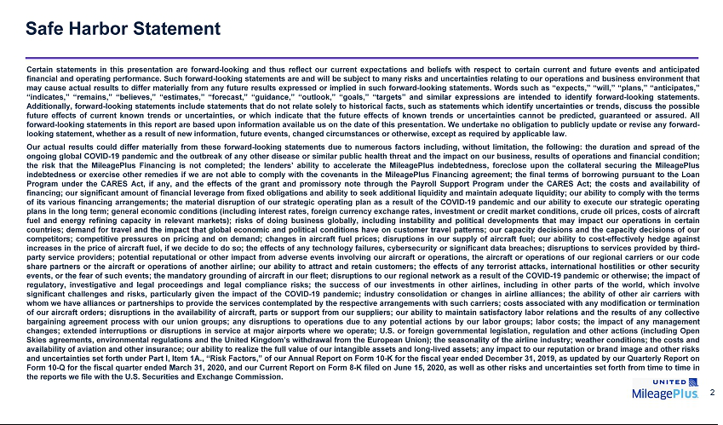

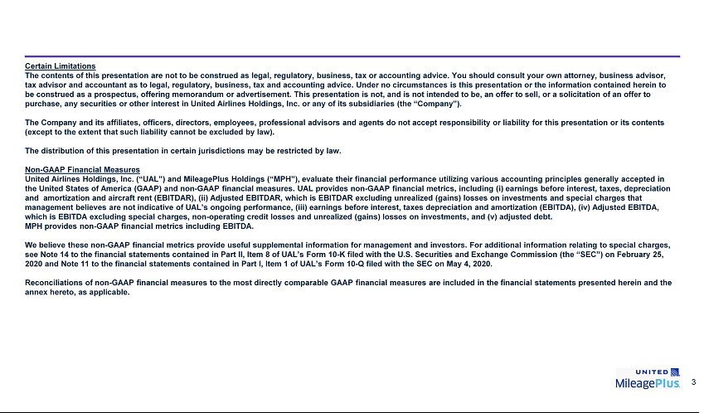

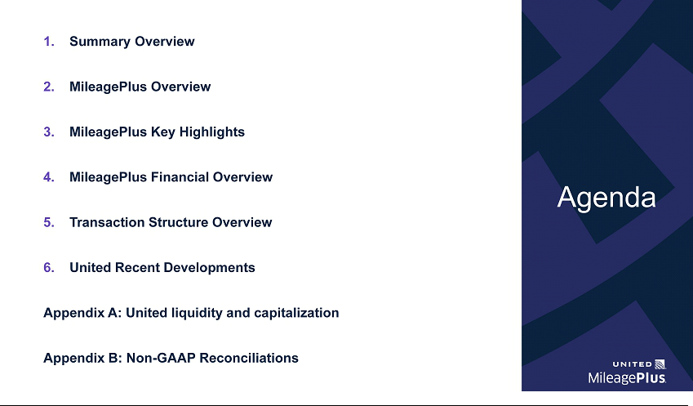



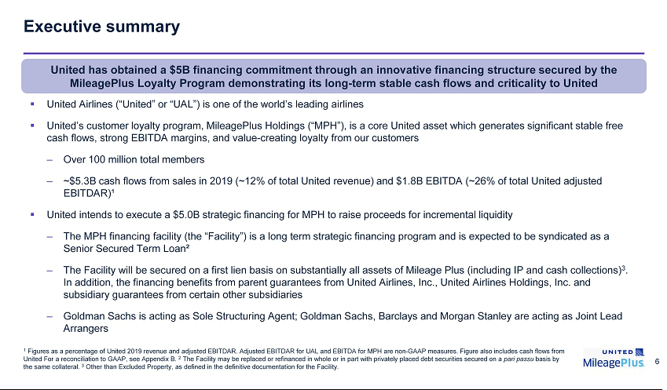

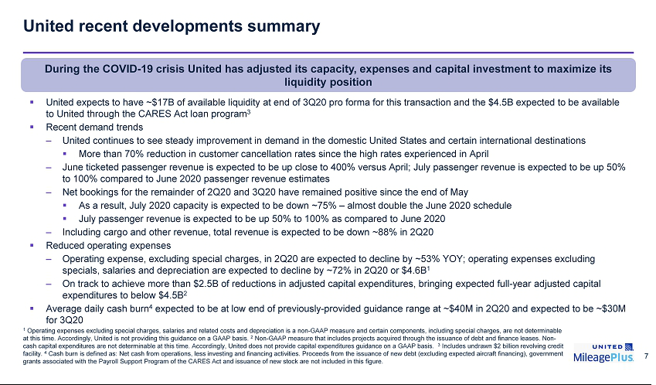



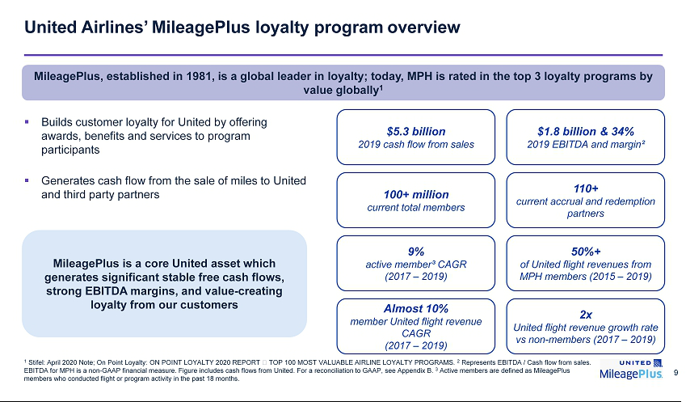

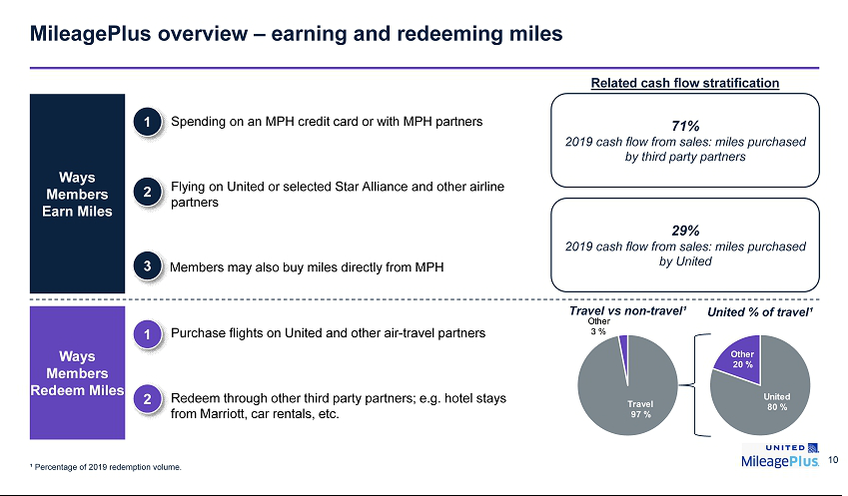

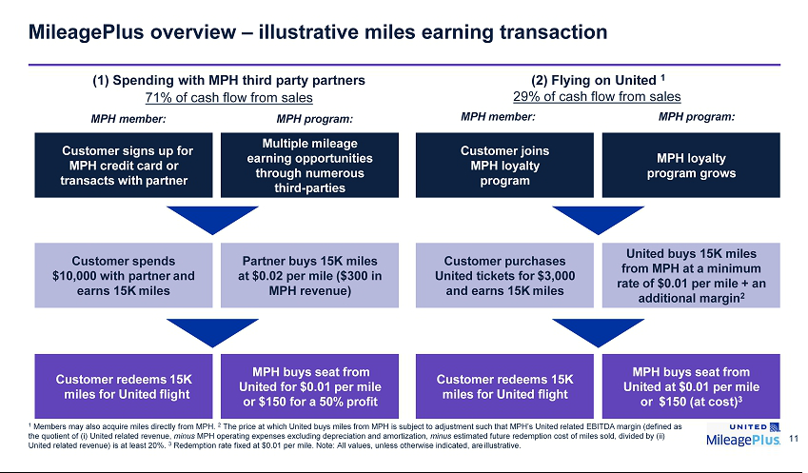

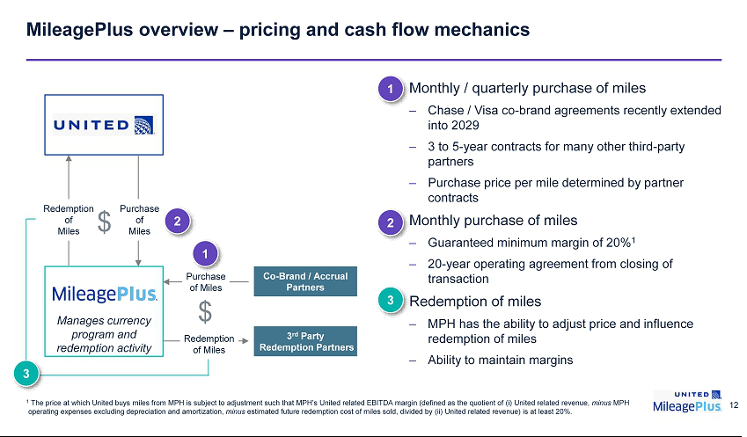

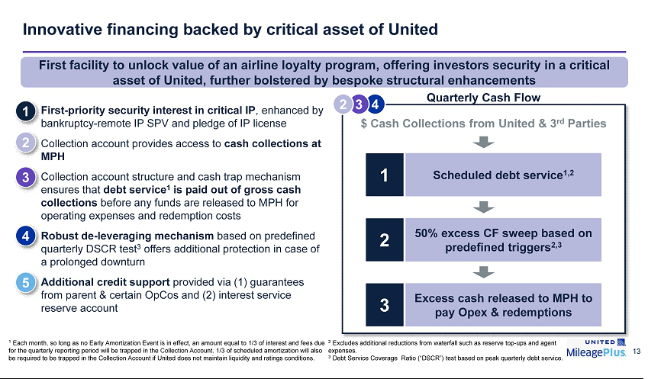



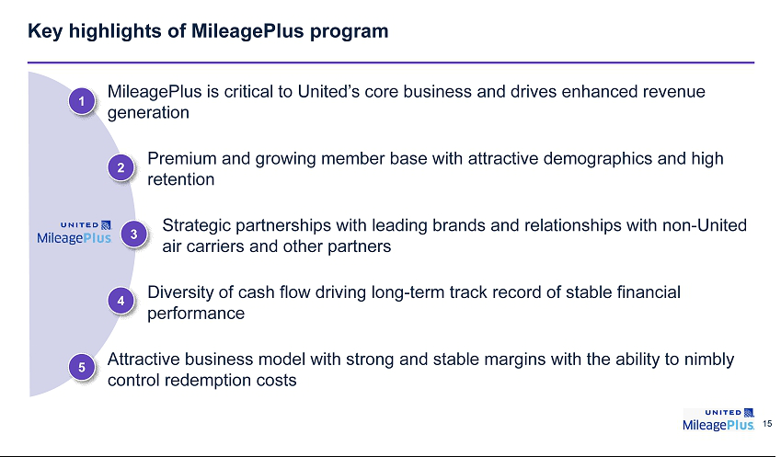

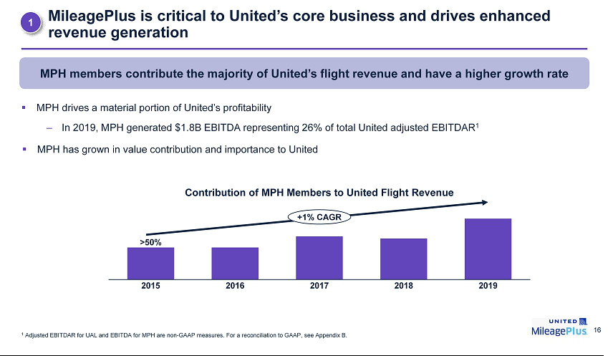

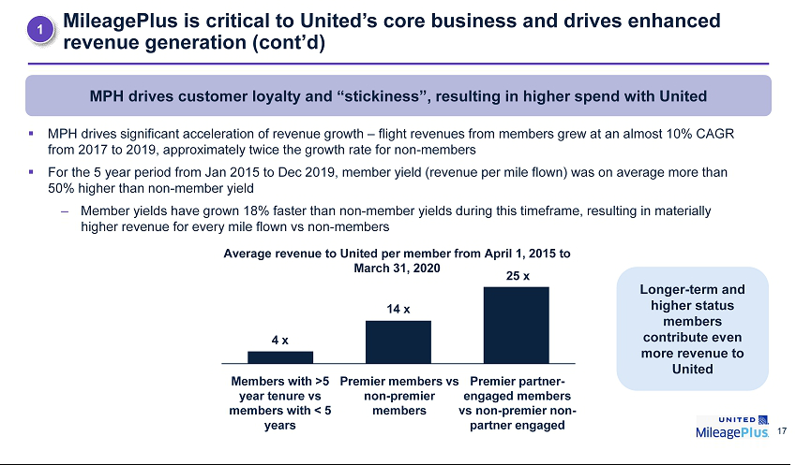

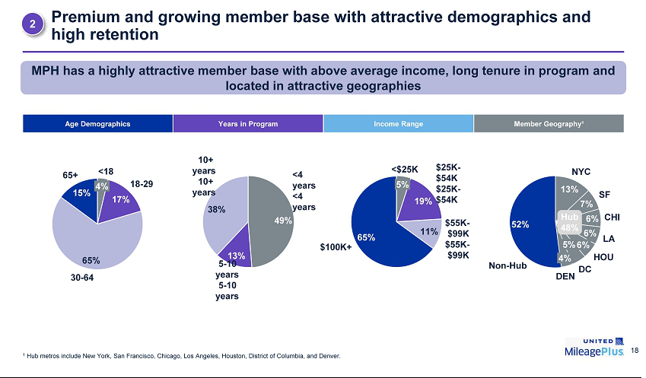

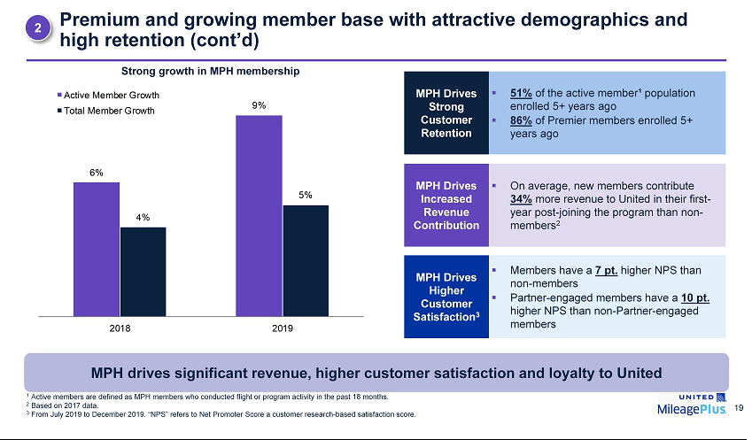

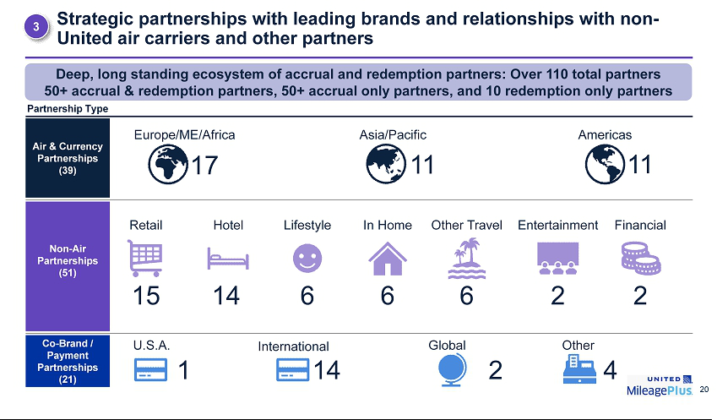

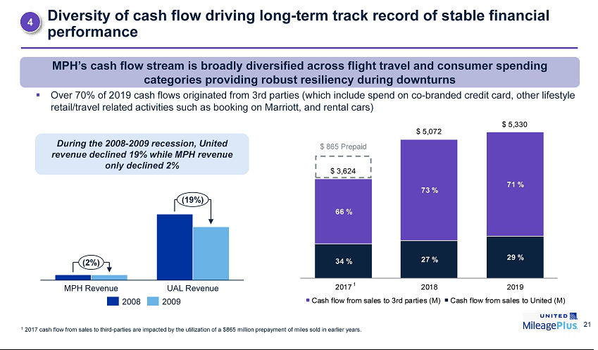

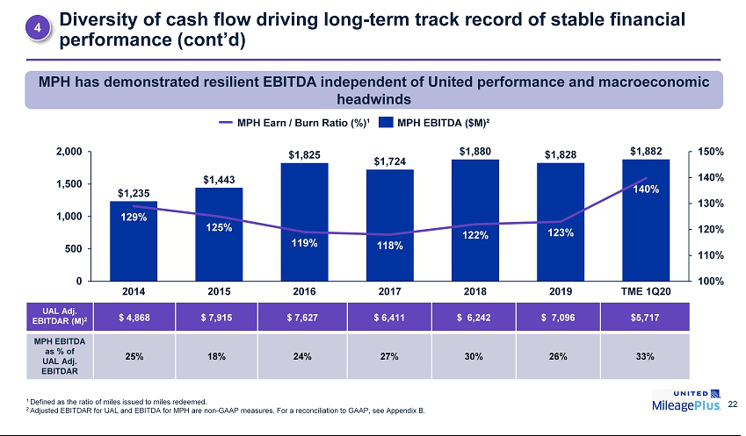

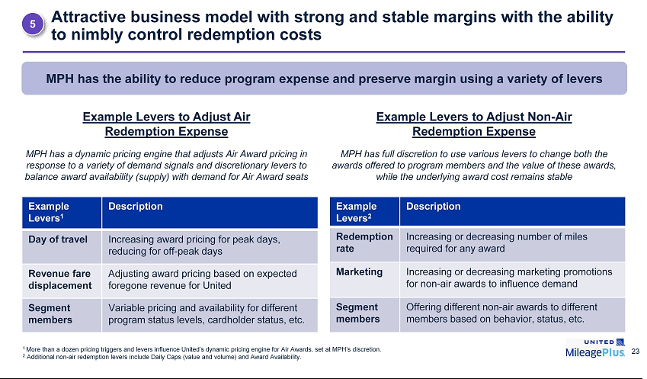



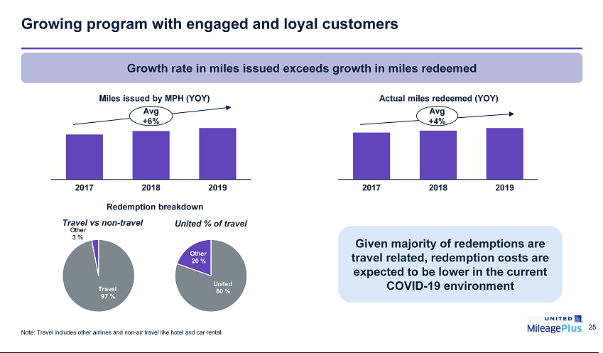

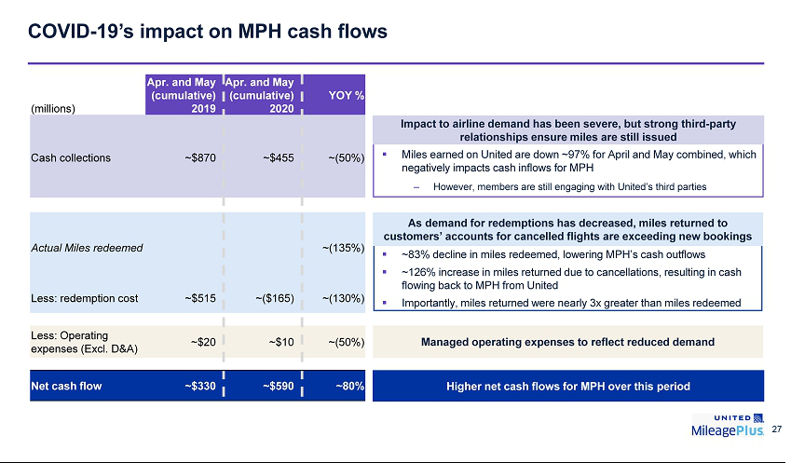



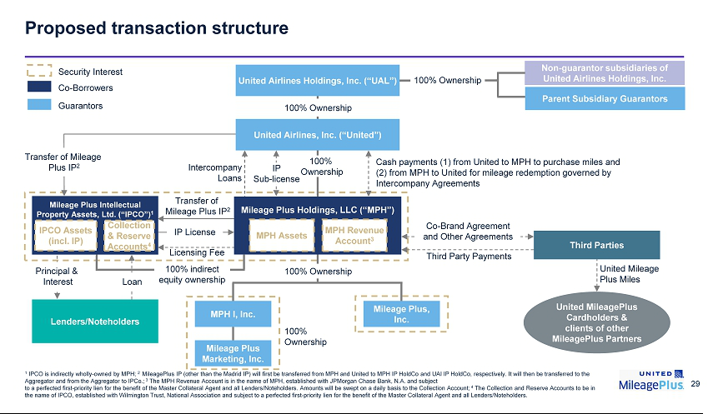

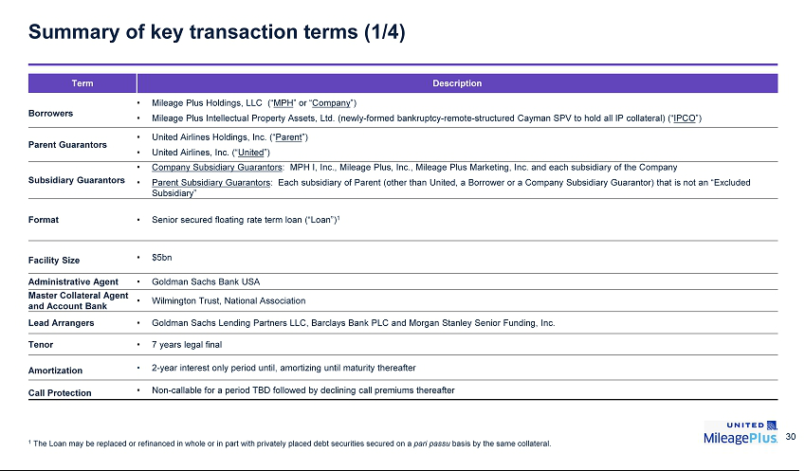

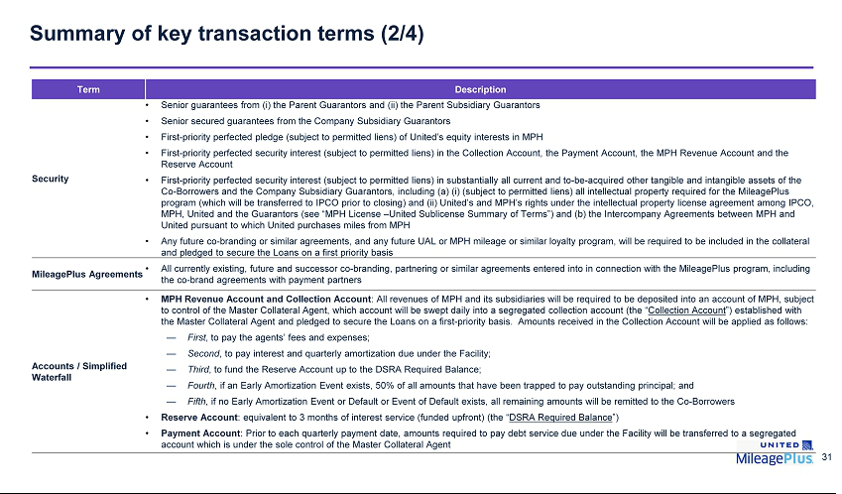

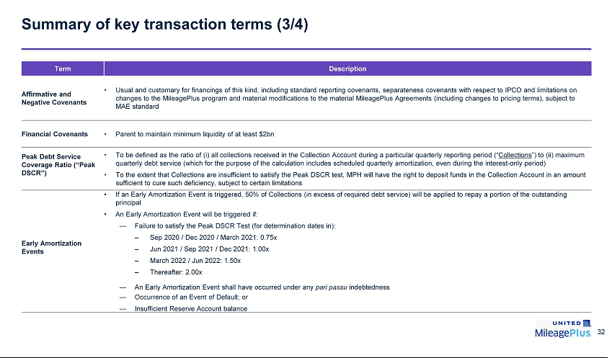

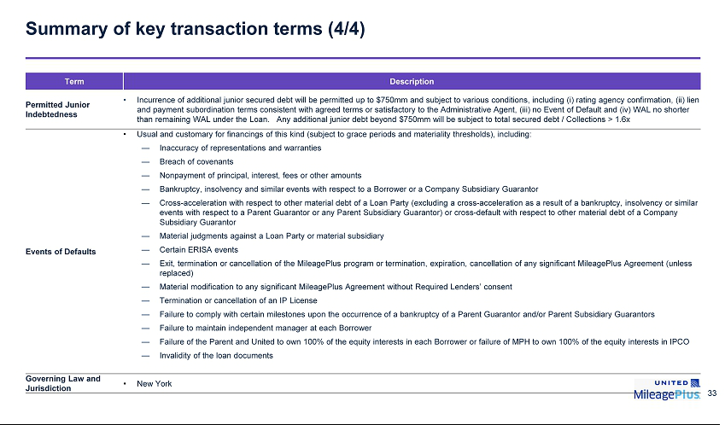

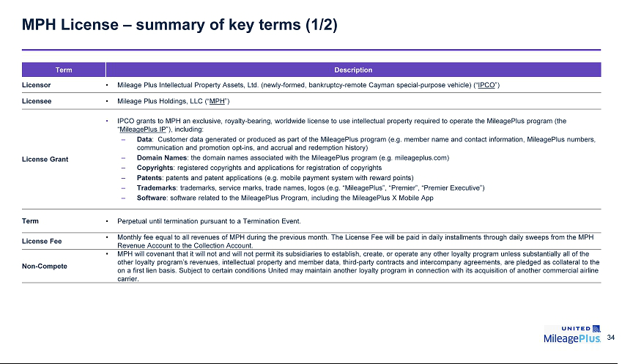

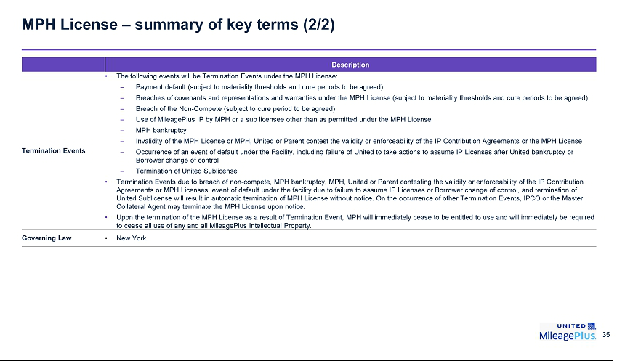

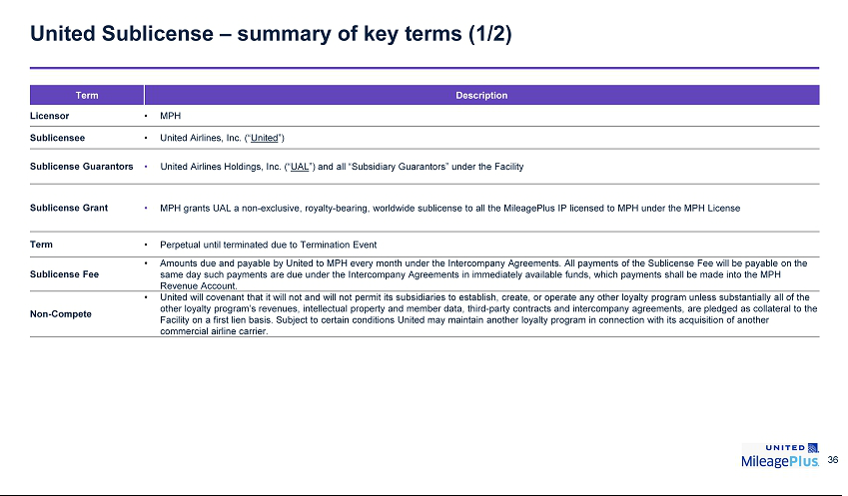



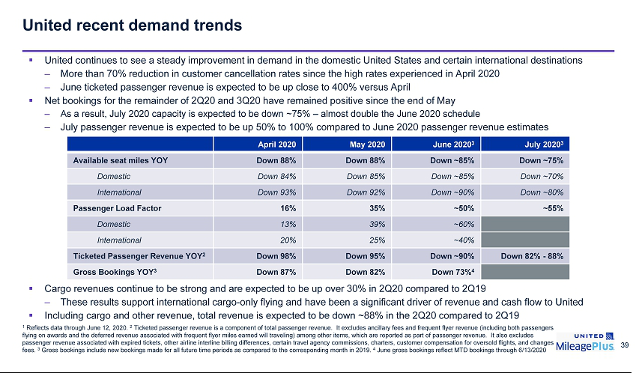

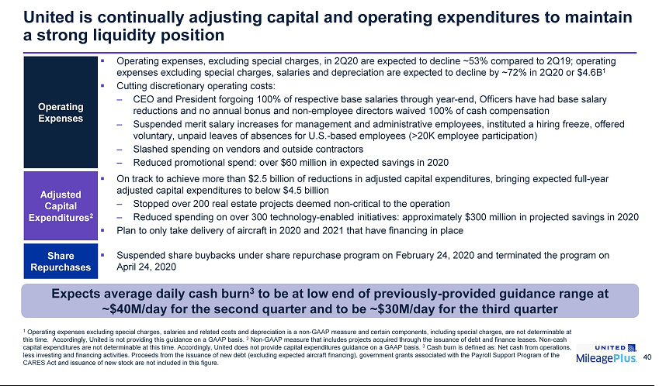

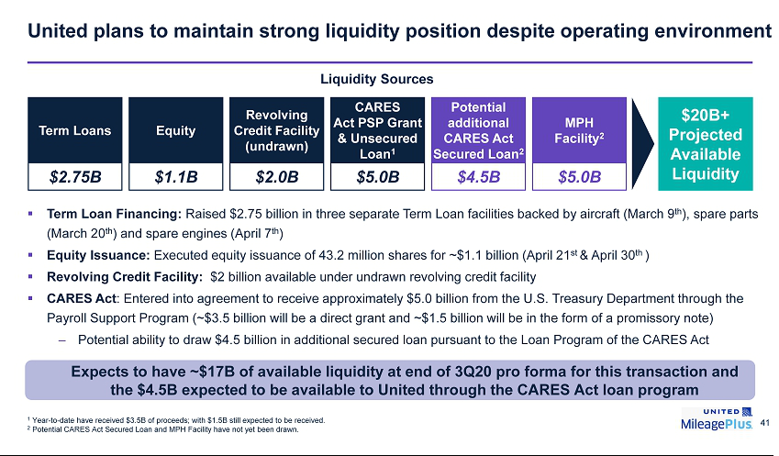

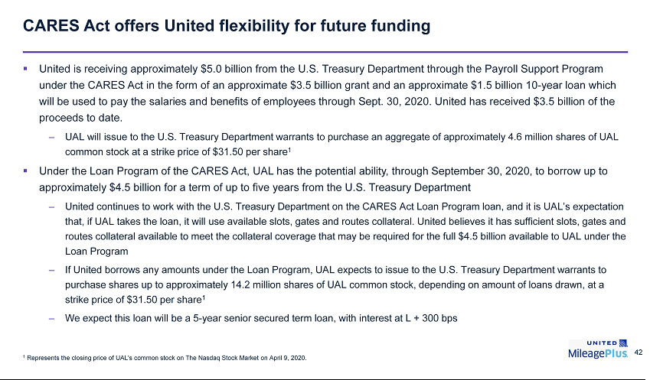



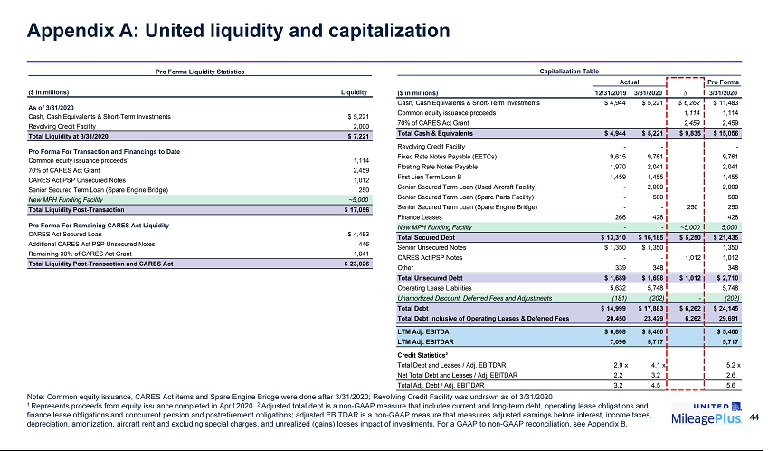

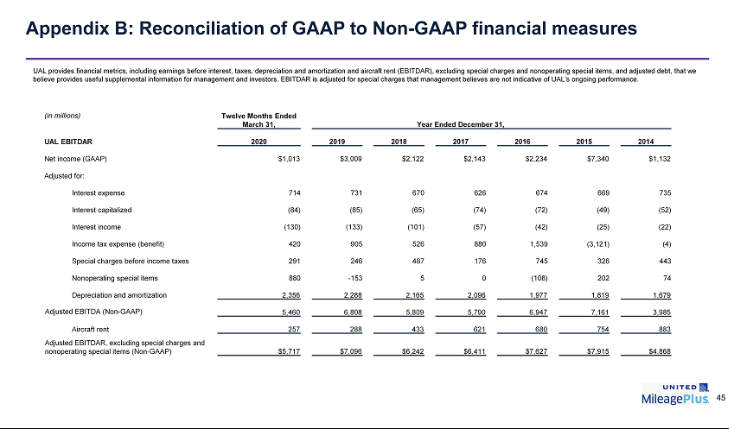

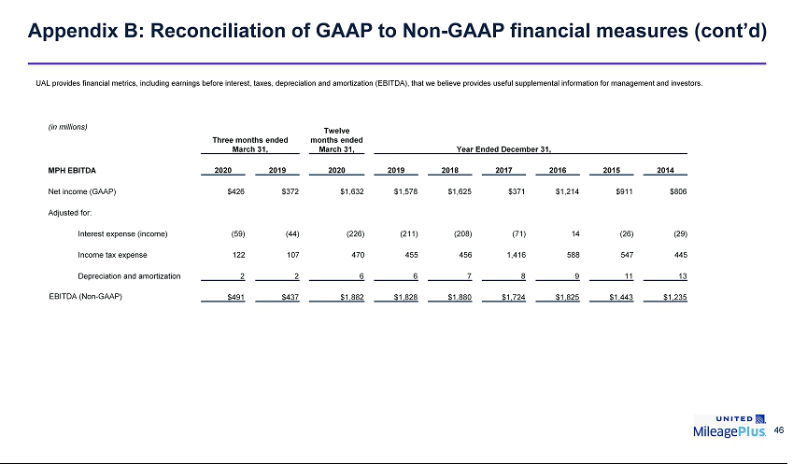

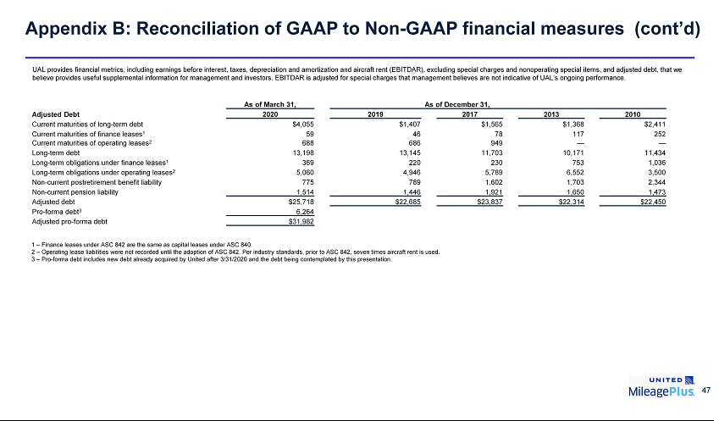

Exhibit 99.2

Summary of Terms and Conditions

$5.0 Billion Senior Secured Term Loan Facility

Mileage Plus Holdings, LLC

This Summary of Terms and Conditions is a summary of principal terms and conditions for the Term Facility (defined below). This Summary of Terms and Conditions is not intended to summarize all of the conditions, covenants, representations, warranties and other provisions that will be contained in the definitive documentation for the Term Facility (as defined below) and is qualified in its entirety by reference thereto. Further, as the documentation for the Term Facility is not finalized, these terms are subject to change in all respects, and reference should be made to the definitive documentation for the final terms of the Term Facility.

Borrowers | Mileage Plus Holdings, LLC, a Delaware limited liability company (the “Company”), and Mileage
 | Plus Intellectual Property Assets, Ltd., an exempted company incorporated with limited liability under
 | the laws of the Cayman Islands (“IPB” and together with the Company, each a “Borrower” and
 | together, the “Borrowers”). The Company shall have at least one independent manager and the IPB
 | shall have at least two independent managers, in each case, which such managers are not affiliated
 | with the Borrowers or United or the Master Collateral Agent and whose consent is necessary for any
 | voluntary bankruptcy filing by such entity. IPB is a special-purpose entity that will have no business
 | other than the transactions described herein or in the Credit Documentation. Additionally, IPB will
 | issue a special share to Walkers Fiduciary Limited who has granted a proxy to vote such share to the
 | Master Collateral Agent. The consent of the special shareholder will be necessary solely for any
 | voluntary bankruptcy filing.
Parent Guarantors | Each of United Airlines Holdings, Inc., a Delaware corporation (the “Parent”), and United Airlines,
 | Inc., a Delaware corporation (“United”, together with the Parent, the “Parent Guarantors” and
 | collectively with the Borrowers, the “Parent/Borrower Parties”).
Company Subsidiary Guarantors | Mileage Plus, Inc., a Delaware corporation, MPH I, Inc., a Delaware corporation and Mileage Plus
 | Marketing, Inc., a Delaware corporation and each subsidiary of the Company, including the
 | Aggregator Entities (as defined below) (the “Company Subsidiary Guarantors”), but excluding
 | IPB.
 | “Aggregator Entity” shall mean each entity (other than United and the Borrowers) party to an IP
 | Contribution Agreement.
Parent Subsidiary Guarantors | Each subsidiary of Parent (other than United, a Borrower or a Company Subsidiary Guarantor) that is
 | not an Excluded Subsidiary (each a “Parent Subsidiary Guarantor”, and together with the Parent
 | Guarantors, the Borrowers and the Company Subsidiary Guarantors, the “Guarantors” or the “Loan
 | Parties”).
Guaranty | Each Guarantor shall jointly and severally guarantee all of the Borrowers’ obligations under the Term
 | Facility on a senior basis (the “Guaranty”).

Excluded Subsidiaries

The Credit Documentation will carve out from the guarantee requirement each (i) Immaterial Subsidiary, (ii) unrestricted subsidiary, (iii) foreign subsidiary, (iv) captive insurance company that is prohibited from becoming a Guarantor pursuant to applicable rules and regulations, (v) receivables subsidiary, (vi) Specified Acquisition Subsidiary, and (vii) United Ground Express, Inc. (“UGE”). For the avoidance of doubt, none of the Company, the Borrower nor any of their respective subsidiaries (including the Aggregator Entities) can be an Excluded Subsidiary.

“Immaterial Subsidiaries” shall mean one or more subsidiaries, for which (a) the assets of all such subsidiaries constitute, in the aggregate, no more than 5.0% of the total assets of the Parent and its subsidiaries on a consolidated basis, and (b) the revenues of all such subsidiaries account for, in the aggregate, no more than 5.0% of the total revenues of the Parent and its subsidiaries on a consolidated basis for the twelve-month period; provided that (x) a subsidiary will not be considered to be an Immaterial Subsidiary if it (i) is a subsidiary of the Company, (ii) directly or indirectly guarantees, or pledges any property or assets to secure, any obligations under the Credit Documentation, or (iii) owns any properties or assets that constitute Collateral and (y) (i) CALFINCO Inc., and (ii) Covia LLC shall not be Immaterial Subsidiaries.

“Specified Acquisition Subsidiary” means any subsidiary (x) acquired by Parent or any of its subsidiaries (other than any Borrower or a Company Subsidiary Guarantor) after the Closing Date or

- which is an entity formed in connection with the acquisition of a subsidiary or any other assets (including any business lines or divisions) from (or constituting) a commercial airline carrier or any of its affiliates with a Loyalty Program, in each case so long as (a) a guarantee by such subsidiary of the obligations under the Credit Documentation are prohibited by applicable law, rule or regulation or by any contractual obligation, or require consent, approval, license or authorization, including from a governmental authority or counterparty to any contract (unless such consent, approval, license or authorization has been received; provided, that there shall be no obligation to obtain such consent) so long as (except in the case of a subsidiary described in clause (y) above) such prohibition is not created in contemplation of such acquisition; (b) which has not guaranteed or pledged its assets to secure (nor has its equity been pledged to secure) any indebtedness of Parent or any of its subsidiaries (other than any other Specified Acquisition Subsidiary or any of its subsidiaries); and (c) any indebtedness of which is not guaranteed or secured by the assets of Parent or any of its subsidiaries (other than any other Specified Acquisition Subsidiary or any of its subsidiaries).

Notwithstanding the foregoing, (i) no subsidiary may be designated an unrestricted subsidiary if, as a result of such designation, either (a) the assets of all subsidiaries that are Immaterial Subsidiaries or unrestricted subsidiaries shall constitute, in the aggregate, more than 5.0% of the total assets of the Parent and its subsidiaries on a consolidated basis, or (b) the revenues of all subsidiaries that are Immaterial Subsidiaries or unrestricted subsidiaries account for, in the aggregate, more than 5.0% of the total revenues of the Parent and its subsidiaries on a consolidated basis for the twelve-month period ending on the last day of the most recent fiscal quarter of the Parent and (ii) (x) CALFINCO Inc., and (y) Covia LLC shall not be unrestricted subsidiaries.

2

Administrative Agent | Goldman Sachs Bank USA (in such capacity, the “Administrative Agent”).
Master Collateral Agent and | Wilmington Trust, National Association (in such capacities, the “Master Collateral Agent” and the
Collateral Administrator | “Collateral Administrator”).
Account Bank | Wilmington Trust, National Association, with respect to the Collection Account, the Payment
 | Account and the Reserve Account (in such capacity, an “Account Bank”). In the event that the
 | Account Bank shall no longer have the required deposit rating (as defined in the Credit
 | Documentation), the Company shall be permitted to and shall promptly, and in any event within 30
 | days, move the Collection Account, the Payment Account and the Reserve Account to a depository
 | institution selected by the Company, subject to the approval of the Administrative Agent, such consent
 | not to be unreasonably withheld, conditioned, delayed or denied, that has the required deposit rating,
 | and will cause such depositary institution to execute a triparty agreement granting control to the
 | Master Collateral Agent over such accounts.
Agents | The Administrative Agent, the Master Collateral Agent, the Collateral Administrator and the Account
 | Bank (the “Agents”, and together with the Lenders, the “Secured Parties”).
Joint Lead Arrangers and Joint Bookrunner | Goldman Sachs Lending Partners LLC, Barclays Bank PLC and Morgan Stanley Senior Funding, Inc.
 | (collectively, the “Lead Arrangers”).
Lenders | Goldman Sachs Lending Partners LLC, Barclays Bank PLC and Morgan Stanley Senior Funding, Inc.
 | and a group of lenders selected by the Lead Arrangers and consented to (such consent not to be
 | unreasonably withheld or delayed) by the Borrowers and excluding, for the avoidance of doubt, any
 | disqualified lenders (the “Lenders”).
Facility | An aggregate principal amount of up to $5.0 billion (the “Term Facility” and the loans thereunder,
 | the “Initial Term Loans”, and together with the Incremental Term Loans and the Replacement Term
 | Loans, the “Term Loans”) minus the gross cash proceeds, net of any original issue discount, from the
 | issuance of any Permitted First Lien Notes (as defined below) or permanent debt.
Availability | The Term Loans will be available in a single drawing on a closing date (the “Closing Date”). The
 | Term Loans may not be re-borrowed once repaid.
Use of Proceeds | The Borrowers will use the net proceeds of the Term Loans (after deducting fees, costs and expenses
 | of the transaction) to fund the Reserve Account (as defined below) and to make an intercompany loan
 | to the Parent and United (the “MileagePlus Intercompany Loan”).
 | 3

Incremental Term Loans | The Borrowers shall have the right to request an increase to the Term Facility or one or more new
 | term loan facilities (the “Incremental Term Loans”), so long as certain conditions are met, including
 | the following:
 | (a) after giving effect to the Incremental Term Loans, the aggregate outstanding principal
 | amount of the existing Term Loans and any Permitted First Lien Notes (such existing debt,
 | the “Priority Lien Debt”), giving effect to any reductions of such outstanding amount
 | including as a result of any voluntary prepayments (including those pursuant to debt
 | buybacks made by the Borrowers in an amount equal to the face value of such indebtedness),
 | mandatory prepayments and amortization of Priority Lien Debt prior to such time, shall not
 | (excluding any fees, premiums, costs and expenses) exceed an amount equal to $[6.8 billion]
 | (the “Priority Lien Cap”);
 | (b) the Rating Agency Condition has been satisfied;
 | (c) the pro forma Peak Debt Service Coverage Ratio (calculated using the Maximum Quarterly
 | Debt Service of the then existing Term Loans and the Incremental Term Loans) as of the
 | immediately preceding Determination Date, immediately after giving effect to the making of
 | the Incremental Term Loans shall be more than (A) so long as a DSCR Step-up Period is not
 | in effect, (i) for any date of determination prior to the Determination Date occurring in
 | March, 2022, 1.50:1.00, (ii) for any date of determination during the period beginning on or
 | after the Determination Date occurring in March 2022 but excluding the Determination Date
 | occurring in September 2022, 1.75:1.00 and (iii) for any date of determination occurring on
 | or after the Determination Date in September 2022, 2.25:1.00 and (B) if a DSCR Step-up
 | Period is in effect on any Determination Date, 2.25:1.00;
 | (d) there is no action, proceeding, or investigation pending or threatened in writing against any
 | Loan Party before any court or administrative agency that has a reasonable likelihood of
 | adverse determination, which determination would reasonably be expected to result in a
 | Material Adverse Effect;
 | (e) the maturity date for any Incremental Term Loans shall not be earlier than the latest maturity
 | date for the then-outstanding Term Loans; and such Incremental Term Loans shall not have a
 | weighted average life to maturity shorter than the weighted average life to maturity of the
 | then-outstanding Term Loans;
 | (f) to the extent that the terms and provisions of Incremental Term Loans are not identical to
 | any outstanding class of Term Loans (except to the extent permitted by the clause (e) above
 | and (g) below), such terms and conditions shall (A) be reasonably acceptable to the
 | Administrative Agent or (B) not be materially more restrictive to the Borrower and the
 | Company Subsidiary Guarantors (as determined in good faith by the Borrowers), when taken
 | as a whole, than the terms of the then-outstanding Term Loans (except for (1) covenants,
 | events of default and guarantees applicable only to periods after the latest maturity date of
 | any then outstanding Loan Parties (as of the date of the incurrence of such Incremental Term
 | Loans) and (2) subject to clause (i), pricing, fees, rate floors, premiums, optional prepayment
 | or redemption terms) unless the Lenders under the then-outstanding Term Loans, receive the
 | benefit of such more restrictive terms;
 | 4

- terms and provisions with respect to interest rates, maturity date and amortization schedule of Incremental Term Loans shall be as agreed upon between the Borrowers and the applicable Lenders providing such Incremental Term Loans (it being understood that the Incremental Term Loans may be part of any existing class of Term Loans);

- such Incremental Term Loans shall not be subject to any guarantee by any person other than a Loan Party and shall not be secured by a lien on any asset other than any asset constituting Collateral (except to the extent that any additional collateral security is added to the Collateral to secure, and additional guarantees are added for the benefit of, the then-outstanding Term Loans); and

- the All-In Yield applicable to any Incremental Term Loans shall be determined by the Company and the applicable Lenders providing such Incremental Term Loans; provided, that if the All-In Yield of any such Incremental Term Loans exceeds the All-In Yield on any then-existing Term Loans (calculated in the same manner and after giving effect to any amendment to interest rate margins applicable to such existing Term Loans after the Closing Date but immediately prior to the time of the making of such Incremental Term Loans) by more than 0.50%, the applicable margins applicable to such existing Term Loans shall be increased to the extent necessary so that the yield on such Term Loans is 0.50% less than the All-In Yield on such Incremental Term Loans (it being agreed that any increase in yield to such existing Term Loans required due to the application of a LIBO Rate or Alternate Base Rate floor on any Incremental Term Loans shall be effected solely through an increase in (or implementation of, as applicable) any LIBO Rate or Alternate Base Rate floor applicable to such existing Term Loans).

“All-In Yield” shall mean as to any debt, the yield thereof, whether in the form of interest rate, margin, original issue discount, upfront fees, a LIBOR or Alternate Base Rate, or otherwise, in each case, incurred or payable by the Borrowers generally to all the lenders of such Indebtedness; provided that upfront fees and original issue discount shall be equated to interest rate based upon an assumed four year average life to maturity (e.g., 100 basis points of original issue discount equals 25 basis points of interest rate margin for a four year average life to maturity); provided, further, that “All-In Yield” shall exclude any structuring, ticking, unused line, commitment, amendment, consent, underwriting, syndication and arranger fees, other similar fees and other fees not generally paid to all lenders and, if applicable, consent fees paid generally to consenting lenders.

5

Maturity | The seventh anniversary of the Closing Date; provided that the Credit Documentation shall provide
 | customary provisions whereby individual Lenders may agree to extend the maturity of their Term
 | Loans upon the request of the Borrowers and without the consent of any other Lender (as further
 | described under the heading “Voting” below).
Interest Rate | The interest rates per annum applicable to the Term Facility will be (i) LIBO Rate plus [__]% per
 | annum, subject to a LIBO Rate floor of 1.0%, or (ii) if the LIBO Rate is unavailable, the Alternate
 | Base Rate plus [__]% per annum, subject to an Alternate Base Rate floor of 0.0%. Interest shall be
 | payable in cash, quarterly in arrears on each Payment Date. The Credit Documentation with include
 | customary LIBO Rate replacement provisions.
 | At any time when the Borrowers are in default in the payment of any amount of principal or interest
 | due under the Term Facility, such overdue amount shall bear interest at 2% above the rate otherwise
 | applicable thereto. Overdue fees and other amounts shall bear interest at 2% above the alternate base
 | rate.
Payment Dates | Quarterly, on the 20th calendar day of March, June, September and December of each year, or if such
 | day is not a business day, the next business day, commencing September 21, 2020.
Allocation Date | With respect to any Payment Date and the related Quarterly Reporting Period, the business day that is
 | two business days prior to such Payment Date.
Interest-Only Period | No principal is scheduled to be paid in respect of the Term Loans during the period from the Closing
 | Date to, but excluding, September 20, 2022. Interest shall be payable in cash, quarterly in arrears on
 | each Payment Date.
Principal Payments | Following the interest-only period, principal shall be payable in equal quarterly installments on each
 | Payment Date (as such amounts may be adjusted for optional and mandatory prepayments, the
 | “Scheduled Principal Amortization Amount”).
Optional Prepayments | The Term Loans may be prepaid, in whole or in part, in minimum principal amounts to be agreed,
 | subject to prepayment premiums and non-call periods as set forth in “Premium Payments” below,
 | together with all accrued interest and unpaid interest thereon, and reimbursement of Lenders’
 | customary redeployment and breakage costs. Optional prepayments shall be applied pro rata to
 | reduce all remaining installments of Scheduled Principal Amortization Amounts.
 | 6

Mandatory Prepayments

The Borrowers will prepay (or, with respect to clauses (b), (c) and (e) below, offer to prepay), Term Loans together with all accrued interest and unpaid interest thereon, and reimbursement of Lenders’ customary redeployment and breakage costs, as follows:

(a) 100% of the net cash proceeds of any debt (other than (i) permitted debt, and (ii) any Permitted Pre-Paid Miles Purchase (as defined below)) of the Borrowers;

(b) 100% of the net cash proceeds of insurance and condemnation events received by the Company or any of its subsidiaries subject to customary exceptions, qualifications and reinvestment rights;

(c) from 100% of the net cash proceeds of any indemnity, termination payment, liquidated damages or similar payment to the Parent or any of its subsidiaries under a MileagePlus Agreement in excess of $50.0 million, in the aggregate after the Closing Date, subject to certain exceptions and limitations;

(d) 100% of the net cash proceeds of any Permitted Pre-Paid Miles Purchase above $300.0 million in the aggregate after the Closing Date; or

(e) 101% of the outstanding principal amount of the Term Loans as a result of a Parent Change of Control.

Mandatory prepayments shall be applied to the Term Loans pro rata to reduce all remaining installments of Scheduled Principal Amortization Amounts.

“Parent Change of Control” to be defined to occur upon the occurrence of following:

(a) the sale, lease, transfer, conveyance or other disposition (other than by way of merger or consolidation), in one or a series of related transactions, of all or substantially all of the properties or assets of the Parent and its subsidiaries taken as a whole to any person (including any “person” (as that term is used in Section 13(d)(3) of the Exchange Act)), together with a Rating Decline; or

(b) the consummation of any transaction (including, without limitation, any merger or consolidation), the result of which is that any person (including any “person” (as that term is used in Section 13(d)(3) of the Exchange Act)) becomes the beneficial owner, directly or indirectly, of more than 50% of the voting stock of the Parent (subject to certain exceptions), together with a Rating Decline.

7

 | “Rating Decline” shall mean with respect to the Term Loans, if, within 60 days after public notice of
 | the occurrence of a Parent Change of Control (which period shall be extended so long as the rating of
 | the Term Loans is under publicly announced consideration for possible downgrade by any nationally
 | recognized statistical rating organization that has provided a rating for the Term Facility (each a
 | “Rating Agency”)), the rating of the Term Loans by each Rating Agency shall be decreased by one or
 | more gradations provided that a Rating Decline shall not be deemed to have occurred if such Rating
 | Agencies have not expressly indicated that such downgrade is a result of such Parent Change of
 | Control.
 | “Rating Agency Condition” means, with respect to any then-existing Term Loans and any action, the
 | Borrowers have provided evidence to the Administrative Agent and the Master Collateral Agent that
 | each Rating Agency that has provided a rating for the Term Facility has provided a written
 | confirmation that such action will not result in either (A) a withdrawal of its credit ratings on the then-
 | existing Term Loans or (B) the assignment of credit ratings on the then-existing Term Loans below
 | the lower of (x) the then-current credit ratings on such Term Loans or (y) the initial credit ratings
 | assigned to such Term Loans (in each case, without negative implications); provided that any time that
 | there are no Term Loans rated by a Rating Agency, references to any condition or requirement that the
 | “Rating Agency Condition” shall have been satisfied shall have no effect and no such action shall be
 | required.
 | A combination of the Parent and United shall not be a Change of Control.
Premium Payments | Non-callable for a period TBD followed by declining call premiums thereafter.
Rating | The Parent/Borrower Parties shall use commercially reasonable efforts to maintain ratings for the
 | Term Facility from two of the Rating Agencies (but not a specific rating). The Borrowers will be
 | responsible for all rating agency fees in connection with obtaining and maintaining such ratings.
MileagePlus Agreements | All currently existing, future and successor co-branding, partnering or similar agreements related to or
 | entered into in connection with the MileagePlus Program (as defined below) (the “MileagePlus
 | Agreements”).
 | 8

Intercompany Agreements | All currently existing or future agreements governing the sale, transfer or redemption of Miles (as
 | defined below), use of the MileagePlus Intellectual Property and Excluded Intellectual Property or
 | provision of services by the Parent Guarantors or any of their subsidiaries to either Borrower or the
 | Company Subsidiary Guarantors in connection with the MileagePlus Program (the “Intercompany
 | Agreements”) including: (a) the Third Amended and Restated General Services Agreement, dated on
 | or about the Closing Date, between the Company and United (the “General Services Agreement”),
 | (b) the Fourth Amended and Restated MileagePlus Operating Agreement, dated on or about the
 | Closing Date (the “Operating Agreement”), between the Company and United, (c) the Fourth
 | Amended and Restated Umbrella Agreement, dated on or about the Closing Date, between the
 | Company and United (the “Umbrella Agreement”, together with the General Services Agreement
 | and the Operating Agreement, the “Integrated Agreements”) and (d) for certain circumstances, the
 | IP Agreements, as defined below. United may terminate its obligations to the Company under the
 | Integrated Agreements upon written notice at any time upon or after (i) the payment in full of all
 | senior secured debt obligations or (ii) the sale or disposition of the Company (or any equity interests
 | in the Company) by the Master Collateral Agent to third parties other than the secured parties after
 | foreclosure following an Event of Default, the Company ceases to be affiliated with United; provided
 | that such termination would not affect the rights and obligations of the parties to such agreements that
 | may have accrued prior to such termination, or as a result of such termination, or that expressly
 | survive termination pursuant to the terms thereof.
IP Contribution Structure and IP Contribution | United, the Company and the Company’s subsidiaries will enter into contribution agreements (the “IP
Agreements | Contribution Agreements”) pursuant to which each of United and the Company will contribute all
 | its rights, title and interest to the MileagePlus Intellectual Property owned or purported to be owned,
 | or later developed (and owned) or acquired, by United or MPH to IPB through a series of
 | contributions as described below, provided that such MileagePlus Intellectual Property will be
 | transferred subject to existing third-party rights to such MileagePlus Intellectual Property under the
 | MileagePlus Agreements and other permitted liens (collectively “Contributed Property”). United or
 | the Company, as applicable, may terminate its obligation to contribute later developed or acquired
 | MileagePlus Intellectual Property to IPB or any immediate assignees upon written notice at any time
 | upon or after (i) the payment in full of all senior secured debt obligations or (ii) the sale or disposition
 | of IPB (or any equity interests in IPB) or any immediate assignees by the Master Collateral Agent to
 | third parties other the secured parties after foreclosure following an Event of Default, IPB or any of
 | the intermediate assignees cease to be affiliated with United; provided that such termination would not
 | affect the rights and obligations of the parties that may have accrued prior to such termination, or as a
 | result of such termination, or that expressly survive termination pursuant to the terms thereof.
 | 9

To the extent that certain MileagePlus Intellectual Property cannot be transferred or contributed under applicable law, domain registrar restrictions or existing contractual restrictions (“Specified IP”), such Specified IP will not be contributed to IPB, provided that it will later be contributed if and when it is permissible to do so.

“MileagePlus Intellectual Property” means (a) MileagePlus Customer Data and (b) all intellectual property (i.e., patents, trademarks, brand names, trade dress, know how, copyrights, trade secrets, domain names, social media accounts and other intellectual property, whether registered or unregistered, including unregistered copyrights in software and source code and applications to register any of the foregoing) (but excluding data, which is addressed in clause (a)) owned or purported to be owned, or later developed or acquired and owned or purported to be owned, by United or MPH and required or necessary to operate the MileagePlus Program. In the case of clause (b) MileagePlus Intellectual Property shall exclude intellectual property used to operate the United airline business that, even if used in connection with the MileagePlus Program, would be required or necessary to operate the United airline business in the absence of a Loyalty Program (the “United Intellectual Property”), including the following and certain other to be agreed specified intellectual property: (1) the UNITED, UAL, STAR ALLIANCE, GLOBAL SERVICES, PERKSPLUS, PERKSPLUS NAVIGATOR, PASSPLUS, PASSPLUS FLEX, PASSPLUS SECURE, PASSPLUS EXEC, UNITED VACATIONS, UNITED PACKAGES, UNITED CORPORATE PREFERRED, UNITED PROPEL, UNITED ACADEMIA, UNITED MEETINGS, UNITED EXPRESS, UNITED CLUB, UNITED POLARIS, UNITED FIRST, UNITED BUSINESS, UNITED PREMIUM PLUS, ECONOMY PLUS, RED CARPET CLUB, FLY THE FRIENDLY SKIES, HEMISPHERES, THREE PERFECT DAYS, and ECO-SKIES marks (including UAL as a stock symbol) and the “globe” logo mark, together with any translations, logos or designs for the foregoing; (2) the composite marks that have been identified and discussed by the parties (which composite marks will be expressly cancelled by United, unless otherwise agreed by the parties); (3) the united.com domain name registration and website (including all content and source code that is not otherwise MileagePlus Intellectual Property) and United’s social media accounts; and (4) the United mobile app. For the avoidance of doubt any use of the MileagePlus Intellectual Property in combination with the specifically excluded intellectual property shall be subject to and governed by the IP Licenses including any termination thereof.

“MileagePlus Customer Data” means all data owned or purported to be owned, or later developed or acquired and owned or purported to be owned, by United or the Company and used, generated or produced as part of the MileagePlus Program, including all of the following: (a) a list of all members of the MileagePlus Program; and (b) the MileagePlus Member Profile Data for each member of the MileagePlus Program, but excluding United Traveler Related Data.

10

“MileagePlus Member Profile Data” means with respect to each member of the MileagePlus Program such member’s (a) name, mailing address, email address, and phone numbers, (b) communication and promotion opt-ins, (c) Premiere Program history, (d) total miles flown, including miles flown for Million Miler program, (e) third party engagement history and (f) accrual and redemption activity of each such MileagePlus member, including any data related to member segment designations or member segment activity or qualifications, but in the case of clauses (b) through (f) excluding United Traveler Related Data.

“United Traveler Related Data” means data (a) generated, produced or acquired as a result of the issuance, modification or cancellation of customer tickets from United or for flights on United or United Express, including data in or derived from “Passenger Name Records” (including name and contact information) associated with flights on United or United Express, and (b) a customer’s flight-related experience, but excluding in the case of clause (a) information that would not be generated, produced or acquired in the absence of a Loyalty Program. The parties acknowledge that customer name and contact information is included in both MileagePlus Customer Data and United Traveler Related Data.

Pursuant to an Intellectual Property Quitclaim Assignment (the “Quitclaim”) to be effective immediately prior to the Closing Date, including prior to the granting of any security interests for the benefit of the Secured Parties, and before giving effect to the IP Contribution Agreements, to the extent that the Company has acquired any right, title and interest to Excluded Intellectual Property, the Company shall assign such right, title and interest to United. The Quitclaim will provide that if any MileagePlus Intellectual Property is determined to have been inadvertently assigned to United, United shall assign such MileagePlus Intellectual Property back to the Company or IPB, as applicable.

The Intercompany Agreements will include a license from United to the Company to use the Excluded Intellectual Property in connection with the MileagePlus Program (to the extent necessary or required) subject to United’s right of termination described in “Intercompany Agreements” above.

“Excluded Intellectual Property” means (1) intellectual property other than the MileagePlus Intellectual Property and (2) the United Traveler Related Data.

United and the Company will initially contribute their respective Contributed Property (other than the Madrid IP and the Specified EU Domain Name) to special purpose holding companies organized under the laws of the Cayman Islands (“United HoldCo” and “Company HoldCo” respectively). United HoldCo and Company HoldCo will then contribute their respective Contributed Property to a bankruptcy remote holding company of IPB organized under the laws of the Cayman Islands (“IPB HoldCo”). IPB HoldCo will then contribute the Contributed Property to IPB.

11

The assignment of MileagePlus Customer Data is subject to all applicable laws, regulations and privacy policies, and IPB will be required to comply with the same.

With respect to any MileagePlus Intellectual Property registered under the Madrid System of the World Intellectual Property Organization (the “Madrid IP”) and the mileageplus.eu domain name (the “Specified EU Domain Name”), United shall undertake the following. On or before the Closing Date, (i) United shall contribute United’s rights to the Madrid IP to the Company and (ii) cause the Company to license the Madrid IP to IPB pursuant to an irrevocable, exclusive, sub-licensable royalty free license (which license will be included in the MPH License).

No later than ninety (90) days after the Closing Date (as extended by the Administrative Agent in its reasonable discretion), United shall take such actions as shall be agreed between the Company and the Administrative Agent to: (a) cause the Madrid IP and the Specified EU Domain Name to be owned by an entity organized in Luxembourg that is a wholly-owned subsidiary of IPB (the “Madrid SPV”),

- cause the Madrid SPV to pledge the Madrid IP and the Specified EU Domain Name as Collateral,

- cause the Madrid SPV to license the Madrid IP and the Specified EU Domain Name to IPB pursuant to an irrevocable, exclusive, sub-licensable royalty free license for inclusion in the IP Licenses described below (which license will be in substantially the form of a license to be attached to the Credit Agreement) and (d) deliver to the Administrative Agent customary legal opinions in respect of joining such person as a guarantor and the security interest on the Madrid IP and other supporting documents in connection with the Madrid Protocol Holding Structure, as modified (the “Madrid Protocol Holding Structure”).

Notwithstanding the foregoing or any provision herein or in any Credit Documentation to the contrary, if, (a) at any time following the Closing Date, a Loan Party determines in its reasonable judgment that, due to applicable law or a change in law (including, for the avoidance of doubt, any legislative or regulatory action or decision by any administrative or judicial body responsible for the administration of Taxes) the Madrid Protocol Holding Structure has or will cause any Loan Party or any of its subsidiaries to incur any material tax detriment (determined after taking into account the ability to utilize any foreign tax credit within the same tax year) that such Loan Party (or such subsidiary) would not recognize if the Madrid Protocol Holding Structure was not in place; or (b) the Company and the Administrative Agent reasonably conclude that there is no structure available that would not violate the foregoing clause (a) without the incurrence of material costs, then, in the case of either clause (a) or clause (b), the Loan Parties and applicable subsidiaries shall, upon notice to the Master Collateral Agent, implement the following alternative structure for the ownership and licensing of the Madrid IP (“Alternative Madrid Structure”): (i) transferring ownership of the Madrid IP to the Company and exclusively licensing it to IPB pursuant to an irrevocable, exclusive, sub-licensable, royalty free license (which license will be in the same form contemplated for the license described in the paragraph above), and (ii) filing national trademark registrations in all material Madrid Protocol jurisdictions in the name of IPB and once deemed advisable in United’s reasonable business judgment (i.e., if advisable to maintain the Madrid IP registration to preserve IPB’s rights in the brand while national trademark registrations are pending) or at the written direction of the Master Collateral Agent, abandon registration under the Madrid System of the World Intellectual Property Organization Madrid IP; provided that the Loan Parties shall have exercised commercially reasonable efforts to implement such Alternative Madrid Structure that are within the control of the Loan Parties within one hundred and eighty (180) days of providing such notice to the Master Collateral Agent (as extended by the Administrative Agent in its reasonable discretion). If the Alternative Madrid Structure is implemented, the Specified EU Domain Name shall constitute Specified IP for all purposes under the Credit Documentation.

12

MPH License | IPB, as licensor, will grant to the Company, as licensee, an exclusive, irrevocable and perpetual
 | (subject to termination as set forth below) worldwide license (with the right to sublicense) to the
 | MileagePlus Intellectual Property pursuant to an Intellectual Property License Agreement (the “MPH
 | License”) and in turn the Company will grant United a non-exclusive, irrevocable and perpetual
 | (subject to termination as set forth below) worldwide sublicense (with the right to grant further
 | sublicenses) to the MileagePlus Intellectual Property pursuant to an Intellectual Property Sub-License
 | Agreement (the “United Sublicense” and together with the MPH License, the “IP Licenses”), in each
 | case subject to any third party rights. The obligations of United under the United Sublicense will be
 | jointly and severally guaranteed by Parent and the Guarantors (the “License Guarantors”).
 | Under the applicable IP License, the Company, United and each License Guarantor will covenant that
 | on and after the Closing Date it shall not, and shall not permit any of its subsidiaries to, establish,
 | create, or operate any Loyalty Program, other than a Permitted Acquisition Loyalty Program, unless
 | substantially all Loyalty Program cash revenues (which excludes, for the avoidance of doubt, airline
 | revenues such as ticket sales and baggage fees), accounts in which such cash revenue is deposited,
 | intellectual property and member data (but solely to the extent that such intellectual property and
 | member data would be included in the definition of MileagePlus Intellectual Property, substituting
 | references to the MileagePlus Program with references to such other Loyalty Program), and third-
 | party contracts and intercompany agreements, related to such Loyalty Program are Collateral on a first
 | lien basis (but solely to the extent such revenues and assets would have been required to have been
 | granted as Collateral as of the Closing Date), subject to third party rights and other permitted liens;
 | provided that, for the avoidance of doubt, nothing shall prohibit Parent or any of its subsidiaries from
 | offering and providing discounts or other incentives for travel or carriage on United, United Express
 | or any of the Star Alliance partners (or, in the case of, United’s Global Services program, from
 | offering and providing other goods and services) to (a) businesses or (b) members of Unaffiliated
 | Loyalty Programs or United’s Global Services program so long as no Currency is provided to such
 | members other than Currency under the MileagePlus Program (the “Non-Compete”).
 | 13

“Permitted Acquisition Loyalty Program” means a Loyalty Program owned, operated or controlled, directly or indirectly by a Specified Acquisition Subsidiary or any of its subsidiaries, or principally associated with such Specified Acquisition Subsidiary or any of its subsidiaries, so long as (1) the MileagePlus Program is the primary Loyalty Program for United Airlines, and (2) the Specified Acquisition Subsidiary’s Loyalty Program is operated so that it is not more competitive, taken as a whole, to the MileagePlus Program (as determined by United in good faith).

If any Specified Acquisition Subsidiary that owns or operates a Permitted Acquisition Loyalty Program generates cash revenues for any twelve month period, as calculated on each Determination Date, greater than 15% of the cash revenues of the MileagePlus Program during such period, each Loan Party agrees to undertake the following actions as soon as commercially practicable after the later of (x) such Determination Date and (y) the date permitted under the Material MileagePlus Agreements, such Specified Acquisition Subsidiary’s co-branding, partnering or similar agreements and debt obligations and applicable law:

- announce and communicate to the general public and each member of the Specified Acquisition Subsidiary’s Loyalty Program that the MileagePlus Program will be the primary Loyalty Program of United Airlines;

- take commercially reasonable efforts to (A) merge and consolidate the Specified Acquisition Subsidiary’s Loyalty Program into the MileagePlus Program, (B) after consummation of the merger described in clause (A), convert the Currency issued under the Specified Acquisition Subsidiary’s Loyalty Program into Miles, and (C) amend or renegotiate the Specified Acquisition Subsidiary’s co-branding, partnering or similar agreements to reflect clauses (A) and (B) to the extent necessary; and

- to the extent not constituting Excluded Property, cause the Permitted Acquisition Loyalty Program’s cash revenues (which excludes airline revenues such as ticket sales and baggage fees) to be pledged as Collateral.

For the avoidance of doubt, until it is merged into or consolidated with the MileagePlus Program, any Permitted Acquisition Loyalty Program shall not constitute a MileagePlus Program and its co-branding, partnering or similar agreements and shall not constitute MileagePlus Agreements.

14

“MileagePlus Program” means any Loyalty Program which is operated, owned or controlled, directly or indirectly by the Company, the Parent Guarantors or any of their respective subsidiaries, or principally associated with the Company, a Parent Guarantor or any of their respective subsidiaries, as in effect from time to time, whether under the “MileagePlus” name or otherwise, in each case including any successor program.

“Loyalty Program” means any customer loyalty program available to individuals (i.e. natural persons) that grants members in such program Currency based on a member’s purchasing behavior and that entitles a member to accrue and redeem such Currency for a benefit or reward, including flights and/or other goods and services.

“Currency” means miles, points and/or other units that are a medium of exchange constituting a convertible, virtual, and private currency that is tradable property and that can be sold or issued to persons.

“Unaffiliated Loyalty Program” means any Loyalty Program not operated, owned or controlled by the Company, the Parent Guarantors or any of its subsidiaries and in each case not principally associated with the Company, the Parent Guarantors or any of their respective restricted subsidiaries.

As security for its obligations under the MPH License, including its obligation to pay the Company License Fee, the Company shall pledge all of its rights to payment (including payment of any License Termination Payments) under the United Sublicense to IPB.

MPH License

As consideration for the right to use and sublicense the MileagePlus Intellectual Property, the Company will pay a monthly license fee to IPB equal to the aggregate amount of all Transaction Revenues of the Company in the immediately preceding month (which, in the case of revenue received from MileagePlus Agreements, shall be net revenue against payments required to be made to the applicable airline partner counter-party to a MileagePlus Agreement) (the “Company License Fee”).

The Company License Fee will be paid to IPB in daily installments pursuant to a standing instruction to sweep all amounts on deposit in the MPH Revenue Account to the Collection Account.

15

The following shall constitute “Termination Events” under the MPH License, subject to materiality thresholds and cure periods to be set forth in the Credit Documentation: (a) payment default in respect of the Company License Fee; (b) breach of representation or warranty; (c) breach of the Non-Compete; (d) use of any MileagePlus Intellectual Property by the Company other than as permitted by the licenses granted under the MPH License; (e) use of any MileagePlus Intellectual Property by a sublicensee of Company other than as permitted by the licenses granted under the MPH License; (f) bankruptcy events in respect of the Company; (g)(i) the MPH License ceasing to be in full force and effect or is declared to be null and void, or (ii) the Company, Parent, United or any of their respective subsidiaries contesting the validity or enforceability of the IP Contribution Agreements or the MPH License; (h) an “Event of Default” with respect to the senior secured debt has occurred; or (i) the termination of the United Sublicense.

Upon the occurrence of the Termination Events described in clauses (c), (f), and (g)(ii), and (h) (solely in respect of (x) a bankruptcy of a Parent Guarantor or Parent Subsidiary Guarantor for which any of the United Case Milestones shall cease to be met or complied with and (y) a Borrower Change of Control) the MPH License shall automatically terminate (without any notice to the Company or any other act by IPB or the Master Collateral Agent). Upon the occurrence of any other Termination Event, so long as such event shall be continuing, IPB or the Master Collateral Agent (acting at the direction of the required holders of the senior secured debt) by written notice to the Company, may declare the MPH License to be terminated.

The Company may terminate the MPH License upon written notice at any time upon or after (i) the payment in full of all senior secured debt obligations or (ii) the sale or disposition of IPB (or any equity interests in IPB) by the Master Collateral Agent to third parties other than the secured parties after foreclosure after an Event of Default, IPB ceases to be affiliated with United; provided that such termination would not affect the rights and obligations of the parties that may have accrued prior to such termination or will accrue upon such termination, or that expressly survive termination pursuant to the terms thereof.

Upon the termination of the MPH License, the Company will immediately cease to be entitled to use and will immediately be required to cease all use of any and all MileagePlus Intellectual Property, all of the rights granted to the Company under the MPH License will immediately cease, and IPB may take all action required to cause the Company and any sublicensees, including United, to cease use of the MileagePlus Intellectual Property (in each case subject to any confidentiality provisions and rights of third parties).

United Sublicense

As consideration for the right to use and sublicense the MileagePlus Intellectual Property, the amounts due and payable by United to the Company under the Intercompany Agreements in such month shall also constitute payment of a monthly license fee (the “United License Fee”). All payments of the United License Fee shall be payable on the same day such payments are due under the Intercompany Agreements in immediately available funds into the MPH Revenue Account.

16

“Miles” means Currency under the MileagePlus Program.

The following shall constitute “Sublicense Termination Events” under the United Sublicense, subject to materiality thresholds and cure periods to be set forth in the Credit Documentation: (a) payment default in respect of the United License Fee; (b) breach of representation or warranty; (c) breach of the Non-Compete by United, any License Guarantor or any of their respective subsidiaries;
- use of any MileagePlus Intellectual Property by United or any License Guarantor other than as permitted by the licenses granted under the United Sublicense; (e) use of any MileagePlus Intellectual Property by a sublicensee of United other than as permitted by the licenses granted under the United Sublicense; (f)(i) the United Sublicense ceasing to be in full force and effect or is declared to be null and void, or (ii) United contesting the validity or enforceability of the IP Contribution Agreements or the United Sublicense; (h) an “Event of Default” with respect to the senior secured debt has occurred; or (i) the termination of the MPH Sublicense.

Upon the occurrence of the Sublicense Termination Events described in clauses (c), (f)(ii), (g) (solely in respect of (x) a bankruptcy of a Parent Guarantor or Parent Subsidiary Guarantor for which any of the United Case Milestones shall cease to be met or complied with and (y) a Borrower Change of Control) or (h), the United Sublicense shall immediately and automatically terminate (without any notice to United or any other act by the Company or the Master Collateral Agent). Upon the occurrence of the Sublicense Termination Events described in clauses (c), (f)(ii), or (g) (solely in respect of (x) a bankruptcy of a Parent Guarantor or Parent Subsidiary Guarantor for which any of the United Case Milestones shall cease to be met or complied with and (y) a Borrower Change of Control) or (h), there shall automatically (without any notice to United or any other act by the Company or the Master Collateral Agent) become due and payable as liquidated damages for loss of bargain and not as a penalty, an amount equal (x) to the present value (the “PV”) of all future payments of the United License Fee, assuming a fixed annual United License Fee of $1.4 billion, from the date of termination through and including the date that is the 30th anniversary of the date of the United Sublicense, discounted to the termination date at a rate of 10% per annum minus (y) the recovery value of the MileagePlus Intellectual Property (the “License Termination Payment”). For illustrative purposes, the results of the PV calculation assuming the termination date occurs on the following days are:

PV if termination date occurs at end of year 1: US$12,918,000,000.00

PV if termination date occurs at end of year 2: US$12,831,000,000.00

PV if termination date occurs at end of year 3: US$12,735,000,000.0

17

 | PV if termination date occurs at end of year 4: US$12,630,000,000.00
 | PV if termination date occurs at end of year 5: US$12,514,000,000.00
 | PV if termination date occurs at end of year 6: US$12,387,000,000.00
 | Upon the occurrence of any other Sublicense Termination Event not resulting in automatic
 | termination, so long as such event shall be continuing, IPB, the Company or the Master Collateral
 | Agent (acting at the direction of the required holders of the senior secured debt) by written notice to
 | the Company and United, may declare the United Sublicense to be terminated. If the United
 | Sublicense is terminated as a result of a Sublicense Termination Event described in clauses (a) or (h)
 | (solely in respect of a payment default under the senior secured debt), the License Termination
 | Payment shall become immediately due and payable. Other than payment, nothing shall relieve
 | United from its obligation to pay the License Termination Payment whether or not the Company is an
 | affiliate of United.
 | United may terminate the United Sublicense upon written notice at any time upon or after (i) the
 | payment in full of all senior secured debt obligations or (ii) the sale or disposition of the Company (or
 | any equity interests in the Company) by the Master Collateral Agent to third parties other than the
 | secured parties after foreclosure following an Event of Default, the Company ceases to be affiliated
 | with United; provided that such termination would not affect the rights and obligations of the parties
 | that may have accrued prior to such termination, or as a result of such termination, or that expressly
 | survive termination pursuant to the terms thereof.
 | If any subsidiary of the Parent becomes a Guarantor under the Term Facility, such person will become
 | a License Guarantor under the United Sublicense.
 | Upon the termination of the United Sublicense, United will immediately cease to be entitled to use
 | and will immediately be required to cease all use of, and cause its subsidiaries to cease all use of, any
 | and all MileagePlus Intellectual Property, all of the rights granted to it under the United Sublicense
 | will immediately cease, and the Company may take all action required to cause United and any
 | sublicensees to cease use of the MileagePlus Intellectual Property, in each case subject to any
 | confidentiality provisions and rights of third parties.
Management Agreement | United will act as manager (in such capacity, the “Manager”) pursuant to a management agreement to
 | be entered into on the Closing Date (the “Management Agreement”), entered into by the Borrowers,
 | United, Parent, and the Master Collateral Agent, pursuant to which the Manager will provide certain
 | to-be-agreed services to IPB with respect to the MileagePlus Intellectual Property on behalf of IPB,
 | including performing IPB’s obligations as licensor under the MPH License, exercising IPB’s rights
 | under the MPH License and prosecuting managing, maintaining, protecting, enforcing, and defending
 | the MileagePlus Intellectual Property and undertaking such other duties and services as may be
 | necessary in connection with the MileagePlus Intellectual Property on behalf of IPB, in each case in
 | accordance with and subject to the terms of the Management Agreement and the IP Licenses.
 | 18

The Manager will be authorized to, and agrees that it will provide services (a) in accordance with those standards imposed by the IP Licenses and (b) otherwise, in accordance with standards that are at least equal to the performance and quality control standards of United and its subsidiaries as of the Closing Date and in a commercially reasonable manner taken as a whole (the “Management Standard”).

The following acts or occurrences will constitute “Manager Termination Events” under the

Management Agreement:

- a material default by the Manager in the due performance and observance of any covenant set forth in the Management Agreement shall have occurred, and such default shall not be cured or remedied within 45 days after the earlier of Manager’s knowledge thereof or notice from the Master Collateral Agent, provided, however, that as long as the Manager is diligently attempting to cure such default (so long as such default is capable of being cured or remedied), such cure period shall be extended by an additional period as may be required to cure or remedy such default, but in no event by more than an additional sixty (60) days (or such later date as the Master Collateral Agent, at the direction of the Administrative Agent, may agree in its reasonable discretion);

- any representation or warranty of the Manager made in the Management Agreement proves to be incorrect in any material respect when made or deemed made and such breach remains unremedied or uncured for 10 business days after the earlier of Manager’s knowledge thereof or notice in writing by the Master Collateral Agent of such breach;

- any final, non-appealable order, judgment or decree is entered in any proceedings against the Manager by a court of competent jurisdiction decreeing the dissolution of the Manager and such order, judgment or decree remains unstayed and in effect for more than 60 consecutive days;

- the Management Agreement ceases to be in full force and effect or enforceable, and such event shall continue unremedied for more than 45 days (or 60 days if being cured or remedied in good faith) after the earlier of the Manager’s knowledge thereof or notice in writing from the Administrative Agent or the Master Collateral Agent of such event;

19

 | (e) | the occurrence of an “Event of Default” under the senior secured debt; or
 | (f) | the termination of any IP License.
 | If a Manager Termination Event has occurred and is continuing, the Master Collateral Agent (acting at
 | the direction of the required holders of the senior secured debt) may (x) waive a Manager Termination
 | Event (other than the Manager Termination Event described in clause (d)) or (y) terminate the
 | Manager in its capacity as such by the delivery of a termination notice to the Manager (with a copy to
 | each of IPB and the Company).
 | Within 60 days of the termination of the Manager under the Manager Agreement for any reason, the
 | Manager will deliver and surrender to IPB (including to any back-up or successor manager) all
 | documentation with respect to the MileagePlus Intellectual Property maintained by the Manager
 | pursuant to the terms of the Management Agreement (except to the extent such documentation is
 | provided to United in its capacity as sublicensee under the United Sublicense and the United
 | Sublicense remains in effect), and subject to confidentiality restrictions.
Collateral | The obligations of the Loan Parties under the Term Facility will be secured on a perfected first
 | priority basis by the applicable Loan Parties’ right, title and interest in the following assets
 | (collectively, the “Collateral”):
 | (a) | a pledge by United of 100% of the equity interests in the Company,
 | (b) | a pledge by each applicable Loan Party of any payment or other rights under MileagePlus
 |  | Agreements,
 | (c) | any Currency under the MileagePlus Program or other Loyalty Program of the Loan Parties
 |  | issued in any form by any of the Loan Parties under any MileagePlus Agreement,
 | (d) | IPB’s, United’s and the Company’s rights under the IP Agreements,
 | (e) | the Collection Account, the Payment Account, the MPH Revenue Account and the Reserve
 |  | Account, in each case including all amounts credited thereto or carried therein, any and all
 |  | investments made with funds therein, any and all other financial assets credited thereto or
 |  | carried therein and any and all security entitlements with respect to such financial assets, and
 |  | 20

- all other right, title and interest, whether now owned or hereafter existing and wherever located, in, to and under all assets of the Borrowers and their subsidiaries, including:

  - all accounts of the Borrowers and their subsidiaries (collectively, the “MPH Accounts”), in each case including all amounts credited thereto or carried therein, any and all investments made with funds therein, any and all other financial assets credited thereto or carried therein and any and all security entitlements with respect to such financial assets,

  - accounts,

  - documents,

  - equipment,

  - fixtures,

  - general intangibles,

  - inventory,

  - cash and currency,

  - deposit accounts and securities accounts,

  - investment property,

  - instruments (including the note evidencing the MileagePlus Intercompany Loan),

  - commercial tort claims,

  - letter-of-credit rights,

  - supporting obligations,

  - financial assets,

  - intellectual property, including MileagePlus Intellectual Property and other Contributed Property,

  - goods,

  - chattel paper,

  - all works of art now owned or hereafter acquired by each of the grantors, including, without limitation, paintings, sketches, drawings, prints, sculptures, crafts, tapestries, porcelain, carvings, artifacts, renderings and designs,

21

- all books, records, ledger cards and other property at any time evidencing, relating to, describing or used in connection with, the collateral,

- all corporate and other business records,

- all customer and supplier lists, correspondence, and advertising materials (to the extent the same are assignable),

- all other personal property of whatever type or description, and

- to the extent not otherwise included, all accessions to and all proceeds of the foregoing, and all offspring, rents, profits and products of any of the foregoing in each case whether now owned or hereafter acquired and wherever the same may be located.

Notwithstanding the foregoing, the following shall be excluded from the Collateral (collectively, the “Excluded Property”):

- Excluded Equity,

- any owned real estate with a fair market value (measured at time of acquisition) of less than any amount to be mutually agreed or any parcel of real estate and the improvements thereto owned in fee by a grantor outside the United States (including, for the avoidance of doubt, any requirement to obtain any mortgage or related documentation with respect to any such real estate) and all leasehold interests in real estate (including, for the avoidance of doubt, any requirement to obtain any landlord or other third party waivers, estoppels, consents or collateral access letters in respect of such leasehold interests),

- any lease, license, instrument, charter, permit, franchise, authorization, contract or other agreement, and any of its rights or interest thereunder or any property subject thereto, if and to the extent (but only to the extent) that a security interest:

  - is prohibited by or in violation of any law, rule or regulation applicable to such

grantor,

  - would (x) result in a breach of the terms of, or constitute a default under, such lease, license, instrument, charter, permit, franchise, authorization, contract or other agreement unless and until any required consent shall have been obtained (provided that except with respect to MileagePlus Agreements in effect on the Closing Date and MileagePlus Agreements that are not reasonably expected to produce $25.0 million or more in revenue, each grantor shall use commercially reasonable efforts to obtain any such required consent) or (y) give any other party to such lease, license, instrument, charter, permit, franchise, authorization, contract or other agreement the right to terminate its obligations thereunder pursuant to a valid and enforceable provision, or

22

- is expressly permitted under such lease, license, instrument, charter, permit, franchise, authorization, contract or other agreement only with consent of the parties thereto (other than consent of a grantor) and such necessary consents to such grant of a security interest have not been obtained, it being understood and agreed that except with respect to MileagePlus Agreements in effect on the Closing Date and MileagePlus Agreements that are not reasonably expected to produce $25.0 million or more in revenue (for which each grantor shall use commercially reasonable efforts to obtain any such required consent) that there shall be no obligation to obtain such consents to permit the security interests contemplated hereby,

in each case of the foregoing clauses (A) through (C) unless such law, rule, regulation, term, provision or condition would be rendered ineffective with respect to the creation of the security interest hereunder pursuant to Sections 9-406, 9-407, 9-408 or 9-409 of the uniform commercial code (or any successor provision or provisions) of any relevant jurisdiction or any other applicable law (including the bankruptcy code) or principles of equity; provided, however, that the Collateral shall include (and such security interest shall attach) immediately at such time as the contractual or legal prohibition shall no longer be applicable and to the extent severable, shall attach immediately to any portion of such lease, license, instrument, charter, permit, franchise, authorization, contract or other agreement not subject to the prohibitions specified in the foregoing clauses (A) through (C) above and such lease, license, instrument, charter, permit, franchise, authorization, contract or other agreement was not entered into in contemplation of circumventing any grantor’s obligation to grant a security interest hereunder,

- any “intent to use” trademark applications for which a statement of use has not been filed with and accepted by the United States Patent and Trademark Office (but only until such statement is filed and accepted),

- any vehicles, trucks, trailers, tractors, service vehicles, automobiles, aircraft, rolling stock or other registered mobile equipment or equipment covered by certificates of title or ownership of any grantor,

- specific assets and proceeds thereof owned by any grantor that is subject to a permitted purchase money lien, capital lease or similar arrangement if the contractual obligation pursuant to which such lien is granted (or in the document providing for such capital lease) prohibits or requires the consent of any person (other than the Borrowers or any subsidiary of the Parent) which has not been obtained as a condition to the creation of any other lien on such property,

23

- cash of the Company that is the subject of a deposit or pledge constituting a permitted lien and that is earmarked to be used to satisfy or discharge Permitted First Lien Notes or permitted junior lien debt in connection with a permitted repayment thereof and in favor of the Master Collateral Agent (in the case of Permitted First Lien Notes) or the collateral agent, administrative agent or trustee in respect of such permitted junior lien debt,

- other than a mortgage over shares of IPB, United HoldCo, Company HoldCo, IPB HoldCo and Madrid IP Holdings II, any assets that require action under the law of any non-U.S. jurisdiction to create or perfect a security interest in such assets (and, other than the IPB share mortgage, United HoldCo share mortgage, Company HoldCo share mortgage, IPB HoldCo share mortgage and Madrid IP Holdings II share mortgage, no security agreements or pledge agreements governed under the laws of any non-U.S. jurisdiction shall be required),

- any rights of United under the Quitclaim Agreement, and

- those assets as to which the Master Collateral Agent, acting at the direction of the Administrative Agent, and the grantors reasonably determine that the cost of obtaining a security interest is excessive in relation to the benefit to the Secured Parties of the security to be afforded thereby;

provided, however, (1) that “Excluded Property” shall not include any proceeds, products, substitutions or replacements of Excluded Property (unless such proceeds, products, substitutions or replacements would otherwise constitute Excluded Property) and (2) in the case of any lease, license or other agreement to which any grantor is a party, and any of its rights or interest thereunder or any property subject thereto (including any general intangibles), if and to the extent (but only to the extent) that a security interest therein to be granted by such grantor would (a) result in a breach of the terms of, or constitute a default under, such contract, instrument, license or other document unless and until any required consent of any grantor shall have been obtained or (b) give any other grantor party to such contract, instrument, license or other document the right to terminate its obligations thereunder, each such grantor hereby agrees that its consent to such security interest is hereby provided and any such right to terminate such obligations is hereby waived, in each case in connection with the security interests granted hereby (and such grantor agrees that such property shall not constitute Excluded Property).

24

For purposes of the foregoing:

“Excluded Equity”, unless otherwise elected by the Borrowers in their sole discretion, means (i) any equity interest with respect to which, in the reasonable judgement of the Administrative Agent and the Borrowers, the burden or cost or other consequences (including tax, regulatory or accounting consequences) of pledging such stock and stock equivalents in favor of the Secured Parties outweighs the benefits to be obtained by the Secured Parties therefrom, (ii) any stock and stock equivalents to the extent the pledge thereof would violate any applicable requirement of law or any contractual obligation (including any legally effective requirement to obtain the consent or approval of, or a license from, any governmental authority or any other third party unless such consent, approval or license has been obtained (it being understood that the foregoing shall not be deemed to obligate either Borrower or any of their subsidiaries to obtain any such consent, approval or license)) and (iii) any equity interest of any foreign subsidiary (other than any direct or indirect subsidiary of a Borrower) not directly owned by a grantor; provided further, that the grantor holding such Excluded Equity, in its sole discretion, may elect (by written notice to the Master Collateral Agent) to cause

- one or more shares, units or equivalent or issuances of Excluded Equity to become Collateral and

- any Collateral that satisfies clauses (i), (ii) or (iii) of this definition to be released from such security interest or pledge thereof. For the avoidance of doubt, none of the equity interests of any Borrower or any Company Subsidiary Guarantor shall be Excluded Equity and the Credit Documentation shall include representations and covenants to such effect.

Each Guarantor shall agree that (1)(a) all indebtedness and other payment obligations owed to any Parent Guarantor or Parent Subsidiary Guarantor by any Borrower or Company Subsidiary Guarantor shall be subordinate and junior in right of payment to (and not subject to setoff, netting or recoupment prior to) the prior payment in full of all the Term Loans (including interest accruing on and after the filing of any petition in bankruptcy or of reorganization of an obligor whether or not post filing interest is allowed in such proceeding); and (b) all indebtedness and other payment obligations owed to any Parent Guarantor or Parent Subsidiary Guarantor by any other Parent Guarantor or Parent Subsidiary Guarantor shall be subordinate and junior in right of payment to (and not subject to setoff, netting or recoupment prior to) the prior payment in full of all the Term Loans (including interest accruing on and after the filing of any petition in bankruptcy or of reorganization of an obligor whether or not post filing interest is allowed in such proceeding); provided, that, in the case of each of clauses (a) and (b) above, so long as no Event of Default shall have occurred and be continuing and neither the Required Lenders nor the Administrative Agent has provided written direction to cease such payments, any payments in respect of such debt and other payment obligations shall not be prohibited (to the extent not otherwise prohibited under the Credit Documents); and (2) all indebtedness and other payment obligations owed by such Parent Guarantor or Parent Subsidiary Guarantor to any Borrower or Company Subsidiary Guarantor shall not be subordinated or junior in right of payment to, and shall rank pari passu with, any other indebtedness or payment obligations of such Parent Guarantor or Parent Subsidiary Guarantor. Notwithstanding anything in this paragraph to the contrary, in no event will setoff or netting apply with respect to amounts due from any Guarantor to the Company pursuant any Integrated Agreement or with respect to funds such Guarantor has received pursuant to certain co-branded agreements.

25

Collection Account | All revenues of the Borrowers and the Company Subsidiary Guarantors, all payments to the
 | Parent/Borrower Parties under the MileagePlus Agreements (it being agreed that revenues from
 | MileagePlus Agreements with third-party counterparties that are airlines and/or Loyalty Programs of
 | airlines (other than United) shall be net payments received) and all payments to Borrowers and
 | Company Subsidiary Guarantors under Intercompany Agreements (the “Transaction Revenues”),
 | will be required to be deposited into an account of the Company, subject to the control of the Master
 | Collateral Agent (the “MPH Revenue Account”). As payment by MPH of the Company License Fee,
 | funds on deposit in the MPH Revenue Account shall be transferred to a segregated account
 | established with an Account Bank (the “Collection Account”) subject to the exceptions specified
 | below. The Company shall promptly, and in any event not later than September 1, 2020 (or such later
 | date as the Administrative Agent may agree in its reasonable discretion), establish a standing order
 | that shall sweep funds from the MPH Revenue Account to the Collection Account no later than the
 | business day after the day such funds are deposited into the MPH Revenue Account. The Collection
 | Account shall be in the name of IPB and subject to the lien of the Master Collateral Agent for the
 | benefit of the Secured Parties and under the control of the Master Collateral Agent as an entitlement
 | holder and bearing a designation clearly indicating that the funds deposited therein are held in trust for
 | the benefit of the Secured Parties. The Account Bank shall have no right of set-off or counterclaim on
 | account of claims against the Loan Parties, the Agents or any other person against the MPH Revenue
 | Account, the Collection Account, the Reserve Account, the Payment Account or any other account
 | established in connection with the Term Facility.
 | The Parent/Borrower Parties shall instruct and use commercially reasonable efforts to cause sufficient
 | counterparties to MileagePlus Agreements and Intercompany Agreements to direct payments of
 | Transaction Revenues into the MPH Revenue Account such that in any Quarterly Reporting Period
 | (as defined below), at least 90% of Collections are deposited into the MPH Revenue Account,
 | provided that if with respect to any Quarterly Reporting Period beginning on or after September 2020,
 | less than 90% of Collections are deposited directly into the MPH Revenue Account, United shall
 | cause control agreements to be granted to the Master Collateral Agent with respect to the accounts
 | into which Transaction Revenues were deposited such that the Master Collateral Agent has control
 | over the accounts into which at least 90% of the Collections are directly deposited. To the extent a
 | Parent/Borrower Party or any of its controlled affiliates receives any such payments to an account
 | other than the MPH Revenue Account or the Collection Account, such Parent/Borrower Parties shall
 | cause such amounts to be deposited into the Collection Account within three business days after
 | receipt and identification thereof.
 | 26

So long as no Event of Default has occurred and is continuing, funds on deposit in the Collection Account (excluding Cure Amounts) in excess of the Aggregate Required Deposit Amount for the related Quarterly Reporting Period will be permitted to be withdrawn from the Collection Account on any business day and released to IPB in accordance with this paragraph. The “Aggregate Required Deposit Amount” with respect to any Quarterly Reporting Period means the sum of the Required Deposit Amount with respect to such Quarterly Reporting Period for the Term Loans and the corresponding amount with respect to such Quarterly Reporting Period for any Permitted First Lien Notes. The “Required Deposit Amount” with respect to the Term Loans means (x) for any Quarterly Reporting Period during the continuance of an Early Amortization Period, so long as no Event of Default has occurred and is continuing, the amount (as estimated by the Parent) necessary to pay in full, on the related Payment Date, all outstanding payments estimated to be due on such Payment Date pursuant to clauses first through ninth under the Payment Account Waterfall set forth below (such estimated payments, in the aggregate, the “Estimated Quarterly Payment Amount”), (y) for any other Quarterly Reporting Period, so long as no Event of Default has occurred and is continuing, (i) with respect to any day in the first calendar month of any Quarterly Reporting Period, one third of the Estimated Quarterly Payment Amount calculated, so long as the Deferral Accrual Conditions are met, on the basis that the Scheduled Principal Amortization Amount for the related Payment Date is deemed to be zero, (ii) with respect to any day in the second calendar month of any Quarterly Reporting Period, two thirds of the Estimated Quarterly Payment Amount calculated, so long as the Deferral Accrual Conditions are met, on the basis that the Scheduled Principal Amortization Amount for the related Payment Date is deemed to be zero, and (ii) with respect to any day in the third calendar month of any Quarterly Reporting Period and until the time when amounts are transferred to the Payment Account on the Allocation Date related to such Quarterly Reporting Period, the Estimated Quarterly Payment Amount calculated, so long as the Deferral Accrual Conditions are met, on the basis that the Scheduled Principal Amortization Amount for the related Payment Date is deemed to be zero, it being agreed that, if the Required Deposit Amount was calculated on the basis that the Scheduled Principal Amortization Amount was deemed to be zero, on or prior to the Determination Date, the Borrowers shall cause an amount equal to the Scheduled Principal Amortization Amount for the related Payment Date to be deposited into the Collection Account, which deposit shall not constitute Cure Amounts, but shall be deemed to be Collections retained in the Collection Account. The “Deferred Accrual Conditions” shall be deemed to be satisfied as of any date on which: (i) no Early Amortization Event is continuing, (ii) United has a long-term unsecured debt rating of either BB- or better by Fitch, Inc. (“Fitch”) or Ba3 or better by Moody’s Investor Services, Inc. (“Moody's”), and (iii) United and its subsidiaries have liquidity (unrestricted cash and availability under then existing credit facilities) of not less than $8.0 billion. If an Event of Default has occurred and is continuing, no funds will be permitted to be released to IPB pursuant to this paragraph.

27

Any amounts not constituting Transaction Revenues or Cure Amounts deposited into the MPH Revenue Account or the Collection Account in error will be permitted to be withdrawn from the Collection Account on any business day and released to United upon certification to the Account Bank and the Master Collateral Agent to such effect.

The Parent/Borrower Parties may or may cause any of their affiliates (with written notice to the Master Collateral Agent) to deposit amounts into the Collection Account from time to time prior to an Allocation Date for the purpose of pre-funding the Aggregate Required Deposit Amount. Any such funds so deposited shall be allocated as set forth above, but shall not constitute “Collections” for purposes of the Peak Debt Service Coverage Ratio Test.

On each Allocation Date, Collections, including any amounts constituting Required Deposit Amounts, on deposit in the Collection Account as of the last day of the prior Quarterly Reporting Period together with any amounts constituting Cure Amounts with respect to such Quarterly Reporting Period on deposit in the Collection Account on or prior to the related Determination Date (the “Ending Balance”) shall be distributed to the Collateral Administrator as follows:

- to the extent the Ending Balance equals or exceeds the Aggregate Required Deposit Amount, in an amount equal to the sum of the Required Deposit Amount plus a pro rata share based on the outstanding principal balance of the Term Loans as of the last day of the Quarterly Reporting Period (the “Allocable Share”) of the amount in excess of the Aggregate Required Deposit Amount; and

- to the extent the Ending Balance is less than the Aggregate Required Deposit Amount, an Allocable Share of the Ending Balance.

If an Allocation Date or Payment Date is not a business day or a payment is required to be made on a day on which payment cannot be made, then the Account Bank will make such payment on its next business day on which such payment can be made.

Pending application, amounts retained in the Collection Account may be invested by the Account Bank (at the instruction of the Company, which may be a standing instruction) in cash equivalent eligible investments that are both denominated and payable in Dollars.

28

Payment Account | The Payment Account shall be in the name of IPB and shall be funded on each Allocation Date with
 | amounts allocated to the Collateral Administrator from the Collection Account as set forth above.
 | Such allocated funds plus any amounts transferred from the Reserve Account are the “Available
 | Funds” for such Payment Date. The Payment Account will be under the sole control and dominion of
 | the Master Collateral Agent, over which the Collateral Administrator shall have sole right of
 | withdrawal.
 | On each Payment Date, Available Funds shall be applied in the priority set forth below (the “Payment
 | Account Waterfall”):
 | first, (x) ratably to the Collateral Administrator, the Master Collateral Agent and the Account
 | Banks, fees, costs, expenses, reimbursements and indemnification amounts due and payable to such
 | Agents pursuant to the terms of the Credit Documentation up to an amount to be mutually agreed and
 | then (y) ratably to the Administrative Agent, fees, costs, expenses, reimbursements and
 | indemnification amounts due and payable to the Administrative Agent pursuant to the terms of the
 | Credit Documentation up to an amount to be mutually agreed;
 | second, to the Administrative Agent, on behalf of the Lenders, an amount equal to the
 | Interest Distribution Amount with respect to such Payment Date minus the amount of interest paid by
 | the Borrowers after the immediately preceding Payment Date and prior to such Payment Date;
 | third, to the Administrative Agent, on behalf of the Lenders, in an amount equal to the
 | Scheduled Principal Amortization Amount due and payable on such Payment Date;
 | fourth, to the Reserve Account, to the extent the amount on deposit in the Reserve Account is
 | less than the Reserve Account Required Balance;
 | fifth, to the Administrative Agent on behalf of the Lenders, as a reduction in the outstanding
 | principal balance of the Term Loans, the amount of any outstanding mandatory prepayments;
 | sixth, after the fifth anniversary of the Closing Date, any “AHYDO catch-up payments” on
 | the Term Loans;
 | seventh, any Premium Payment due and unpaid as of such Payment Date;
 | eighth, to pay (x) ratably to each of the Collateral Administrator, the Master Collateral Agent
 | and the Account Bank, and then (y) to the Administrative Agent on behalf of the Lenders, any
 | additional obligations under the Credit Documentation that are due and payable to such person on
 | such Payment Date;
 | ninth, if an Early Amortization Period is in effect as of the last day of the related Quarterly
 | Reporting Period, then to the Administrative Agent on behalf of the Lenders, as a reduction in the
 | outstanding principal balance of the Term Loans, an amount equal to the Early Amortization Payment
 | for such Payment Date;
 | 29

tenth, to the extent any amounts are due and owing under any other Priority Lien Debt, to the Master Collateral Agent for further distribution to the appropriate person pursuant to a Collateral Agency and Accounts Agreement to be dated as of the Closing Date (the “Collateral Agency and Accounts Agreement”) among the Borrowers, the Collateral Custodian, the Collateral Administrator, each other Senior Secured Debt Representative (as defined therein) from time to time party thereto

 | and the Master Collateral Agent; and
 |  | eleventh, all remaining amounts shall be released to or at the direction of the Company.
 |  | For the avoidance of doubt, to the extent that Available Funds with respect to any Payment
 | Date are insufficient to pay amounts due to any person on such Payment Date, the Borrowers and, to
 | the extent provided in the Credit Documentation, the Guarantors, are fully obligated to timely pay
 | such amounts.
 |  | “Early Amortization Payment” shall mean, with respect to any Payment Date relating to a
 | Quarterly Reporting Period in which the Early Amortization Period was in effect as the last day of the
 | related Quarterly Reporting Period, an amount equal to the lesser of (i) 50% of the excess of (A) the
 | Term Loans’ Allocable Share of the sum of the Collections received in the Collection Account on or
 | after the start of the Early Amortization Period during the related Quarterly Reporting Period plus any
 | Cure Amounts deposited on or prior to the related Determination Date with respect to such Quarterly
 | Reporting Period over (B) the amount estimated to be distributed pursuant to clauses first through
 | eighth of the Payment Account Waterfall on the related Payment Date and (ii) the amount necessary to
 | pay the outstanding principal balance of the Term Loans in full.
Reserve Account | The Reserve Account shall be in the name of IPB and shall maintain a balance at all times of not less
 | than the Reserve Account Required Balance.
 | The “Reserve Account Required Balance” means, with respect to any Payment Date, an amount
 | equal to the Interest Distribution Amount due with respect to the Term Loans on the related Payment
 | Date.
 | The account will be under the sole control and dominion of the Master Collateral Agent, over which
 | the Collateral Administrator shall have sole right of withdrawal.
 | Amounts on deposit in the Reserve Account shall be applied as follows:
 | (a) | If on any Determination Date, the amount then on deposit in the Reserve Account would
 |  | exceed the then-applicable Reserve Account Required Balance for the related Payment Date,
 |  | such excess shall be withdrawn from the Reserve Account and deposited into the Payment
 |  | Account on the related Allocation Date.
 |  | 30

Credit Documentation

Conditions Precedent to Closing Date

Representations and Warranties

- If on any Determination Date Available Funds for the related Payment Date would be insufficient to pay in full all amounts required to be paid on such Payment Date pursuant to clauses first through third of the Payment Account Waterfall, amounts shall be withdrawn from the Reserve Account in the amount of such deficiency and deposited into the Payment Account on the related Allocation Date.

Pending application, amounts in the Reserve Account may be invested by the Account Bank (at the instruction of the Company, which may be a standing instruction) for the benefit of the Borrowers in cash equivalent eligible investments that are both denominated and payable in Dollars.

The definitive documentation for the Term Facility (the “Credit Documentation”) shall be negotiated in good faith and shall contain only those financial covenants and mandatory prepayments set forth herein, and include only those representations and warranties, conditions to borrowing, affirmative covenants, negative covenants, and events of default set forth herein, with customary materiality thresholds, qualifications, exceptions, “baskets” and grace and cure periods. The Credit Documentation shall include LSTA model EU/UK bail-in provisions and QFC stay provisions.

The availability of the borrowing under the Term Facility on the Closing Date will be subject to the satisfaction (or waiver by the Lead Arrangers) of conditions customary for transactions of this type.

Usual and customary for facilities of this type and to include only the following (to be applicable to the Loan Parties): organization and authority, air carrier status, licenses, due execution, written factual statements made, financial statements, Material Adverse Change (as defined below), ownership of subsidiaries, liens, use of proceeds, litigation and compliance with laws, margin regulations, investment company act, ownership of collateral, perfected security interests, payment of taxes, anti-corruption laws and sanctions, provision and accuracy of the MileagePlus Agreements, representations regarding the MileagePlus Agreements, compliance with the IP Agreements, solvency on the Closing Date, intellectual property and privacy and data security.

“Material Adverse Change” shall mean any event, development or circumstance that has had or could reasonably be expected to have a Material Adverse Effect (as defined below).

31

Affirmative Covenants | Usual and customary for facilities of this type and to include only the following (which shall be
 | subject to customary materiality qualifiers, exceptions and limitations): reports, taxes, stay, extension
 | and usury laws, corporate existence, compliance with laws, designation of unrestricted subsidiaries,
 | special purpose covenants for IPB, independent managers, regulatory matters, citizenship, utilization,
 | collateral requirements, collateral ownership, guarantors, grantors, collateral, access to books and
 | records, further assurances, commercially reasonable efforts to maintain ratings (but no specific
 | ratings), MileagePlus Program, MileagePlus Agreements, accounts and mandatory prepayments.
 | Financial Reporting: The Company will provide:
 | ☐ (i) within 90 days after the end of each fiscal year, annual audited consolidated financial
 | statements (including cash flows) of the Parent and its subsidiaries on a consolidated basis, to
 | be accompanied by an opinion of a nationally recognized independent accounting firm
 | (which opinion shall be without exception as to the scope of such audit) and (ii) within 180
 | days after the end of the fiscal year ending December 31, 2020, and within 90 days after the
 | end of each fiscal year thereafter, annual audited consolidated financial statements (including
 | cash flows) of the Company, to be accompanied by an opinion of a nationally recognized
 | independent accounting firm (which opinion shall be without exception as to the scope of
 | such audit); and
 | ☐ (i) within 45 days after the end of each of the first three fiscal quarters of each fiscal year,
 | consolidated financial statements (including cash flows) of the Parent and its subsidiaries on
 | a consolidated basis and (ii) within 90 days after the end of the fiscal quarter ending June 30,
 | 2020 and within 45 days after the end of each of the first three fiscal quarters of each fiscal
 | year thereafter, consolidated financial statements (including cash flows) of the Company and
 | its subsidiaries on a consolidated basis.
 | MileagePlus Agreement Reporting: In addition, the Borrowers shall provide the Lenders on a
 | quarterly basis a report, certified by a responsible officer of a Borrower, (i) setting forth the name of
 | each new Material MileagePlus Agreement (other than the IP Agreements) entered into as of such
 | date and each of the parties thereto, (ii) certifying compliance with deposit requirements with respect
 | to such MileagePlus Agreements, and (iii) with respect to any Quarterly Reporting Period beginning
 | on or after September 2020, (x) verifying that Transaction Revenues representing 90% of all
 | Collections from MileagePlus Agreements and Intercompany Agreements for such Quarterly
 | Reporting Period were deposited directly into the MPH Revenue Account or (y) providing the control
 | agreements as previously described under the “Collection Account” heading.
 | 32

United shall within six (6) months of the Closing Date segregate, compile, host and maintain MileagePlus Customer Data on a database separate from the database containing United Traveler Related Data; provided that such period may be extended (a) by an additional one (1) month period upon written notice to the Administrative Agent by United certifying that it is diligently taking steps to complete such action and (b) thereafter to a later date as the Administrative Agent may agree in its reasonable discretion.

The Loan Parties will covenant (and ensure its subsidiaries agree) (i) to honor Miles according to the policies and procedure of the MileagePlus Program, except to the extent that would not be reasonably expected to cause a Material Adverse Effect, (ii) not to change the policies and procedures of the MileagePlus Program except to the extent that would not be reasonably expected to cause a Material Adverse Effect, (iii) not to substantially reduce the MileagePlus business in any manner that would reasonably be expected to have a Material Adverse Effect, (iv) not to modify the terms of the MileagePlus Program in any manner that may reasonably be expected to have a Material Adverse Effect, or (v) comply with the Non-Compete, provided that in the cases of clauses (ii), (iii) and (iv) such condition continues for a period of 90 consecutive days.

For purposes hereof:

“IP Agreements” shall mean (a) each IP Contribution Agreement, (b) each IP License, (b) the Quitclaim Agreement, (c) the Management Agreement and (d) each other license related to the MileagePlus Intellectual Property that is required to be entered into after the Closing Date pursuant to the terms of the Credit Agreement and mutually specified as an IP Agreement. Notwithstanding anything to contrary, the rights of United under the Quitclaim Agreement are not collateral and is excluded from definition of IP Agreements to the extent IP Agreements are pledged.

“Material MileagePlus Agreements” shall mean (a) each Integrated Agreement, (b) certain existing co-branded agreements, (c) any Permitted Replacement MileagePlus Agreement and (d) each other MileagePlus Agreement identified as a Material MileagePlus Agreement, as updated from time to time pursuant to the terms of the Credit Agreement.

“Permitted Replacement MileagePlus Agreement” shall mean any MileagePlus Agreement entered into by any Parent Guarantor or the Company to replace any Significant MileagePlus Agreement (other than an Integrated Agreement) that has been (or will be) terminated, cancelled or expired; provided that:

- the Rating Agency Condition has been met;

- the counterparty to such Permitted Replacement MileagePlus Agreement shall have a corporate rating from at least two of Standard & Poor’s Ratings Group (“S&P”), Moody’s and Fitch of not lower than BBB, Baa2 and BBB, respectively;

33

(c) the projected revenues (as determined in good faith by the Loan Parties) under such Permitted Replacement MileagePlus Agreement for the immediately succeeding 12 months shall equal no less than 85% of the actual revenues of the Significant MileagePlus Agreement that it is replacing for the 12 months preceding the termination of such Significant MileagePlus Agreement;

(d) such Permitted Replacement MileagePlus Agreement shall expressly permit the applicable Loan Party to pledge its rights thereunder to the Master Collateral Agent;

(e) such Permitted Replacement MileagePlus Agreement shall have confidentiality obligations that are not materially more restrictive (taken as a whole) than the confidentiality obligations in the Significant MileagePlus Agreements in existence on the date hereof (as determined in good faith by the Loan Parties); and

(f) such Permitted Replacement MileagePlus Agreement shall not have a scheduled termination date prior to the latest maturity date for the then-outstanding Term Loans.

Negative Covenants

Usual and customary for facilities of this type and to include the following (which shall be subject to

customary materiality qualifiers, exceptions and limitations as set forth below or in the Credit Documentation):

(a) restricted payments of the Parent and its restricted subsidiaries, including repayments of subordinated intercompany debt by the Borrowers and their subsidiaries, subject to exceptions and baskets consistent with those in the Parent’s existing credit facilities; provided that restricted payments will build, among other things, with the sum of (x) 50% of the consolidated net income of Parent for the period (taken as one accounting period) from July 1, 2011 to the end of Parent’s first fiscal quarter of 2020 and (y) 50% of the consolidated net income of Parent for the period (taken as one accounting period) from January 1, 2021 to the end of Parent’s most recently ended fiscal quarter for which internal financial statements are available at the time of such restricted payment (or consolidated net income for such period is a deficit, less 100% of such deficit); provided further that the Company may only make restricted payments (x) so long as no Event of Default exists or would result therefrom, in cash payments (including the making of any intercompany loans and any payments in respect of intercompany debt or Junior Secured Debt) from amounts released to the Borrowers under clause eleventh in the Payment Account Waterfall described above (including any payment with respect to indebtedness in the nature of an “AHYDO catch-up payment” with respect to any indebtedness that constitutes an applicable high-yield discount obligation); and (y) solely in the form of distributions of a portion of its rights in respect of the MileagePlus Intercompany Loan, so long as after giving effect to such distribution the principal amount owing to the Company shall not be less than the then-outstanding principal amount of Priority Lien Debt;

34

- dispositions of Collateral; subject to limited ordinary course exceptions and including (i) Permitted Pre-Paid Miles Purchases (as described in clause (g) below) in an aggregate amount of up to $500.0 million and (ii) a general basket for sales of assets (other than by IPB) of $10.0 million;

  - transactions with affiliates;

  - liens on Collateral, prohibiting additional consensual liens (other than liens imposed by law) on rights under any MileagePlus Agreement but permitting (i) customary liens not securing indebtedness, (ii) pari passu liens on the Collateral to secure Priority Lien Debt, subject to the Collateral Agency Agreement and (iii) junior liens on the Collateral to secure Junior Secured Debt (as defined below), subject to a customary intercreditor agreement (the “Junior Lien Intercreditor Agreement”);

  - business activities;

  - merger, consolidation, sale of assets;

  - debt of the Borrowers and their subsidiaries, subject to baskets including:

    - debt (the “Permitted First Lien Notes”) issued in a public offering or private placement by the Borrowers under a single indenture; provided that (w) any such debt (other than with respect to clauses (A) and (B), customary bridge loans which, subject only to customary conditions (which shall be limited to no payment or bankruptcy event of default), would either automatically be converted into or required to be exchanged for permanent refinancing that does not mature prior to the latest maturity date of any then-outstanding Term Loans) incurred in connection therewith (A) shall have a maturity date not earlier than the latest maturity date of any then-outstanding Term Loans, (B) shall have a weighted average life to maturity thereof no shorter than the weighted average life to maturity of any existing Term Loans, and (C) shall not be subject to any guarantee by any person other than a Loan Party, (x) after giving effect to any such debt, the outstanding principal amount of the Priority Lien Debt shall not exceed the Priority Lien Cap (plus, fees, expenses, premium and accrued interest in respect of any permitted refinancing), (y) prior to the issuance of such Permitted First Lien Notes (other than the Permitted First Lien Notes to be issued on the Closing Date), the Rating Agency Condition shall be satisfied, and (z) the terms and conditions governing such indebtedness shall (A) be reasonably acceptable to the Administrative Agent or (B) be substantially similar to, or (taken as a whole) no more favorable (as reasonably determined by the Company) to the investors or holders providing such indebtedness than those applicable to the then-outstanding Term Loans (except to the extent (I) such terms are conformed (or added) in the Credit Documentation for the benefit of the Lenders holding then-outstanding Term Loans pursuant to an amendment hereto or thereto subject solely to the reasonable satisfaction of the Company and the Administrative Agent or (II) applicable solely to periods after the latest final maturity date of any Term Loans existing at the time of such incurrence) and any permitted refinancing thereof;

35

  - secured debt (the “Junior Secured Debt”), so long as (a) the liens on the Collateral securing such debt are subordinated to the liens on the Collateral securing the Term Loans, and such indebtedness of the Loan Parties shall be subordinated to the Term Loans, in each case pursuant to the Junior Lien Intercreditor Agreement, (b) the weighted average life to maturity of such indebtedness shall be no shorter than the weighted average life to maturity of the existing Term Loans, (c) the maturity date for such debt shall be at least 91 days after the latest maturity of the then-outstanding Term Loans, (d) prior to the incurrence of such debt, the Borrowers have provided rating agency confirmation after giving effect to such incurrence of Junior Secured Debt, (e) no Event of Default or Early Amortization Event shall have occurred and be continuing or would result from the issuance of such Junior Secured Debt, (f) to the extent that immediately after giving effect to the issuance of such Junior Secured Debt the aggregate outstanding amount of Junior Secured Debt would exceed $750.0 million, the ratio of (A) (I) the aggregate outstanding amount of Junior Secured Debt (including such Junior Secured Debt being then issued) plus (II) the greater of
- the then outstanding principal amount of Priority Lien Debt and (y) the Priority Lien Cap divided by (B) the aggregate amount of Transaction Revenues received during the period of four consecutive Quarterly Reporting Periods ending on the most recent Determination Date, shall not exceed 1.60 to 1.00 on a pro forma basis, and (g) the terms and conditions governing such debt shall (A) be reasonably acceptable to the Administrative Agent or (B) not be materially more restrictive to the Borrowers and the Company Subsidiary Guarantors (as determined in good faith by the Borrowers), when taken as a whole, than the terms of the then-outstanding Term Loans (except for (1) terms that are conformed (or added) in the Credit Documentation for the benefit of the Lenders holding then-outstanding Term Loans pursuant to an amendment hereto or thereto subject solely to the reasonable satisfaction of the Company and the Administrative Agent, (2) covenants, events of default and guarantees applicable only to periods after the latest maturity date then in effect for any Term Loans (as of the date of the incurrence of such Junior Secured Debt) and (3) pricing, fees, rate floors, premiums, optional prepayment or redemption terms) unless the Lenders under the then-outstanding Term Loans receive the benefit of such more restrictive terms, provided that in no event shall such Junior Secured Debt include an event of default or mandatory prepayment or acceleration upon a bankruptcy of the Parent or any of its subsidiaries (other than the Company and its subsidiaries);

36

  - Pre-paid Miles Purchases, so long as (i) the aggregate amount of Miles purchased thereunder does not exceed an amount equal to the result of (x) $500.0 million divided by

- the rate by which such person purchases Miles from the Company as of the Closing Date, (ii) such Pre-paid Miles Purchases are consummated on or before December 31, 2020,
- the proceeds of such Pre-paid Miles Purchases are deposited to the MPH Revenue Account and (iv) the debt related thereto is (x) unsecured and subordinated to the obligations under the Credit Documentation pursuant to an agreement in form and substance reasonably satisfactory to the Administrative Agent and (y) not guaranteed by Parent or any of its subsidiaries; and

  - a general basket for the Company and its subsidiaries (other than IPB) in an aggregate outstanding amount not to exceed $50.0 million;

- use of proceeds;

- amendments to organizational documents; and

- termination, amendment, waiver, supplement or other modification of any IP Agreement or any provision thereof, exercise any right or remedy under or pursuant to or under any IP Agreement, without the prior written consent of the Required Lenders if such termination, amendment, waiver, supplement or modification or exercise of remedies would reasonably be expected to result in a Material Adverse Effect; provided however, that (i) termination of any IP License or the Management Agreement or any amendment to the termination provisions thereof, or (ii) any amendment to an IP Agreement that (A) materially and adversely affects rights to the Contributed Property or rights to use Contributed Property, (B) shortens the scheduled term thereof, (C) in the case of the United Sublicense and the MPH License, materially and adversely changes the amount or calculation of the termination payment, or the amount, calculation or rate of fees due and owing thereunder, (D) changes the contractual subordination of payments thereunder in a manner materially adverse to Lenders, (E) reduces the frequency of payments thereunder or permits payments due to the Company or IPB thereunder to be deposited to an account other than the MPH Revenue Account or the Collection Account, respectively, (F) changes the amendment standards applicable to such IP Agreement (other than changes affecting rights of the Administrative Agent or the Collateral Agent to consent to amendments, which is covered by clause (G)) in a manner that would reasonably be expected to result in a Material Adverse Effect or (G) materially impairs the rights of the Administrative Agent or the Master Collateral Agent to enforce or consent to amendments to any provisions thereof in accordance therewith shall, in each case, be deemed to have a Material Adverse Effect.

37

“Material Adverse Effect” means a material adverse effect on (a) the consolidated business, operations or financial condition of the Parent and its subsidiaries, taken as a whole (b) the validity or enforceability of the Credit Documentation or the rights or remedies of the Lenders and the secured parties thereunder, (c) the ability of the Borrowers to pay the obligations under the Credit Documentation, (d) the validity, enforceability or collectability of the Material MileagePlus Agreements, the IP Licenses or the IP Contribution Agreements generally or any material portion of the Material MileagePlus Agreements, the IP Licenses or the IP Contribution Agreements, taken as a whole, (e) the business and operations of the MileagePlus Program, taken as a whole, or (f) the ability of the Loan Parties to perform their material obligations under the IP Agreements, the MileagePlus Intercompany Loan, or the Material MileagePlus Agreements to which it is a party; provided, that no condition or event that has been disclosed in the public filings for Parent on or prior to the Closing Date shall be considered a “Material Adverse Effect” hereunder.

Financial Covenants | Financial covenants to be limited to the Parent to maintain minimum liquidity at the end of any
 | business day of at least $2.0 billion.
Early Amortization Events | The occurrence of each of the following shall constitute an “Early Amortization Event”:
 | (a) | the Peak Debt Service Coverage Ratio test as set forth in the quarterly statement is not satisfied
 |  | on any Determination Date;
 | (b) | the balance in the Reserve Account is less than the Reserve Account Required Balance on any
 |  | Payment Date after giving effect to the deposits made pursuant to the Payment Account
 |  | Waterfall;
 | (c) | the Borrower has received written notice or has actual knowledge that an Event of Default
 |  | shall have occurred; or
 | (d) | the Borrower has received written notice or has actual knowledge that an “Early Amortization
 |  | Event” shall have occurred under the Permitted First Lien Notes.
 |  | 38

The “Early Amortization Period” shall mean the period commencing on the occurrence of an Early Amortization Event, and ending on the earlier of (a) the date (if any) on which the Early Amortization Cure is consummated and (b) the date all obligations under the Credit Documentation (other than contingent obligations not due and owing) have been paid in full.

For purposes of the foregoing:

“Collections” means, with respect to any Quarterly Reporting Period, the aggregate amount of Transaction Revenues during such period. For the avoidance of doubt, amounts deposited into the Collection Account to pre-fund the Aggregate Required Deposit Amount shall not constitute Collections.

“Determination Date” means the third business day preceding each Payment Date.

“Early Amortization Cure” shall be deemed to occur on, (a) in the case of an Early Amortization Event that arises under clause (a) of the definition thereof, the earlier of (i) the date Cure Amounts related to the Early Amortization Event have been deposited to the Collection Account and (ii) the first day of the Quarterly Reporting Period following the Quarterly Reporting Period related to the Determination Date on which the Peak Debt Service Coverage Ratio has been satisfied for two consecutive Determination Dates following the Determination Date on which the Early Amortization Event was triggered, (b) in the case of an Early Amortization Event that arises under clause (b) of the definition thereof, the date on which the balance in the Reserve Account is at least equal to the Reserve Account Required Balance, (c) in the case of an Early Amortization Event under clause (c) or clause (d) of the definition thereof, the date that no Event of Default or “Early Amortization Event” under the Permitted First Lien Notes, as applicable, shall exist or be continuing.

“Interest Distribution Amount” shall mean, with respect to each Payment Date, and each class of Term Loans, an amount equal to (a) the product of (i) the Interest Rate for the related interest period, multiplied by (ii) the day count fraction, multiplied by (iii) the outstanding principal amount of Term Loans of such class as of the first day of the related interest period, and (b) any unpaid Interest Distribution Amounts from prior Payment Dates plus, to the extent permitted by law, interest thereon at the applicable Interest Rate for the related interest period.

39

“Maximum Quarterly Debt Service” means, for any Determination Date, an amount equal to the sum of:

- for any Determination Date related to the Quarterly Reporting Period during the interest-only period, the amount of the Scheduled Principal Amortization Amount for the first Quarterly Reporting Period Payment Date after the interest-only period has ended, provided that with respect to the first Determination Date, such amount shall be prorated for the number of days in the first Quarterly Reporting Period, and for each other Determination Date, the Scheduled Principal Amortization Amount for the related Payment Date;

- the maximum scheduled principal amortization amount for the Permitted First Lien Notes for the related Payment Date;

- the Interest Distribution Amount for the related Payment Date; and

- the interest distribution amount (as defined in the indenture governing the Permitted First Lien Notes) for the related Payment Date.

“Peak Debt Service Coverage Ratio” shall mean, with respect to any Determination Date, the ratio obtained by dividing (i) the sum of (x) the aggregate amount of Collections deposited to the Collection Account during the related Quarterly Reporting Period and (y) Cure Amounts deposited to the Collection Account on or prior to such Determination Date (and which remain on deposit in the Collection Account on such Determination Date) by (ii) the Maximum Quarterly Debt Service for such Determination Date; provided, however, that any amounts due during a Quarterly Reporting Period but deposited into the Collection Account no later than the Determination Date related to such Quarterly Reporting Period may at the Company’s option upon notice to the Master Collateral Agent and the Administrative Agent, be treated as if such amounts were on deposit in the Collection Account as of the end of such Quarterly Reporting Period and if so treated, such amounts shall not be considered Collections for any other Payment Date for purposes of the Peak Debt Service Coverage Ratio calculation.

“Peak Debt Service Coverage Ratio Test” shall be satisfied as of any Determination Date if the Peak Debt Service Coverage Ratio is not less than (A) so long as the DSCR Step-up Period is not in effect,

- for the Determination Dates in September 2020, December 2020 and March 2021, 0.75 to 1.0; (ii) for the Determination Dates in June 2021, September 2021 and December 2021, 1.0 to 1.0; (iii) for the Determination Dates in March 2022 and June 2022, 1.5 to 1.0; and (iv) for any Determination Date thereafter, 2.0 to 1.0 and (B) for any Determination Date on which a DSCR Step-up Period is in effect, 2.0 to 1.0.

40

The “DSCR Step-up Period” shall mean the period commencing on the Determination Date on which a Specified Acquisition Subsidiary that owns or operates a Permitted Acquisition Loyalty Program generates cash revenues for any twelve month period, as calculated on such Determination Date, in an amount greater than 15% of the cash revenues of the MileagePlus Program during such period and ending on the date on which substantially all of the Permitted Acquisition Loyalty Program’s cash revenues (which excludes airline revenues such as ticket sales and baggage fees) are pledged as Collateral.

To the extent that Collections received in the Collection Account with respect to any Quarterly Reporting Period are insufficient to satisfy the Peak Debt Service Coverage Ratio Test for such Quarterly Reporting Period, the Company may deposit, or cause to be deposited into the Collection Account, funds in an amount necessary to satisfy the Peak Debt Service Coverage Ratio Test for such Quarterly Reporting Period (such amounts, the “Cure Amounts”); provided that such deposit and deemed cures shall not occur more than five times and no more than two times in any 12 month period. To the extent that Cure Amounts are received in the Collection Account on or prior to the Determination Date with respect to the Quarterly Reporting Period in which such funds are necessary to satisfy the Peak Debt Service Coverage Ratio Test, Cure Amounts will be treated as Collections for such Quarterly Reporting Period; if Cure Amounts are deposited to the Collection Account after such Determination Date, such Cure Amounts shall constitute an Early Amortization Cure for the existing Early Amortization Event, but shall be treated as Collections for the Quarterly Reporting Period in which such funds were deposited.

“Quarterly Reporting Period” means (a) initially, the period commencing on the Closing Date and ending on August 31, 2020 and (b) thereafter, each successive period of three consecutive months.

“Significant MileagePlus Agreement” shall mean (i) each Integrated Agreement, (ii) certain existing co-branded agreements, (iii) any Permitted Replacement MileagePlus Agreement and (iv) as of any date, each other MileagePlus Agreement that generated Transaction Revenues equal to 15% or more of Transaction Revenues received over the twelve months prior to such date, in each case, as amended, restated, supplemented, or otherwise modified from time to time as permitted by the Credit Documentation.

41

Events of Default | Usual and customary (subject to cure periods and materiality qualifiers and thresholds to be set forth
 | in the Credit Documentation), as follows (the “Events of Default”): (i) material inaccuracy of
 | representations and warranties, (ii) breach of covenants, (iii) nonpayment of principal, (iv)
 | nonpayment of interest (subject to a grace period of 5 business days), (v) nonpayment of fees or other
 | amounts (subject to a grace period of 10 business days), (vi) bankruptcy, insolvency or similar events
 | with respect to a Borrower or a Company Subsidiary Guarantor (subject to a 60 day grace period for
 | involuntary proceedings), (vii) (a) cross-acceleration with respect to other material debt of a Loan
 | Party (excluding a cross-acceleration as a result of a bankruptcy, insolvency or similar events with
 | respect to a Parent Guarantor or any Parent Subsidiary Guarantor) or (b) cross-default with respect to
 | other material debt of a Company Subsidiary Guarantor, (viii) material final judgments against a Loan
 | Party or material subsidiary (in excess of insurance and indemnities) (ix) certain material ERISA
 | events (in excess of insurance and third party indemnities), (x) (a) an exit from, or a termination or
 | cancellation of, the MileagePlus Program or (b) any termination, expiration or cancellation of (1) an
 | Integrated Agreement, (2) the MileagePlus Intercompany Loan or (3) a Significant MileagePlus
 | Agreement (other than an Integrated Agreement) for which, solely in the case of clause (3), a
 | Permitted Replacement MileagePlus Agreement is not entered into as of the effective date of such
 | termination, expiration or cancellation, (xi) any Material Modification to a Significant MileagePlus
 | Agreement or the MileagePlus Intercompany Loan without the prior written consent of the Required
 | Lenders, (xii) a termination or cancellation of an IP License, (xiii) upon the bankruptcy of a Parent
 | Guarantor and/or Parent Subsidiary Guarantors, any of the United Case Milestones shall cease to be
 | met or complied with, as applicable, (xiv) failure to maintain independent manager(s) at each
 | Borrower and each Aggregator Entity subject to a grace period of seven (7) business days, provided
 | that there shall be only one independent manager at each Aggregator Entity, and such independent
 | manager may be the same individual as the independent managers at each Borrower (xv) a Borrower
 | Change of Control and (xvi) any material provision of any Credit Documentation ceases to be valid
 | and binding, or any lien on any material portion of the Collateral shall cease to be valid and binding or
 | perfected with the appropriate priority, or any action shall be taken to discontinue or to assert the
 | invalidity or unenforceability of a material portion of any Collateral or guaranty document, or any
 | guaranty shall cease to be valid and binding.
 | “Borrower Change of Control” to be defined to occur upon the occurrence of following:
 | (a) | the failure of the Parent and United to own, directly or indirectly, 100% of equity interests
 | in each Borrower; or
 | (b) | the failure of the Company, to own, directly or indirectly, 100% of the equity interests in
 | IPB.
 | “Material Modification” shall mean any amendment or waiver of, or modification or supplement to,
 | a Significant MileagePlus Agreement or the MileagePlus Intercompany Loan executed or effected on
 | or after the Closing Date, which:
 | (a) | extends, waives, delays or contractually or structurally subordinates one or more
 | payments due to any Loan Party with respect to such MileagePlus Agreement;
 | (b) | reduces the rate or amount of payments due to any Loan Party with respect to such
 | MileagePlus Agreement;
 |  | 42

- gives any person other than Loan Parties party to such MileagePlus Agreement additional or improved termination rights with respect to such MileagePlus Agreement;

- shortens the term of such MileagePlus Agreement or expands or improves any counterparty’s rights or remedies following a termination; or

- imposes new financial obligations on any Loan Party under such MileagePlus

Agreement,

in each case, to the extent such amendment, waiver, modification or supplement could reasonably be expected to result in a Material Adverse Effect; provided, however, that any amendment to an Intercompany Agreement or the MileagePlus Intercompany Loan that (i) shortens the scheduled maturity or term thereof, (ii) amends, modifies or otherwise changes the calculation or rate of fees, expenses or termination payments due and owing thereunder, including changes to the “Base Accrual Cost Per Mile”, “Adjusted Accrual Cost Per Mile” or “United Business EBITDA Threshold,” in each case as defined in the Operating Agreement, and in a manner reducing the amount owed to the Borrowers or the Company Subsidiary Guarantors, (iii) changes the contractual subordination of payments thereunder in a manner materially adverse to Lenders, reduces the frequency of payments thereunder or permits payments due to the Company to be deposited to an account other than the MPH Revenue Account, (iv) changes the amendment standards applicable to such Intercompany Agreement in a manner that would reasonably be expected to result in a Material Adverse Effect, or

- materially impairs the rights of the Administrative Agent or the Master Collateral Agent to enforce or consent to amendments to any provisions of an Intercompany Agreement in accordance therewith shall be deemed to result in a Material Adverse Effect and shall be considered a Material Modification.

“United Case Milestones” means that, during a bankruptcy case (the “Bankruptcy Case”) of any

Parent Guarantor or Parent Subsidiary Guarantor:

- each Loan Party shall continue to perform its respective obligations under the Credit Documentation, the IP Agreements, the Intercompany Agreements, and all other Material MileagePlus Agreements to which such Loan Party is party (collectively, the “Agreements”) and there shall be no material interruption in the flow of funds under the Agreements in accordance with the terms thereunder; provided, that (i) the performance by the Loan Parties under this clause (a) shall in all respects be subject to any applicable materiality qualifiers, cure rights and/or grace periods provided for under the respective Agreements, and (ii) the Loan Parties shall have thirty (30) days from the Petition Date (as defined below) to cure any failure to perform that requires court authorization to perform;

43

  - the debtors in respect of the Bankruptcy Case (the “Debtors”) shall file with the applicable U.S. bankruptcy court (the “Bankruptcy Court”), within ten (10) days of the date of petition in respect of the Bankruptcy Case (the “Petition Date”), a customary and reasonable motion to assume all Agreements under section 365 of title 11 of the United States Code, as heretofore and hereafter amended, 11 U.S.C. Section 101-1532 (the “Bankruptcy Code”) (the “Assumption Motion”), and shall thereafter pursue (including by contesting any objections to) the approval of the Assumption Motion;

  - the Bankruptcy Court shall have entered a customary and reasonable final order (the “Assumption Order”) granting the Assumption Motion, within sixty (60) days after the Petition Date, and such Assumption Order shall not be amended, stayed (unless the party seeking a stay has posted a cash bond in an amount equal to or greater than the maximum Amount of the License Termination Payment that could be asserted if the license were to terminate (without reduction for any potential mitigation), vacated, or reversed;

  - the parties agree and acknowledge that the Assumption Motion and Assumption Order shall be reasonable and customary and the Assumption Order shall provide, among other things, that:

- the Debtors are authorized to assume and perform all obligations under the Agreements and implement actions contemplated thereby and, pursuant to the Assumption Order, will assume the Agreements pursuant to section 365 of the Bankruptcy Code; (ii) the Agreements are binding and enforceable against the parties thereto in accordance with their terms, without exception or amendment; (iii) any amounts payable under the Agreements are actual and necessary costs and expenses of preserving the Debtors’ estates and shall be entitled to priority as an allowed administrative expenses of the Debtors pursuant to sections 503(b) and 507(a)(2) of the Bankruptcy Code; (iv) the Debtors must cure any defaults under the Agreements as a condition to assumption; and

- the Debtors are authorized to take any action necessary to implement the terms of the Assumption Order;

  - each of the Debtors and each other Loan Party (i) shall not take any action to materially interfere with the assumption of the Agreements, or support any other person to take any such action; and (ii) shall take all steps commercially reasonably necessary, to contest any action that would materially interfere with the assumption of the Agreements, including, without limitation, litigating any objections and/ or appeals;

  - each of the Debtors and each other Loan Party (i) shall not file any motion seeking to avoid, disallow, subordinate, or recharacterize any obligation under the Credit Documentation, the MileagePlus Intercompany Loan or any IP License and (ii) shall take all steps commercially reasonably necessary, to contest any action that would seek to avoid, disallow, subordinate, or recharacterize any obligation under the Credit Documentation, the MileagePlus Intercompany Loan or any IP License, including, without limitation, litigating any objections and/or appeals;

44

 | (g) | in the event there is an appeal of the Assumption Order:
 |  | (i) if the appeal has not been dismissed within sixty (60) days, then (A) the Reserve
 |  | Account Required Balance shall increase by $15.0 million per month (the “Monthly
 |  | Additional Reserve”) as long as such appeal is pending, up to a cap of $300.0 million
 |  | (the “Additional Reserve Cap”), and (B) such additional amounts accrued pursuant to
 |  | clause (A) above shall be released to United within five (5) business days after the end of
 |  | such appeal; and
 |  | (ii) the Debtors shall pursue a court order requiring any appellants to post a cash
 |  | bond in an amount equal to $300.0 million, to an account held solely for the sole benefit
 |  | of the Secured Parties;
 | (h) | the Bankruptcy Case shall not, and is not converted into, a case under chapter 7 of the
 | Bankruptcy Code; and
 | (i) | any plan of reorganization filed or supported by any Debtor shall expressly provide for
 | assumption of the Agreements and reinstatement or replacement of each of the related guarantees,
 | subject to applicable cure periods.
 | For the avoidance of doubt, notwithstanding the foregoing, during the pendency of and following any
 | stay or appeal of the Assumption Order, each Loan Party must continue to perform all obligations
 | under the Agreements, including making any and all payments under the Agreements in accordance
 | with the terms thereof and as described above and, in the event of any such payment default (subject
 | to any applicable cure or grace periods under the applicable Agreements), nothing shall limit any of
 | the Lenders’ rights and remedies including but not limited to any termination rights under the
 | Agreements.
 | Notwithstanding the foregoing, for the avoidance of doubt and without limiting the Loan Parties’
 | other rights and remedies, during the sixty (60) day period following the Petition Date, the Loan
 | Parties shall have the right to pay all obligations in cash and in full as if there has been an acceleration
 | under the Credit Documentation as though such filing constituted an Event of Default.
Increased Costs, Yield Protection and | Usual and customary for facilities of this type.
Indemnification
 |  | 45

Voting | Amendments, waivers and other modifications to the Credit Documentation shall require the consent
 | of Lenders holding more than 50% of total commitments and/or applicable Term Loans (“Required
 | Lenders”), subject to customary “all affected lender” and class voting provisions and the ability of the
 | Borrowers to incur customary extension commitments and (subject to the Rating Agency Condition)
 | refinancing term loans. The Collateral Agency and Accounts Agreement shall provide for voting on a
 | pro rata basis among the holders of Term Loans and of Permitted First Lien Notes in connection with
 | certain enforcements of rights.
Assignment and Participations | Each of the Lenders may assign all or (subject to minimum assignment amount requirements) any part
 | of its Term Loans to (a) any Lender or any affiliate of any Lender, (b) an approved fund of any Lender
 | and (c) any other person (other than a defaulting lender, disqualified lender or natural person or a
 | holding company, investment vehicle or trust for, or owned and operated by or for the primary benefit
 | of natural persons or any affiliates of the foregoing) reasonably satisfactory to the Administrative
 | Agent and, so long as no Event of Default has occurred and is continuing, the Borrowers (such
 | consent to not be unreasonably withheld or delayed provided, that the Borrowers’ consent will be
 | deemed given with respect to a proposed assignment if no response is received within 10 business
 | days after having received a written request from such Lender); provided that in the event that an
 | Event of Default has occurred and is continuing, a disqualified lender (other than a competitor or
 | affiliate thereof) shall be deemed to be an Eligible Assignee; provided, however, disqualified lenders
 | shall exclude any bona fide debt funds or investment vehicles unless otherwise specified prior to the
 | Closing Date by the Borrowers. The Credit Documentation will also include customary Borrower
 | buy-back provisions.
 | The Lenders will also have the right to sell participations (other than to natural persons), without
 | restriction and without the consent of the Borrowers, subject to customary limitations on voting rights,
 | in their respective Term Loans.
Governing Law | New York, unless otherwise required with respect to the Collateral.
Counsel to Lead Arrangers | Mayer Brown LLP
Counsel to Borrower | Kirkland & Ellis LLP
 | 46

