Filed by UAL Corporation

Pursuant to Rule 425 under the Securities Act of 1933

and deemed filed pursuant to Rule 14a-12

under the Securities Exchange Act of 1934

Subject Company: Continental Airlines, Inc.

Commission File No.: 1-10323

Important Information For Investors And Stockholders

This communication does not constitute an offer to sell or the solicitation of an offer to buy any securities or a solicitation of any vote or approval. The proposed merger of equals transaction between UAL Corporation (“UAL”) and Continental Airlines, Inc. (“Continental”) will be submitted to the respective stockholders of UAL and Continental for their consideration. UAL will file with the Securities and Exchange Commission (“SEC”) a registration statement on Form S-4 that will include a joint proxy statement of Continental and UAL that also constitutes a prospectus of UAL. UAL and Continental also plan to file other documents with the SEC regarding the proposed transaction. INVESTORS AND SECURITY HOLDERS OF CONTINENTAL ARE URGED TO READ THE JOINT PROXY STATEMENT/PROSPECTUS AND OTHER RELEVANT DOCUMENTS THAT WILL BE FILED WITH THE SEC CAREFULLY AND IN THEIR ENTIRETY WHEN THEY BECOME AVAILABLE BECAUSE THEY WILL CONTAIN IMPORTANT INFORMATION ABOUT THE PROPOSED TRANSACTION. Investors and stockholders will be able to obtain free copies of the joint proxy statement/prospectus and other documents containing important information about UAL and Continental, once such documents are filed with the SEC, through the website maintained by the SEC at http://www.sec.gov. Copies of the documents filed with the SEC by UAL will be available free of charge on UAL’s website at www.united.com under the tab “Investor Relations” or by contacting UAL’s Investor Relations Department at (312) 997-8610. Copies of the documents filed with the SEC by Continental will be available free of charge on Continental’s website at www.continental.com under the tab “About Continental” and then under the tab “Investor Relations” or by contacting Continental’s Investor Relations Department at (713) 324-5152.

UAL, Continental and certain of their respective directors and executive officers may be deemed to be participants in the solicitation of proxies from the stockholders of Continental in connection with the proposed transaction. Information about the directors and executive officers of Continental is set forth in its proxy statement for its 2010 annual meeting of stockholders, which was filed with the SEC on April 23, 2010. Information about the directors and executive officers of UAL is set forth in its proxy statement for its 2010 annual meeting of stockholders, which was filed with the SEC on April 30, 2010. These documents can be obtained free of charge from the sources indicated above. Other information regarding the participants in the proxy solicitation and a description of their direct and indirect interests, by security holdings or otherwise, will be contained in the joint proxy statement/prospectus and other relevant materials to be filed with the SEC when they become available.

Cautionary Statement Regarding Forward-Looking Statements

This communication contains “forward-looking statements” within the meaning of the safe harbor provisions of the Private Securities Litigation Reform Act of 1995 that are not limited to historical facts, but reflect Continental’s and UAL’s current beliefs, expectations or intentions regarding future events. Words such as “may,” “will,” “could,” “should,” “expect,” “plan,” “project,” “intend,” “anticipate,” “believe,” “estimate,” “predict,” “potential,” “pursue,” “target,” “continue,” and similar expressions are intended to identify such forward-looking statements. These forward-looking statements include, without limitation, Continental’s and UAL’s expectations with respect to the synergies, costs and other anticipated financial impacts of the proposed transaction; future financial and operating results of the combined company; the combined company’s plans, objectives, expectations and intentions with respect to future operations and services; approval of the proposed transaction by stockholders and by governmental regulatory authorities; the satisfaction of the closing conditions to the proposed transaction; and the timing of the completion of the proposed transaction.

All forward-looking statements involve significant risks and uncertainties that could cause actual results to differ materially from those in the forward-looking statements, many of which are generally outside the control of Continental and UAL and are difficult to predict. Examples of such risks and uncertainties include, but are not limited to, (1) the possibility that the proposed transaction is delayed or does not close, including due to the failure to receive required stockholder or regulatory approvals, the taking of governmental action (including the passage of legislation) to block the transaction, or the failure of other closing conditions, and (2) the possibility that the expected synergies will not be realized, or will not be realized within the expected time period, because of, among other things, significant volatility in the cost of aircraft fuel, the high leverage and other significant capital commitments of Continental and UAL, the ability to obtain financing and to refinance the combined company’s debt, the ability of Continental and UAL to maintain and utilize their respective net operating losses, the impact of labor relations, global economic conditions, fluctuations in exchange rates, competitive actions taken by other airlines, terrorist attacks, natural disasters, difficulties in integrating the two airlines, the willingness of customers to travel by air, actions taken or conditions imposed by the U.S. and foreign governments or other regulatory matters, excessive taxation, further industry consolidation and changes in airlines alliances, the availability and cost of insurance and public health threats.

UAL and Continental caution that the foregoing list of factors is not exclusive. Additional information concerning these and other risk factors is contained in Continental’s and UAL’s most recently filed Annual Reports on Form 10-K, subsequent Quarterly Reports on Form 10-Q, recent Current Reports on Form 8-K, and other SEC filings. All subsequent written and oral forward-looking statements concerning Continental, UAL, the proposed transaction or other matters and attributable to Continental or UAL or any person acting on their behalf are expressly qualified in their entirety by the cautionary statements above. Neither Continental nor UAL undertakes any obligation to publicly update any of these forward-looking statements to reflect events or circumstances that may arise after the date hereof.

The following supplemental or revised pages were added to the website www.unitedcontinentalmerger.com on May 4, 2010.

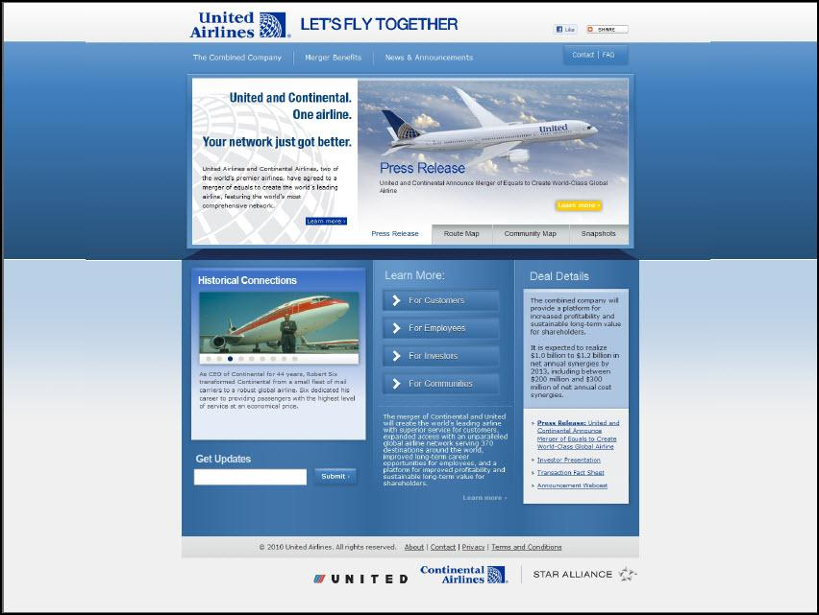

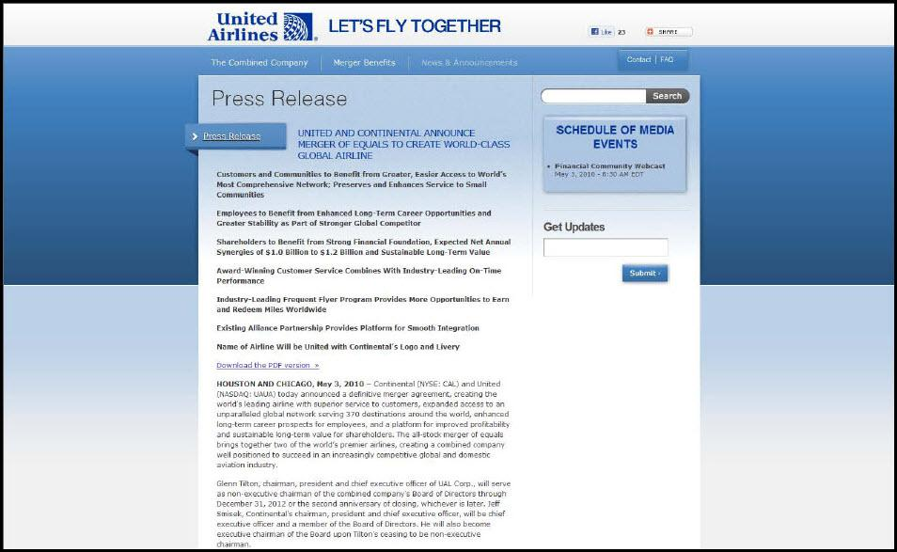

Press Release UNITED AND CONTINENTAL ANNOUNCE MERGER OF EQUALS TO CREATE WORLD-CLASS GLOBAL AIRLINE Customers and Communities to Benefit from Greater, Easier Access to World’s Most Comprehensive Network; Preserves and Enhances Service to Small Communities Employees to Benefit from Enhanced Long-Term Career Opportunities and Greater Stability as Part of Stronger Global Competitor Shareholders to Benefit from Strong Financial Foundation, Expected Net Annual Synergies of $1.0 Billion to $1.2 Billion and Sustainable Long-Term Value Award-Winning Customer Service Combines With Industry-Leading On-Time Performance Industry-Leading Frequent Flyer Program Provides More Opportunities to Earn and Redeem Miles Worldwide Existing Alliance Partnership Provides Platform for Smooth Integration Name of Airline Will be United with Continental’s Logo and Livery Download the PDF version » HOUSTON AND CHICAGO, May 3, 2010 – Continental (NYSE: CAL) and United (NASDAQ: UAUA) today announced a definitive merger agreement, creating the world’s leading airline with superior service to customers, expanded access to an unparalleled global network serving 370 destinations around the world, enhanced long-term career prospects for employees, and a platform for improved profitability and sustainable long-term value for shareholders. The all-stock merger of equals brings together two of the world’s premier airlines, creating a combined company well positioned to succeed in an increasingly competitive global and domestic aviation industry. Glenn Tilton, chairman, president and chief executive officer of UAL Corp., will serve as non-executive chairman of the combined company’s Board of Directors through December 31, 2012 or the second anniversary of closing, whichever is later. Jeff Smisek, Continental’s chairman, president and chief executive officer, will be chief executive officer and a member of the Board of Directors. He will also become executive chairman of the Board upon Tilton’s ceasing to be non-executive chairman.

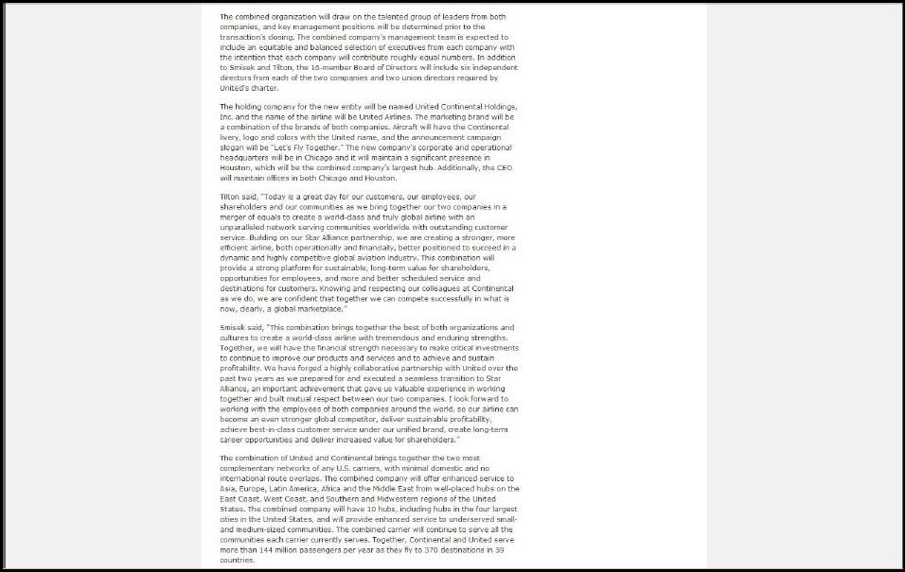

The combined organization will draw on the talented group of leaders from both companies, and key management positions will be determined prior to the transaction’s closing. The combined company’s management team is expected to include an equitable and balanced selection of executives from each company with the intention that each company will contribute roughly equal numbers. In addition to Smisek and Tilton, the 16-member Board of Directors will include six independent directors from each of the two companies and two union directors required by United’s charter. The holding company for the new entity will be named United Continental Holdings, Inc. and the name of the airline will be United Airlines. The marketing brand will be a combination of the brands of both companies. Aircraft will have the Continental livery, logo and colors with the United name, and the announcement campaign slogan will be “Let’s Fly Together.” The new company’s corporate and operational headquarters will be in Chicago and it will maintain a significant presence in Houston, which will be the combined company’s largest hub. Additionally, the CEO will maintain offices in both Chicago and Houston. Tilton said, “Today is a great day for our customers, our employees, our shareholders and our communities as we bring together our two companies in a merger of equals to create a world-class and truly global airline with an unparalleled network serving communities worldwide with outstanding customer service. Building on our Star Alliance partnership, we are creating a stronger, more efficient airline, both operationally and financially, better positioned to succeed in a dynamic and highly competitive global aviation industry. This combination will provide a strong platform for sustainable, long-term value for shareholders, opportunities for employees, and more and better scheduled service and destinations for customers. Knowing and respecting our colleagues at Continental as we do, we are confident that together we can compete successfully in what is now, clearly, a global marketplace.” Smisek said, “This combination brings together the best of both organizations and cultures to create a world-class airline with tremendous and enduring strengths. Together, we will have the financial strength necessary to make critical investments to continue to improve our products and services and to achieve and sustain profitability. We have forged a highly collaborative partnership with United over the past two years as we prepared for and executed a seamless transition to Star Alliance, an important achievement that gave us valuable experience in working together and built mutual respect between our two companies. I look forward to working with the employees of both companies around the world, so our airline can become an even stronger global competitor, deliver sustainable profitability, achieve best-in-class customer service under our unified brand, create long-term career opportunities and deliver increased value for shareholders.” The combination of United and Continental brings together the two most complementary networks of any U.S. carriers, with minimal domestic and no international route overlaps. The combined company will offer enhanced service to Asia, Europe, Latin America, Africa and the Middle East from well-placed hubs on the East Coast, West Coast, and Southern and Midwestern regions of the United States. The combined company will have 10 hubs, including hubs in the four largest cities in the United States, and will provide enhanced service to underserved small- and medium-sized communities. The combined carrier will continue to serve all the communities each carrier currently serves. Together, Continental and United serve more than 144 million passengers per year as they fly to 370 destinations in 59 countries.

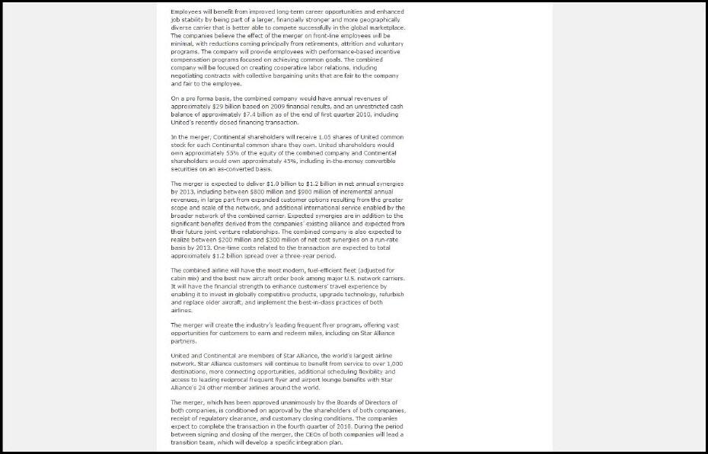

Employees will benefit from improved long-term career opportunities and enhanced job stability by being part of a larger, financially stronger and more geographically diverse carrier that is better able to compete successfully in the global marketplace. The companies believe the effect of the merger on front-line employees will be minimal, with reductions coming principally from retirements, attrition and voluntary programs. The company will provide employees with performance-based incentive compensation programs focused on achieving common goals. The combined company will be focused on creating cooperative labor relations, including negotiating contracts with collective bargaining units that are fair to the company and fair to the employee. On a pro forma basis, the combined company would have annual revenues of approximately $29 billion based on 2009 financial results, and an unrestricted cash balance of approximately $7.4 billion as of the end of first quarter 2010, including United’s recently closed financing transaction. In the merger, Continental shareholders will receive 1.05 shares of United common stock for each Continental common share they own. United shareholders would own approximately 55% of the equity of the combined company and Continental shareholders would own approximately 45%, including in-the-money convertible securities on an as-converted basis. The merger is expected to deliver $1.0 billion to $1.2 billion in net annual synergies by 2013, including between $800 million and $900 million of incremental annual revenues, in large part from expanded customer options resulting from the greater scope and scale of the network, and additional international service enabled by the broader network of the combined carrier. Expected synergies are in addition to the significant benefits derived from the companies’ existing alliance and expected from their future joint venture relationships. The combined company is also expected to realize between $200 million and $300 million of net cost synergies on a run-rate basis by 2013. One-time costs related to the transaction are expected to total approximately $1.2 billion spread over a three-year period. The combined airline will have the most modern, fuel-efficient fleet (adjusted for cabin mix) and the best new aircraft order book among major U.S. network carriers. It will have the financial strength to enhance customers’ travel experience by enabling it to invest in globally competitive products, upgrade technology, refurbish and replace older aircraft, and implement the best-in-class practices of both airlines. The merger will create the industry’s leading frequent flyer program, offering vast opportunities for customers to earn and redeem miles, including on Star Alliance partners. United and Continental are members of Star Alliance, the world’s largest airline network. Star Alliance customers will continue to benefit from service to over 1,000 destinations, more connecting opportunities, additional scheduling flexibility and access to leading reciprocal frequent flyer and airport lounge benefits with Star Alliance's 24 other member airlines around the world. The merger, which has been approved unanimously by the Boards of Directors of both companies, is conditioned on approval by the shareholders of both companies, receipt of regulatory clearance, and customary closing conditions. The companies expect to complete the transaction in the fourth quarter of 2010. During the period between signing and closing of the merger, the CEOs of both companies will lead a transition team, which will develop a specific integration plan.

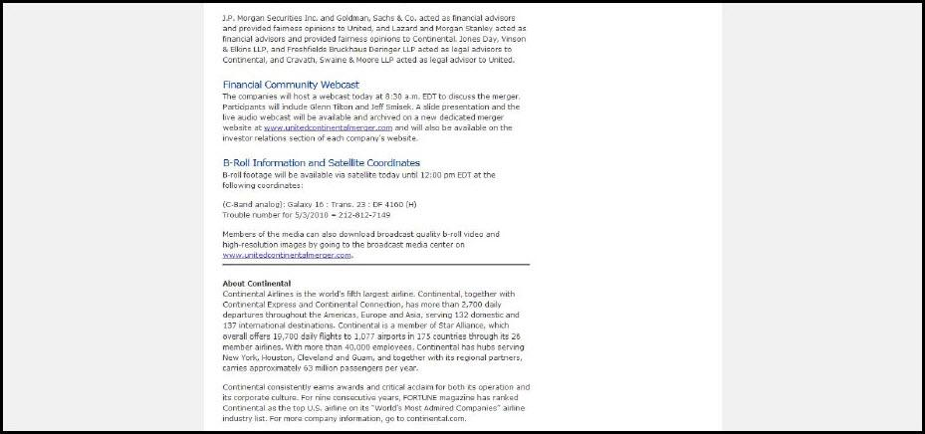

Employees will benefit from improved long-term career opportunities and enhanced job stability by being part of a larger, financially stronger and more geographically diverse carrier that is better able to compete successfully in the global marketplace. The companies believe the effect of the merger on front-line employees will be minimal, with reductions coming principally from retirements, attrition and voluntary programs. The company will provide employees with performance-based incentive compensation programs focused on achieving common goals. The combined company will be focused on creating cooperative labor relations, including negotiating contracts with collective bargaining units that are fair to the company and fair to the employee. On a pro forma basis, the combined company would have annual revenues of approximately $29 billion based on 2009 financial results, and an unrestricted cash balance of approximately $7.4 billion as of the end of first quarter 2010, including United’s recently closed financing transaction. In the merger, Continental shareholders will receive 1.05 shares of United common stock for each Continental common share they own. United shareholders would own approximately 55% of the equity of the combined company and Continental shareholders would own approximately 45%, including in-the-money convertible securities on an as-converted basis. The merger is expected to deliver $1.0 billion to $1.2 billion in net annual synergies by 2013, including between $800 million and $900 million of incremental annual revenues, in large part from expanded customer options resulting from the greater scope and scale of the network, and additional international service enabled by the broader network of the combined carrier. Expected synergies are in addition to the significant benefits derived from the companies’ existing alliance and expected from their future joint venture relationships. The combined company is also expected to realize between $200 million and $300 million of net cost synergies on a run-rate basis by 2013. One-time costs related to the transaction are expected to total approximately $1.2 billion spread over a three-year period. The combined airline will have the most modern, fuel-efficient fleet (adjusted for cabin mix) and the best new aircraft order book among major U.S. network carriers. It will have the financial strength to enhance customers’ travel experience by enabling it to invest in globally competitive products, upgrade technology, refurbish and replace older aircraft, and implement the best-in-class practices of both airlines. The merger will create the industry’s leading frequent flyer program, offering vast opportunities for customers to earn and redeem miles, including on Star Alliance partners. United and Continental are members of Star Alliance, the world’s largest airline network. Star Alliance customers will continue to benefit from service to over 1,000 destinations, more connecting opportunities, additional scheduling flexibility and access to leading reciprocal frequent flyer and airport lounge benefits with Star Alliance's 24 other member airlines around the world. The merger, which has been approved unanimously by the Boards of Directors of both companies, is conditioned on approval by the shareholders of both companies, receipt of regulatory clearance, and customary closing conditions. The companies expect to complete the transaction in the fourth quarter of 2010. During the period between signing and closing of the merger, the CEOs of both companies will lead a transition team, which will develop a specific integration plan.

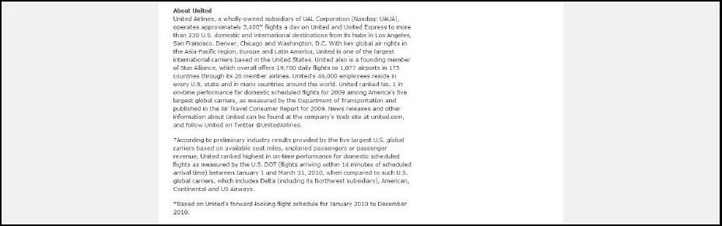

J.P. Morgan Securities Inc. and Goldman, Sachs & Co. acted as financial advisors and provided fairness opinions to United, and Lazard and Morgan Stanley acted as financial advisors and provided fairness opinions to Continental. Jones Day, Vinson & Elkins LLP, and Freshfields Bruckhaus Deringer LLP acted as legal advisors to Continental, and Cravath, Swaine & Moore LLP acted as legal advisor to United. Financial Community Webcast The companies will host a webcast today at 8:30 a.m. EDT to discuss the merger. Participants will include Glenn Tilton and Jeff Smisek. A slide presentation and the live audio webcast will be available and archived on a new dedicated merger website at www.unitedcontinentalmerger.com and will also be available on the investor relations section of each company’s website. B-Roll Information and Satellite Coordinates B-roll footage will be available via satellite today until 12:00 pm EDT at the following coordinates: (C-Band analog): Galaxy 16 : Trans. 23 : DF 4160 (H) Trouble number for 5/3/2010 = 212-812-7149 Members of the media can also download broadcast quality b-roll video and high-resolution images by going to the broadcast media center on www.unitedcontinentalmerger.com. - -------------------------------------------------------------------------------- About Continental Continental Airlines is the world’s fifth largest airline. Continental, together with Continental Express and Continental Connection, has more than 2,700 daily departures throughout the Americas, Europe and Asia, serving 132 domestic and 137 international destinations. Continental is a member of Star Alliance, which overall offers 19,700 daily flights to 1,077 airports in 175 countries through its 26 member airlines. With more than 40,000 employees, Continental has hubs serving New York, Houston, Cleveland and Guam, and together with its regional partners, carries approximately 63 million passengers per year. Continental consistently earns awards and critical acclaim for both its operation and its corporate culture. For nine consecutive years, FORTUNE magazine has ranked Continental as the top U.S. airline on its “World’s Most Admired Companies” airline industry list. For more company information, go to continental.com.

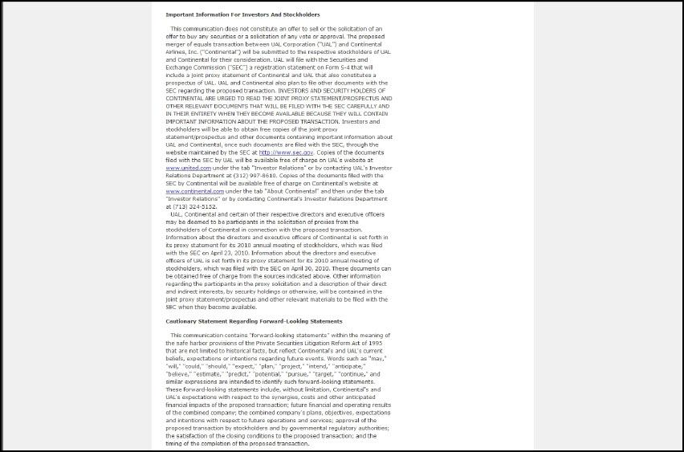

Important Information For Investors And Stockholders This communication does not constitute an offer to sell or the solicitation of an offer to buy any securities or a solicitation of any vote or approval. The proposed merger of equals transaction between UAL Corporation (“UAL”) and Continental Airlines, Inc. (“Continental”) will be submitted to the respective stockholders of UAL and Continental for their consideration. UAL will file with the Securities and Exchange Commission (“SEC”) a registration statement on Form S-4 that will include a joint proxy statement of Continental and UAL that also constitutes a prospectus of UAL. UAL and Continental also plan to file other documents with the SEC regarding the proposed transaction. INVESTORS AND SECURITY HOLDERS OF CONTINENTAL ARE URGED TO READ THE JOINT PROXY STATEMENT/PROSPECTUS AND OTHER RELEVANT DOCUMENTS THAT WILL BE FILED WITH THE SEC CAREFULLY AND IN THEIR ENTIRETY WHEN THEY BECOME AVAILABLE BECAUSE THEY WILL CONTAIN IMPORTANT INFORMATION ABOUT THE PROPOSED TRANSACTION. Investors and stockholders will be able to obtain free copies of the joint proxy statement/prospectus and other documents containing important information about UAL and Continental, once such documents are filed with the SEC, through the website maintained by the SEC at http://www.sec.gov. Copies of the documents filed with the SEC by UAL will be available free of charge on UAL’s website at www.united.com under the tab “Investor Relations” or by contacting UAL’s Investor Relations Department at (312) 997-8610. Copies of the documents filed with the SEC by Continental will be available free of charge on Continental’s website at www.continental.com under the tab “About Continental” and then under the tab “Investor Relations” or by contacting Continental’s Investor Relations Department at (713) 324-5152. UAL, Continental and certain of their respective directors and executive officers may be deemed to be participants in the solicitation of proxies from the stockholders of Continental in connection with the proposed transaction. Information about the directors and executive officers of Continental is set forth in its proxy statement for its 2010 annual meeting of stockholders, which was filed with the SEC on April 23, 2010. Information about the directors and executive officers of UAL is set forth in its proxy statement for its 2010 annual meeting of stockholders, which was filed with the SEC on April 30, 2010. These documents can be obtained free of charge from the sources indicated above. Other information regarding the participants in the proxy solicitation and a description of their direct and indirect interests, by security holdings or otherwise, will be contained in the joint proxy statement/prospectus and other relevant materials to be filed with the SEC when they become available.

Cautionary Statement Regarding Forward-Looking Statements This communication contains “forward-looking statements” within the meaning of the safe harbor provisions of the Private Securities Litigation Reform Act of 1995 that are not limited to historical facts, but reflect Continental’s and UAL’s current beliefs, expectations or intentions regarding future events. Words such as “may,” “will,” “could,” “should,” “expect,” “plan,” “project,” “intend,” “anticipate,” “believe,” “estimate,” “predict,” “potential,” “pursue,” “target,” “continue,” and similar expressions are intended to identify such forward-looking statements. These forward-looking statements include, without limitation, Continental’s and UAL’s expectations with respect to the synergies, costs and other anticipated financial impacts of the proposed transaction; future financial and operating results of the combined company; the combined company’s plans, objectives, expectations and intentions with respect to future operations and services; approval of the proposed transaction by stockholders and by governmental regulatory authorities; the satisfaction of the closing conditions to the proposed transaction; and the timing of the completion of the proposed transaction.

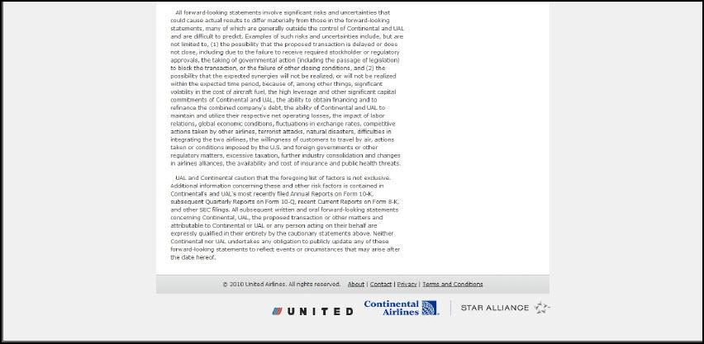

All forward-looking statements involve significant risks and uncertainties that could cause actual results to differ materially from those in the forward-looking statements, many of which are generally outside the control of Continental and UAL and are difficult to predict. Examples of such risks and uncertainties include, but are not limited to, (1) the possibility that the proposed transaction is delayed or does not close, including due to the failure to receive required stockholder or regulatory approvals, the taking of governmental action (including the passage of legislation) to block the transaction, or the failure of other closing conditions, and (2) the possibility that the expected synergies will not be realized, or will not be realized within the expected time period, because of, among other things, significant volatility in the cost of aircraft fuel, the high leverage and other significant capital commitments of Continental and UAL, the ability to obtain financing and to refinance the combined company’s debt, the ability of Continental and UAL to maintain and utilize their respective net operating losses, the impact of labor relations, global economic conditions, fluctuations in exchange rates, competitive actions taken by other airlines, terrorist attacks, natural disasters, difficulties in integrating the two airlines, the willingness of customers to travel by air, actions taken or conditions imposed by the U.S. and foreign governments or other regulatory matters, excessive taxation, further industry consolidation and changes in airlines alliances, the availability and cost of insurance and public health threats. UAL and Continental caution that the foregoing list of factors is not exclusive. Additional information concerning these and other risk factors is contained in Continental’s and UAL’s most recently filed Annual Reports on Form 10-K, subsequent Quarterly Reports on Form 10-Q, recent Current Reports on Form 8-K, and other SEC filings. All subsequent written and oral forward-looking statements concerning Continental, UAL, the proposed transaction or other matters and attributable to Continental or UAL or any person acting on their behalf are expressly qualified in their entirety by the cautionary statements above. Neither Continental nor UAL undertakes any obligation to publicly update any of these forward-looking statements to reflect events or circumstances that may arise after the date hereof. UAL and Continental have created a website at www.unitedcontinentalmerger.com with information about the merger. The website includes the information being filed herewith.

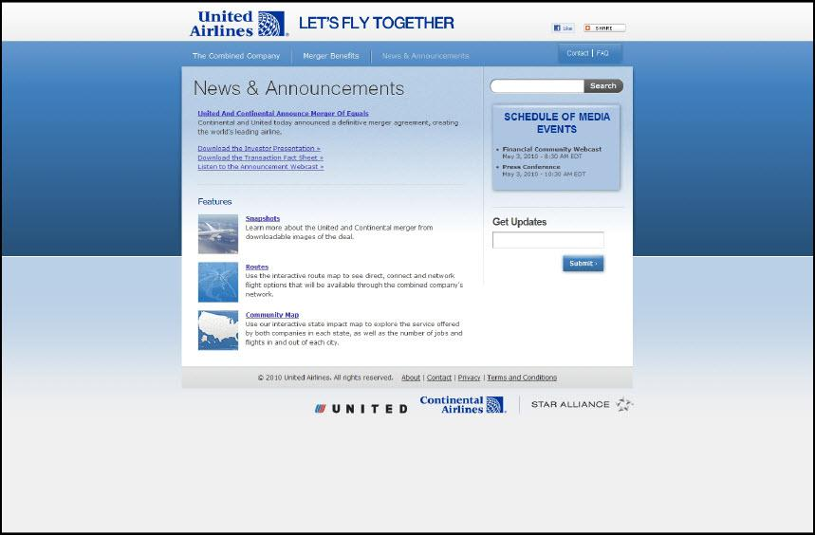

United Airlines and Continental Airlines, two of the world’s premier airlines, have agreed to a merger of equals to create the world’s leading airline, featuring the world’s most comprehensive network. Press Release United and Continental Announce Merger of Equals to Create World-Class Global Airline In 2004, Continental becomes the first major U.S. airline to order the Boeing 787 aircraft. The merger of Continental and United will create the world’s leading airline with superior service for customers, expanded access with an unparalleled global airline network serving 370 destinations around the world, improved long-term career opportunities for employees, and a platform for improved profitability and sustainable long-term value for shareholders. The combined company will provide a platform for increased profitability and sustainable long-term value for shareholders. It is expected to realize $1.0 billion to $1.2 billion in net annual synergies by 2013, including between $200 million and $300 million of net annual cost synergies. Press Release: United and Continental Announce Merger of Equals to Create World-Class Global Airline Investor Presentation Announcement Webcas

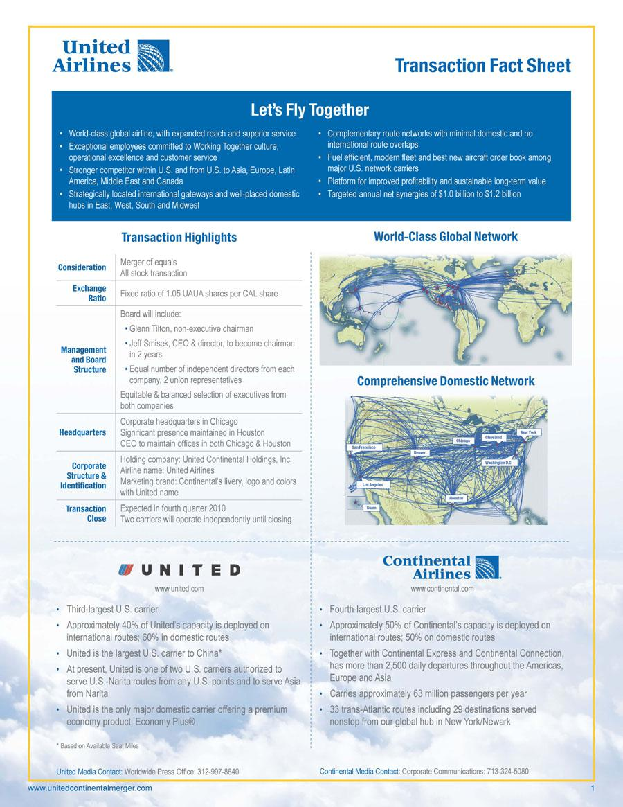

United Airlines Transaction Fact Sheet Let’s Fly Together World-class global airline, with expanded reach and superior service Exceptional employees committed to Working Together culture, operational excellence and customer service Stronger competitor within U.S. and from U.S. to Asia, Europe, Latin America, Middle East and Canada Strategically located international gateways and well-placed domestic hubs in East, West, South and Midwest Complementary route networks with minimal domestic and no international route overlaps Fuel efficient, modern fleet and best new aircraft order book among major U.S. network carriers Platform for improved profitability and sustainable long-term value Targeted annual net synergies of $1.0 billion to $1.2 billion Transaction Highlights Consideration Merger of equals All stock transaction Exchange Ratio Fixed ratio of 1.05 UAUA shares per CAL share Management and Board Structure Board will include: Glenn Tilton, non-executive chairman Jeff Smisek, CEO & director, to become chairman in 2 years Equal number of independent directors from each company, 2 union representatives Equitable & balanced selection of executives from both companies Headquarters Corporate headquarters in Chicago Significant presence maintained in Houston CEO to maintain offices in both Chicago & Houston Corporate Structure & Identification Holding company: United Continental Holdings, Inc. Airline name: United Airlines Marketing brand: Continental’s livery, logo and colors with United name Transaction Close Expected in fourth quarter 2010 Two carriers will operate independently until closing World-Class Global Network Comprehensive Domestic Network New York Denver Chicago Cleveland Los Angeles San Francisco UNITED Third-largest U.S. carrier Approximately 40% of United’s capacity is deployed on international routes; 60% in domestic routes United is the largest U.S. carrier to China* At present, United is one of two U.S. carriers authorized to serve U.S.-Narita routes from any U.S. points and to serve Asia from Narita United is the only major domestic carrier offering a premium economy product, Economy Plus® *Based on Available Seat Miles Continental Airlines Fourth-largest U.S. carrier Approximately 50% of Continental’s capacity is deployed on international routes; 50% on domestic routes Together with Continental Express and Continental Connection, has more than 2,500 daily departures throughout the Americas, Europe and Asia Carries approximately 63 million passengers per year 33 trans-Atlantic routes including 29 destinations served nonstop from our global hub in New York Newark United Media Contact: Worldwide Press Office: 312-997-8640 Continental Media Contact: Corporate Communications: 713-324-5080

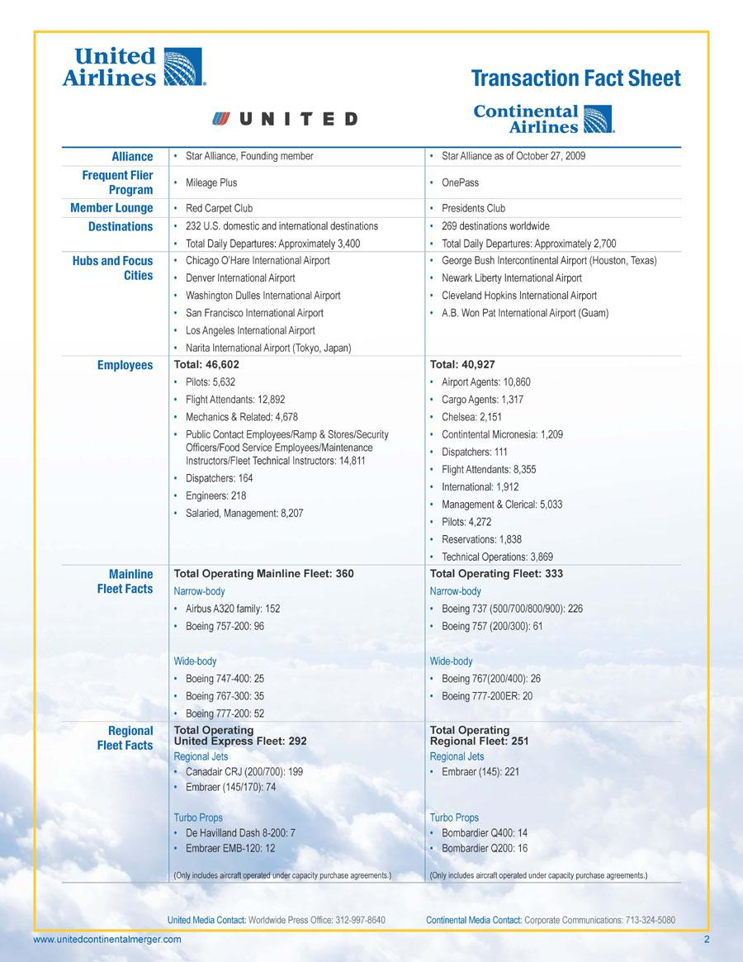

United Airlines’ Transaction Fact Sheet UNITED Continental Airlines Alliance StarAlliance, Founding member Star Alliance as of October 27, 2009 Frequent Flier Program Mileage Plus OnePass Member Lounge Red Carpet Club Presidents Club Destinations 232 U.S. domestic and international destinations 269 destinations worldwide Total Daily Departures: Approximately 3,400 Total Daily Departures: Approximately 2,700 Hubs and Focus Cities Chicago O’Hare International Airport George Bush Intercontinental Airport (Houston, Texas) Denver International Airport Newark Liberty International Airport Washington Dulles International Airport Cleveland Hopkins International Airport San Francisco International Airport A.B. Won Pat International Airport (Guam) Los Angeles International Airport Narita International Airport (Tokyo, Japan) Employees Total: 46,602 Total:

40,927 Pilots: 5,632 Airport Agents: 10,860 Flight Attendants: 12,892 Cargo Agents: 1,317 Mechanics & Related: 4,678 Chelsea: 2,151 Public Contact Employees/Ramp & Stores/Security Contintental Micronesia: 1,209 Officers/Food Service Employees/Maintenance Dispatchers: 111 Instructors/Fleet Technical Instructors: 14,811 Flight Attendants: 8,355 Dispatchers: 164 International: 1,912 Engineers: 218 Management &Clerical: 5,033 Salaried, Management: 8,207 Pilots: 4,272 Reservations: 1,838 Technical Operations: 3,869 Mainline Fleet Facts Total Operating Mainline Fleet: 360 Total Operating Fleet: 333 Narrow-body Narrow-body Airbus A320 family: 152 Boeing 737 (500/700/800/900): 226 Boeing 757-200: 96 Boeing 757 (200/300): 61 Wide-body Wide-body Boeing 747-400: 25 Boeing 767(200/400): 26 Boeing 767-300:35 Boeing 777-200ER: 20 Boeing 777-200:

52 Regional Fleet Facts Total Operating United Express Fleet: 292 Total Operating Regional Fleet: 25 Regional Jets Regional Jets Canadair CRJ (200/700): 199 Embraer (145): 221 Embraer (145/170): 74 Turbo Props Turbo Props De Havilland Dash 8-200: 7 Bombardier Q400: 14 Embraer EMB-120: 12 Bombardier Q200: 16 (Only includes aircraft operated under capacity purchase agreements.) (Only includes aircraft operated under capacity purchase agreements.) United Media Contact: Worldwide Press Office: 312-997-8640 Continental Media Contact: Corporate Communications: 713-324-5080

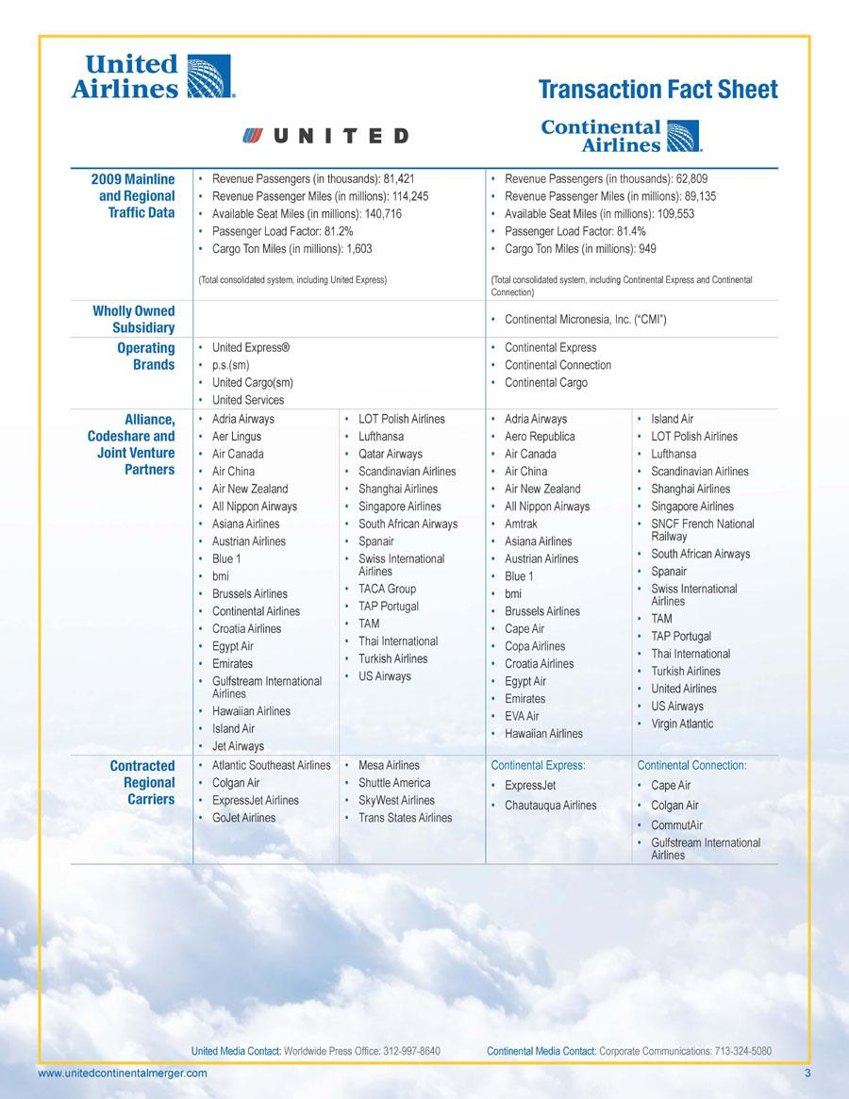

United Airlines Transaction Fact Sheet ®UNITED Continental Airlines 2009 Mainline Revenue Passengers (in thousands): 81,421 Revenue Passengers (in thousands): 62,809 and Regional Revenue Passenger Miles (in millions): 114,245 Revenue Passenger Miles (in millions): 89,135 Traffic Data Available Seat Miles (in millions): 140,716 Available Seat Miles (in millions): 109,553 Passenger Load Factor: 81.2% Passenger Load Factor: 81.4% Cargo Ton Miles (in millions): 1,603 Cargo Ton Miles (in millions): 949 (Total consolidated system, including United Express) (Total consolidated system, including Continental Express and Continental Connection) Wholly Owned Subsidiary Continental Micronesia, Inc. (“CMI”) Operating United Express® Continental Express Brands p.s.(sm) Continental Connection United Cargo(sm) Continental Cargo United Services Alliance, Codeshare and Joint Venture Partners Adria Airways LOT Polish Airlines AdriaAirways Island Air Aer Lingus Lufthansa Aero Republica LOT Polish Airlines Air Canada QatarAirways Air Canada Lufthansa Air China Scandinavian Airlines Air China Scandinavian Airlines Air New Zealand Shanghai Airlines Air New Zealand Shanghai Airlines All Nippon Airways Singapore Airlines All Nippon Airways Singapore Airlines Asiana Airlines South African Airways Amtrak SNCF French National Austrian Airlines Spanair AsianaAirlinesRailway Blue 1 Swiss International Austrian Airlines South African Airways bmi Airlines Blue 1 Spanair Brussels Airlines TACAGroup bmi Swiss International TAP Portugal Airlines Continental AirlinesBrussels Airlines Croatia Airlines TAM Cape Air TAM TAP Portugal Egypt Air Thai International CopaAirlines Emirates Turkish Airlines Croatia Airlines Thai International Gulfstream International USAirways Egypt Air Turkish Airlines Airlines Emirates : United Airlines Hawaiian Airlines EVAAirUS Airways Island Air.Virgin Atlantic Hawaiian Airlines Jet Airways Contracted Atlantic Southeast Airlines Mesa AirlinesContinental Express:Continental Connection: Regional Colgan Air Shuttle America ExpressJet Cape Air ti Carriers ExpressJet Airlines SkyWestAirlines Chautauqua Airlines Colgan Air GoJetAirlines Trans States Airlines CommutAir Gulfstream International Ilk Airlines do .1 United Media Contact: Worldwide Press Office: 312-997-8640 Continental Media Contact: Corporate Communications: 713-324-5080

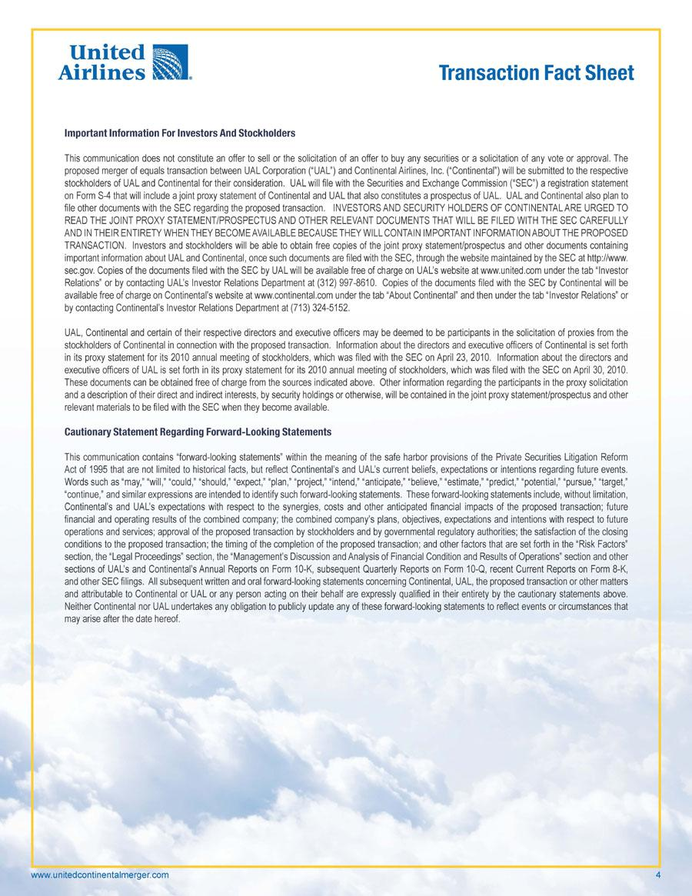

United Airlines Transaction Fact Sheet Important Information For Investors And Stockholders This communication does not constitute an offer to sell or the solicitation of an offer to buy any securities or a solicitation of any vote or approval. The proposed merger of equals transaction between UAL Corporation (“UAL”) and Continental Airlines, Inc. (“Continental”) will be submitted to the respective stockholders of UAL and Continental for their consideration. UAL will file with the Securities and Exchange Commission (“SEC”) a registration statement on Form S-4 that will include a joint proxy statement of Continental and UAL that also constitutes a prospectus of UAL. UAL and Continental also plan to file other documents with the SEC regarding the proposed transaction. INVESTORS AND SECURITY HOLDERS OF CONTINENTAL ARE URGED TO READ THE JOINT PROXY STATEMENT/PROSPECTUS AND OTHER RELEVANT DOCUMENTS THAT WILL BE FILED WITH THE SEC CAREFULLY AND IN THEIR ENTIRETY WHEN THEY BECOMEAVAILABLE BECAUSE THEY WILL CONTAIN IMPORTANT INFORMATION ABOUT THE PROPOSED TRANSACTION. Investors and stockholders will be able to obtain free copies of the joint proxy statement/prospectus and other documents containing important information about UAL and Continental, once such documents are filed with the SEC, through the website maintained by the SEC at http://www. sec.gov. Copies of the documents filed with the SEC by UAL will be available free of charge on UAL’s website at www.united.com under the tab “Investor Relations” or by contacting UAL’s Investor Relations Department at (312) 997-8610. Copies of the documents filed with the SEC by Continental will be available free of charge on Continental’s website at www.continental.com under the tab “About Continental” and then under the tab “Investor Relations” or by contacting Continental’s Investor Relations Department at (713) 324-5152. UAL, Continental and certain of their respective directors and executive officers may be deemed to be participants in the solicitation of proxies from the stockholders of Continental in connection with the proposed transaction. Information about the directors and executive officers of Continental is set forth in its proxy statement for its 2010 annual meeting of stockholders, which was filed with the SEC on April 23, 2010. Information about the directors and executive officers of UAL is set forth in its proxy statement for its 2010 annual meeting of stockholders, which was filed with the SEC on April 30, 2010. These documents can be obtained free of charge from the sources indicated above. Other information regarding the participants in the proxy solicitation and a description of their direct and indirect interests, by security holdings or otherwise, will be contained in the joint proxy statement/prospectus and other relevant materials to be filed with the SEC when they become available. Cautionary Statement Regarding Forward-Looking Statements This communication contains “forward-looking statements” within the meaning of the safe harbor provisions of the Private Securities Litigation Reform Act of 1995 that are not limited to historical facts, but reflect Continental’s and UAL’s current beliefs, expectations or intentions regarding future events. Words such as “may,” “will,” “could,” “should,” “expect,” “plan,” “project,” “intend,” “anticipate,” “believe,” “estimate,” “predict,” “potential,” “pursue,” “target,” “continue,” and similar expressions are intended to identify such forward-looking statements. These forward-looking statements include, without limitation, Continental’s and UAL’s expectations with respect to the synergies, costs and other anticipated financial impacts of the proposed transaction; future financial and operating results of the combined company; the combined company’s plans, objectives, expectations and intentions with respect to future operations and services; approval of the proposed transaction by stockholders and by governmental regulatory authorities; the satisfaction of the closing conditions to the proposed transaction; the timing of the completion of the proposed transaction; and other factors that are set forth in the “Risk Factors” section, the “Legal Proceedings” section, the “Management’s Discussion and Analysis of Financial Condition and Results of Operations” section and other sections of UAL’s and Continental’s Annual Reports on Form 10-K, subsequent Quarterly Reports on Form 10-Q, recent Current Reports on Form 8-K, and other SEC filings. All subsequent written and oral forward-looking statements concerning Continental, UAL, the proposed transaction or other matters and attributable to Continental or UAL or any person acting on their behalf are expressly qualified in their entirety by the cautionary statements above. Neither Continental nor UAL undertakes any obligation to publicly update any of these forward-looking statements to reflect events or circumstances that may arise after the date hereof.

